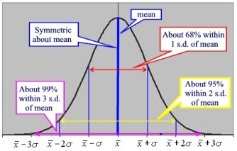
Int 3 MA –Ch 4 – Normal Distributions & Geometric Modeling
Date | Sections Covered | Assignment
Thursday  Sept. 26 | Interim SBAC Assessment | C4H1 Linear Programming WS
Friday  Sept. 27 | Linear Programming Quiz | C4H2 SAT #3 WS
Monday  Sept. 30 | Section 4.3.1  CP #61-63 | 4.3.1 Relative Frequency Histograms  C4H3 #67-71
BLOCK  Oct. 1-2 | Section 4.3.2  IB Normal Curve CP #72-74 | 4.3.2 The Normal Probability Density Function  C4H4 IB Normal Curve WS#1
Thursday  Oct. 3 | Section 4.3.1  CP #82-86  Exit Ticket | 4.3.3 Percentiles  C4H5 IB Normal Curve WS#2
Friday  Oct. 4 | Probability  Expected Value  C4 Quiz | C4H6 Expected Value WS
Monday  Oct. 7 | Ogive WS  Rat WS | C4H7 Probability Revisit WS
BLOCK  Oct. 8-9 | C4 Group Quiz | C4H8 C4 DDAY
Thursday  Oct. 10 | Review  Group Problems | C4H9 Check For Understanding WS
Friday  Oct. 11 | C4 TEST | C4H10 C4 SAT Prep WS

CAML #1 Oct. 15, 2019 at lunch in rooms 816 & 811
PSAT TEST on Oct. 16, 2019

