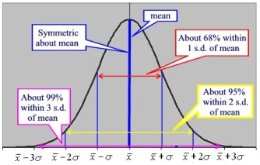
Int 3 MA –Ch 4 – Normal Distributions & Geometric Modeling
Date | Sections Covered | Assignment
Wednesday  October 10 | Probability Review  Worksheet | PSAT TEST
Thursday  October 11 | Section 4.3.1  CP #61-63 | 4.3.1 Relative Frequency Histograms  C4H1 #67-71
Friday  October 12 | Section 4.3.2  IB Normal Curve CP #72-74 | 4.3.2 The Normal Probability Density Function  C4H2 IB Normal Curve WS#1
Monday  Oct. 15 | Section 4.3.1  CP #82-86 | 4.3.3 Percentiles  C4H3 IB Normal Curve WS#2
BLOCK  Oct. 16-17 | Probability  Expected Value  C4 Quiz | C4H4 Expected Value WS
Thursday  Oct. 18 | Ogive  Group Problems | C4H5 Probability Revisit WS
Friday  Oct. 19 | C4 Group Quiz | C4H6 C4 DDAY
Monday  Oct. 22 | Review | C4H7 Check For Understanding WS
BLOCK  Oct. 23-24 | C4 TEST | C4H8 C4 SAT Prep WS

CAML #1 Oct. 16, 2018 at lunch in rooms 816 & 811

