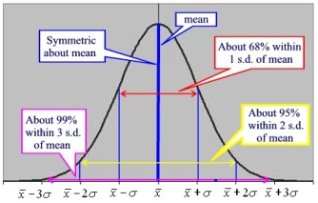
Int 3 MA –Ch 4 – Normal Distributions & Geometric Modeling
Date | Sections Covered | Assignment
Monday  Oct. 16 | Section 4.3.1  CP #61-63 | 4.3.1 Relative Frequency Histograms  C4H1 #67-71
BLOCK  Oct. 17-18 | Section 4.3.2  IB Normal Curve CP #72-74 | 4.3.2 The Normal Probability Density Function  C4H2 IB Normal Curve WS#1
Thursday  Oct. 19 | Section 4.3.1  CP #82-86 | 4.3.3 Percentiles  C4H3 IB Normal Curve WS#2
Friday  Oct. 20 | Probability  Expected Value | C4H4 Expected Value WS
Monday  Oct. 23 | Ogive  Group Problems | C4H5 Probability Revisit WS
BLOCK  Oct. 24-25 | C4 Group Quiz | C4H6 #134-140
Thursday  Oct. 26 |  | C4H7 C4 DDAY
Friday  Oct. 27 | C4 TEST | C4H8 C4 SAT Prep WS

