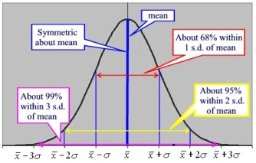
Int 3 –Ch 4 – Normal Distributions & Geometric Modeling
Date | Sections Covered | Assignment
Monday  September 30 | Section 4.3.1  CP #61-63 | 4.3.1 Relative Frequency Histograms  C4H1 #67-71
BLOCK  Oct. 1-2 | Interim Assessment | C4H2 Int2 Prob Review
Thursday  Oct. 3 | Section 4.3.2  CP #72-74 | 4.3.2 The Normal Probability Density Function  C4H3#79-81
Friday  Oct. 4 | Section 4.3.1  CP #82-86 | 4.3.3 Percentiles  C4H4 #90,91,93,94
Monday  Oct. 7 | Normal Curve WS | C4H5 Normal Curve WS #1
BLOCK  Oct. 8-9 | Normal Curve | C4H6 Normal Curve WS #2
Thursday  Oct. 10 | Review | C4H7 C4 DDAY
Friday  Oct. 11 | C4 Group Quiz. | C4H8 C4 DDAY #2
Monday  Oct. 14 | Review | C4H9 #136-140
Tuesday  Oct. 15 | C4 TEST | C4H10 C4 SAT Prep WS

Extra Credit: CAML Contest #1: Tues. Oct. 15 at lunch in rooms 811 & 816
PSAT : Wed. Oct. 16

