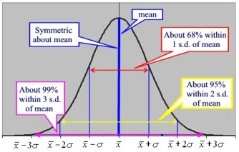
Int 3 –Ch 4 – Normal Distributions & Geometric Modeling
Date | Sections Covered | Assignment
Thursday  Oct. 25 | Section 4.3.1  CP #61-63 | 4.3.1 Relative Frequency Histograms  C4H1 #67-71
Friday  Oct. 26 | Section 4.3.2  CP #72-74 | 4.3.2 The Normal Probability Density Function  C4H2 #79-81
Monday  Oct. 29 | Section 4.3.1  CP #82-86 | 4.3.3 Percentiles  C4H3 #90,91,93,94
BLOCK  Oct. 30-31 | Normal Curve WS | C4H4 Normal Curve WS #2
Thursday  Nov. 1 | Review | C4H5 C4 DDAY
Friday  Nov. 2 | C4 Group Quiz. | C4H6 C4 DDAY #2
Monday  Nov. 5 | Review | C4H7 #136-140
BLOCK  Nov. 6-7 | C4 TEST | C4H8 C4 SAT Prep WS

