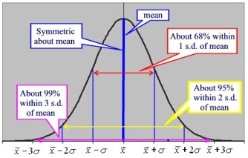
Int 3 –Ch 4 – Normal Distributions & Geometric Modeling
Date | Sections Covered | Assignment
Monday  Oct. 23 | Section 4.3.1  CP #61-63 | 4.3.1 Relative Frequency Histograms  C4H1 #67-71
BLOCK  Oct. 24-25 | Section 4.3.2  CP #72-74  Normal Curve WS | 4.3.2 The Normal Probability Density Function  C4H2 #79-81 & complete Normal Curve WS
Thursday  Oct. 26 | Section 4.3.1  CP #82-86 | 4.3.3 Percentiles  C4H3 #90,91,93,94
Friday  Oct. 27 | Catch up  Mini-quiz | C4H4 #136-140
Monday  Oct. 30 | review | C4H5 C4 DDAY
BLOCK  Oct. 31-Nov.1 | C4 Group Quiz. | C4H6 C4 DDAY #2
Thursday  Nov. 2 | Review
Friday  Nov. 3 | C4 TEST | C4H7 C4 SAT Prep WS

