**Int 3 IB Trig Practice WS Name _________________________________ Per ____ Group ____**

**No calculator for problem #1-5. Use a calculator for #6.**

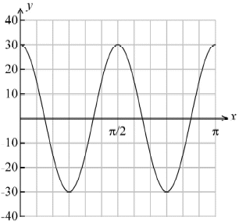**1.** The graph of a function of the form *y* = *p* cos *qx* is given to the right.

|  |  |
| --- | --- |
| a) Write down the value of *p*. | b) Calculate the value of *q*. |

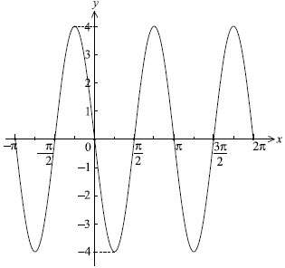**2.** Let ƒ (*x*) = *a* sin *b* (*x* − *c*). Part of the graph of ƒ is given to the right.

Given that *a*, *b* and *c* are positive, find the value of *a*, of *b* and of *c*.

**3.** Let *f*(*x*) =  +1, *g*(*x*) = 4cos – 1. Let *h*(*x*) = (*g* ° *f*)(*x*).

|  |  |  |
| --- | --- | --- |
| a) Find an expression for *h*(*x*). | b) Write down the period of *h*. | c) Write down the range of *h*. |

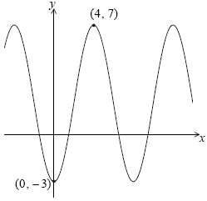**4.** The graph of *y* = *p* cos *qx* + *r*, for –5 ≤ *x* ≤ 14, is shown below.

There is a minimum point at (0, –3) and a maximum point at (4, 7).

(a) Find the value of

(i) *p*;

(ii) *q*;

(iii) *r*.

(b) The equation *y* = *k* has exactly **two** solutions. Write down the value of *k*.

5. Let *f*(*t*) = *a* cos *b* (*t* – *c*) + *d*, *t* ≥ 0. Part of the graph of *y* = *f*(*t*) is given below.

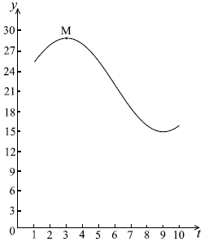

When *t* = 3, there is a maximum value of 29, at M.  
When *t* = 9 , there is a minimum value of 15.

(a) (i) Find the value of *a.*

(ii) Show that *b* = .

(iii) Find the value of *d*.

(iv) Write down a value for *c*.

**6.** **Use a calculator to answer this question.** Let *f*(*x*) = 3sin*x* + 4 cos *x*, for –2π ≤ *x* ≤ 2π.

(a) Sketch the graph of *f*.

(b) Write down

(i) the amplitude;

(ii) the period;

(iii) the *x*-intercept that lies between  and 0.