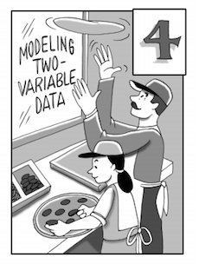

# Chapter 4   Modeling Two-Variable Data

In Chapter 4 you will be describing a dependent relationship, called the association, between two numerical variables.  You will use scatterplots of data to create lines and curves that model the data, and then use those models to make predictions.  You will mathematically describe the form, direction, strength, and outliers of an association.



|  |  |  |
| --- | --- | --- |
| https://ebooks.cpm.org/images/int1/ch4/int1.ch4puzzle1.png | **Section 4.1** | Throughout this section, you will “eyeball” a line of best fit and use it to make predictions, interpret the slope andy‑intercept in a statistical situation, and describe the form, direction, strength, and outliers of an association. You will also calculate residuals and create upper and lower bounds for predictions that you make, and use your calculator to create the unique line of best fit called the least squares regression line.  You will start this section by investigating how much of a football field you can see through a hole in the wall.  Later you will make predictions in an anthropologist’s investigation of forearm length. |
| https://ebooks.cpm.org/images/int1/ch4/int1.ch4puzzle2.png | **Section 4.2** | In this section you will have several problems that help Giulia and her dad open a pizza parlor.  To help them, you will create residual plots and analyze them to determine whether a model is an appropriate fit to the data. You will calculate the correlation coefficient and R2 and interpret them in context. This section allows you to use more mathematical terms to describe the form, direction, and strength of an association, and you will discover that “association is not causation” because there might be a lurking variable. |

4.1.1a Integrated 1: Two Variable Statistics Name__________________Per_____

Car Skid Marks and Speeds

When police investigate the scene of an automobile accident, they look for skid marks and use the length of those marks to estimate the speed at which the car was traveling. The results of experiments with a test car, giving skid mark length (in feet) and speed (in miles per hour), are shown here. *(http://www.nctm.org/resources/content.aspx?id=32702)*



|  |  |
| --- | --- |
| Length of Skid mark | Speed of car |
| 5 | 10 |
| 17 | 20 |
| 37 | 30 |
| 65 | 40 |
| 105 | 50 |
| 150 | 60 |
| 205 | 70 |

|  |
| --- |
| a) Create a scatter plot. Be sure and label! |
| b) Describe the scatter plot. |
| c) Suppose the equation for the line of best fit is *predicted speed of car = 16.20 + 0.29(skid)* and sketch the line. | |
| d) Interpret the slope | e) Interpret the y-intercept |
| f) Predict the speed of the car if the skid mark measures 105 ft. Use the equation. | |

Sentence Frames for Statistics

Describe the Scatter plot:

There is a __________, _________, ___________

(strength: Strong/Weak) (direction: Pos/Neg) (form: linear, exponential)

relationship between ________ and _________.

x – variable y- variable

Interpret the slope:

On average, as the _________ increases by _______ the

x – variable # in denominator

_______ increases/decreases by about _________.

y- variable # in numerator

Interpret the y-intercept:

When the _________ is 0, the __________

x – variable y- variable

is about ________.

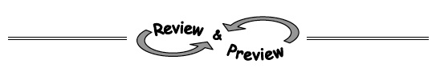Name________________________Per______

**HOMEWORK ASSIGNMENT**



**4-4.** Sam collected data by measuring the pencils of her classmates.  She recorded the length of the painted part of each pencil and its weight.  Her data is shown on the graph at right.

* 1. 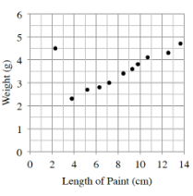Describe the association between weight and length of the pencil.  Remember to describe the form, direction, strength, and outliers.
  2. Make a conjecture (a guess) about why Sam’s data had an outlier.
  3. Sam created a line of best fit: w = 1.4 + 0.25lwhere wis the weight of the pencil in grams and l is the length of the paint on the pencil in centimeters.  What does the slope represent in this context?
  4. Sam’s teacher has a pencil with 11.5 cm of paint.  Predict the weight of his teacher’s pencil.
  5. Interpret the meaning of the y‑intercept in context.

**4-5.** Rewrite each expression without parentheses and use only positive exponents.

|  |  |
| --- | --- |
| a. (3xy3)(–2y) | b. (x3y2)(x–2y–2) |
| https://ebooks.cpm.org/images/int1/ch4/int1.4-5c.gifc. | d. (–2x)–3 |

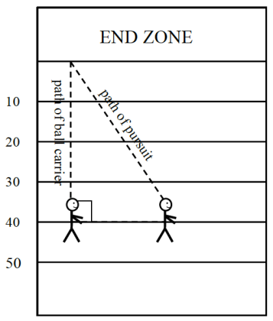**4-6.** In football, the path that a defender must run to tackle the ball carrier is called the path of pursuit.  If the ball carrier runs 40 yards to the end zone and the path of pursuit is 45 yards, how far apart were the ball carrier and defender when they started?  Answer with appropriate precision.  (Hint: Use the Pythagorean Theorem.)

**4-7.** While on vacation with your family, you will be driving from Los Angeles to San Diego.  If you take the freeway it is a distance of 144 miles and the average freeway speed is 75 miles per hour.  If you take the scenic route along the coast, the drive will be 122 miles at an average speed of 65 miles per hour.  Which is the better route to take if you want to get to San Diego in the shortest amount of time?  Show your work using Giant Ones.

**4-8.** Solve the equations below by first rewriting each equation as a simpler, equivalent equation.  Check your solutions.

1. 200x + 50 = 8000 b. 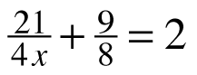

**4-9.** Copy and complete the table below.  Then write an equation for the function.

|  |  |  |  |  |  |  |  |  |  |
| --- | --- | --- | --- | --- | --- | --- | --- | --- | --- |
| input (x) | 2 | 10 | 6 | 7 | −3 | 0 | −10 | 100 | x |
| output (f(x)) | −7 |  |  |  | 18 | 3 |  |  |  |

4.1.1b  Integrated 1: Two Variable Statistics Name__________________Per_____

**Social Media**

A report by the New York Times claimed teeneages spend around 52.5 hours a week on the internet. As a result a study was contducted to see the effects of internet time on ones ability to focus on a task. The results are listed below.

|  |  |
| --- | --- |
| Internet time in one week (hrs) | Focus time on an activity (min) |
| 40 | 60 |
| 43 | 55 |
| 44 | 45 |
| 45 | 40 |
| 48 | 35 |
| 52 | 32 |
| 55 | 28 |
| 58 | 20 |

|  |
| --- |
| a) Create a scatter plot. Label! |
| b) Describe the scatter plot. |
| c) Suppose the equation for the line of best fit is *predicted focus time = 138 - 2(study time)* now sketch the line. | |
| d) Interpret the slope | e) Interpret the y-intercept |
| f) Predict the focus time if the internet time is about 48 hours. Use your LSRL. | |

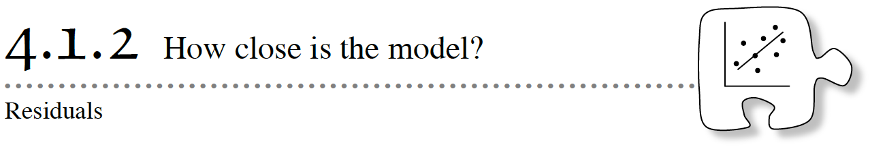Today you will investigate residuals.  A residual is the difference between what actually occurred and what was predicted by your best-fit model.

**4-10.** Battle Creek Cereal is trying a variety of packaging sizes for their Crispy Puffs cereal.  Below is a list of data for six current packages.

|  |  |
| --- | --- |
| Packaging Cardboard (in2) | Net Weight of Cereal (g) |
| 34 | 21 |
| 150 | 198 |
| 218 | 283 |
| 325 | 567 |
| 357 | 680 |
| 471 | 1020 |

Suppose the equation for the line of best fit is *predicted weight of cereal = -132 + 2.3(amt. cardboard)*

1. Write a few sentences to the executives of Battle Creek Cereal describing the association.
2. Tell the executives how much cereal a new experimental “green” package that uses 260 in2 of cardboard is expected to hold.

**4-11.**Interpret the meaning of the slope and *y‑*intercept of your model in the context of the Battle Creek Cereal situation.  Does the *y‑*intercept make sense in the context of the problem?

**4-12.** A **residual** is a measure of how far a prediction is from what is actually observed.

residual = actual − predicted

The 260 in2 box from problem 4-10 will actually hold 355 g of cereal.

1. What is the residual for the 260 in2 box?
2. What is the difference between a positive and a negative residual in the context of this problem?
3. How could graphing the actual and predicted data points help?

**4-13.** What is the residual for the 471 in2 box?  Draw the residual on your scatterplot.  Be sure to include units for your residual.  

**4-14.** The warehouse store wants to offer a super-sized 600 in2box.

* 1. The residual for this box is 1005 grams.  What is the actual weight of a 600 in2 box?
  2. Why do you suppose the residual is so large?

**4-15.** Armen was concerned about the amount of sugar in his diet, so he went to the store and collected data from several cereal boxes.  Armen used the data to create a model that related the amount of sugar in cereal to the number of calories:

*s* = –16.9 + 0.23*c*

where *s* is the amount of sugar in grams and *c* is the number of calories in one cup of cereal.

a. What does a negative residual mean in this context?

b. Is a cereal with a positive or negative residual better for Armen’s diet?

Interpret the meaning of the slope and *y*-intercept in the context of the problem.  Does the *y*-intercept make sense in the context of the problem?

******4-16.** LEARNING LOG

Work with your team to summarize what you have learned about residuals today.  When you have come to a consensus, write your ideas as a Learning Log entry.  Title this entry “Residuals” and label it with today’s date.

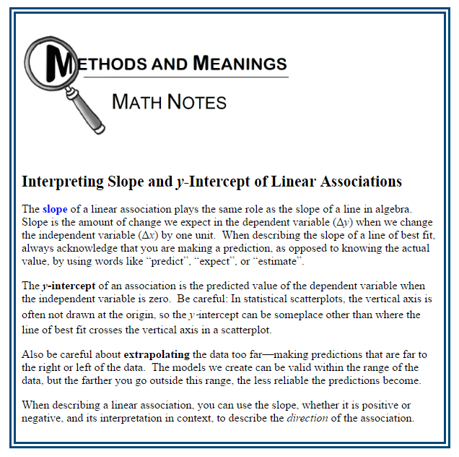

Name________________________Per______

**HOMEWORK ASSIGNMENT**

Studying vs. Grades

Before the last test, students were asked how many hours they studied for the test. The hours studied and the percent grade they received were recorded in the table below.

|  |  |
| --- | --- |
| Hours studied | Grade on test  % |
| 0 | 50 |
| 0.5 | 55 |
| 1 | 64 |
| 1 | 60 |
| 1.5 | 74 |
| 2 | 82 |
| 3 | 97 |

|  |
| --- |
| a) Create a scatter plot. Be sure and label! |
| b) Describe the scatter plot. |
| c) Suppose the equation for the line of best fit is *predicted grade = 48 + 16(study time)* and sketch the line. | |
| d) Interpret the slope | e) Interpret the y-intercept |
| f) Predict the grade of a person who studies for 2 hours. Use the equation. | |

**4-19.**If f(a) = 16, calculate the following values, if possible.

* 1. f(a) – 2
  2. f(2a)
  3. 3f(a) + 2

**4-20.**Write an equation for the following situation.  You do not need to solve it.

Laura takes very good care of her vehicles.  She owns a blue van and a red truck.  Although she bought them both new, she has owned the truck for 17 years longer than she has owned the van.  The sum of the ages of the vehicles is 41 years.

**4-21.**Plot ΔABC on graph paper with points A(2, 2), B(–2, –2), and C(8, –2).

a. Use the function (x, y) → (–1x, –1y) to transform ΔABC.  Graph and connect the new points then label this triangle ΔA′B′C′.  Describe how ΔABC has been transformed.  What, if anything, about the original triangle has been preserved in its image?

b. Now use the function (x, y) → (–2x, –2y) to transform the original ΔABC to create ΔA″B″C″.  Has ΔABC undergone a rigid transformation to create ΔA″B″C″?  What, if anything, about the original triangle has been preserved in its image?

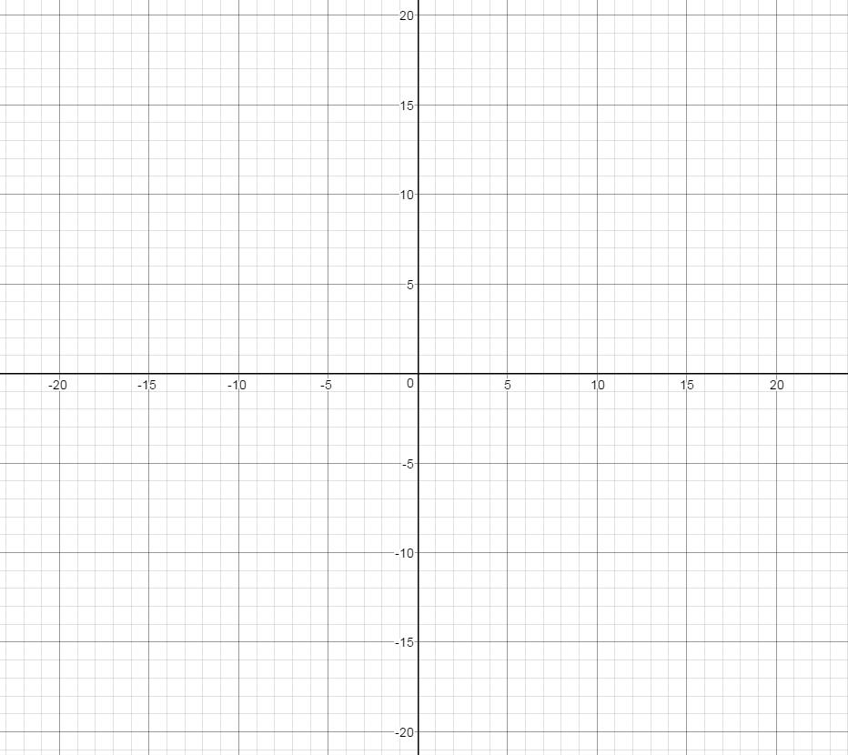

**4-22.** Rewrite each of the following products as a sum by using the Distributive Property.

a. 5x(x – 6) b. –9y(6 – 3y)

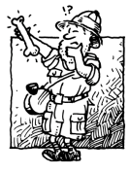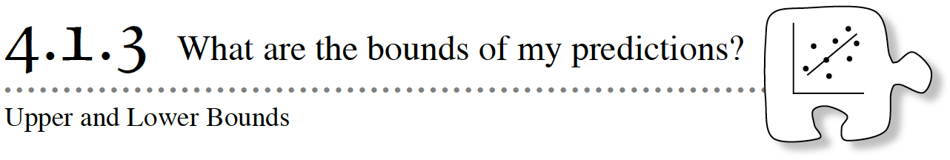

Today you will think about everything you know so far about statistical analyses and will write a report with all these elements.  Then you will learn how you can report a range of values for your predictions.

**4-23.** In 1997, an anthropologist discovered an early humanoid in Europe.  As part of the analysis of the specimen, the anthropologist needed to determine the approximate height of this humanoid.  The skeletal remains were highly limited, with only an ulna bone (forearm) being complete.  The bone measured 26.4 cm in length.

**Your Task:**Consider how you could determine how tall the humanoid was.  Discuss the questions below with your team.  Be ready to share your responses with the rest of the class.

https://ebooks.cpm.org/images/shared/discussionpoints.png

What information should we gather to answer this question?

What process can we use to gather this information?

What statistical information can we report back to the anthropologist

Once your class has decided what elements your report should contain, collect and analyze data with your team.  Write a few sentences to the anthropologist explaining your findings.

|  |  |
| --- | --- |
| Forearm Length (cm) | Height (cm) |
|  |  |
|  |  |
|  |  |
|  |  |
|  |  |
|  |  |
|  |  |
|  |  |

|  |  |  |  |  |  |  |  |  |  |  |  |  |  |  |  |  |
| --- | --- | --- | --- | --- | --- | --- | --- | --- | --- | --- | --- | --- | --- | --- | --- | --- |
|  |  |  |  |  |  |  |  |  |  |  |  |  |  |  |  |  |
|  |  |  |  |  |  |  |  |  |  |  |  |  |  |  |  |  |
|  |  |  |  |  |  |  |  |  |  |  |  |  |  |  |  |  |
|  |  |  |  |  |  |  |  |  |  |  |  |  |  |  |  |  |
|  |  |  |  |  |  |  |  |  |  |  |  |  |  |  |  |  |
|  |  |  |  |  |  |  |  |  |  |  |  |  |  |  |  |  |
|  |  |  |  |  |  |  |  |  |  |  |  |  |  |  |  |  |
|  |  |  |  |  |  |  |  |  |  |  |  |  |  |  |  |  |
|  |  |  |  |  |  |  |  |  |  |  |  |  |  |  |  |  |
|  |  |  |  |  |  |  |  |  |  |  |  |  |  |  |  |  |
|  |  |  |  |  |  |  |  |  |  |  |  |  |  |  |  |  |
|  |  |  |  |  |  |  |  |  |  |  |  |  |  |  |  |  |
|  |  |  |  |  |  |  |  |  |  |  |  |  |  |  |  |  |
|  |  |  |  |  |  |  |  |  |  |  |  |  |  |  |  |  |
|  |  |  |  |  |  |  |  |  |  |  |  |  |  |  |  |  |
|  |  |  |  |  |  |  |  |  |  |  |  |  |  |  |  |  |

|  |
| --- |
| a) Create a scatter plot. Be sure and label! |
| b) Describe the scatter plot. |
| c) Suppose the equation for the line of best fit is and sketch the line. | |
| d) Interpret the slope | e) Interpret the y-intercept |
| f) Predict the height of the humanoid using your model (line of best fit). Read the intro to determine the forearm length. | |

**4-24.** Because the height you found for the humanoid is a prediction, the actual height of the early humanoid was probably a little shorter or a little taller.  In this problem, you will investigate how you can report a *range* of values for your prediction of the humanoid’s height.

* 1. Look at the data you collected and the line that models the data.  Identify the point that is farthest from the line you drew.  Calculate the residual for this point.

* 1. In a different color, draw a dashed line that goes through this maximum residual point and is parallel to the line of your model.  An example is shown below.  Then draw another dashed line that is on the other side of your model and is the same distance away as the first dashed line.  You have just drawn the upper and lower bounds for the variability of the data.

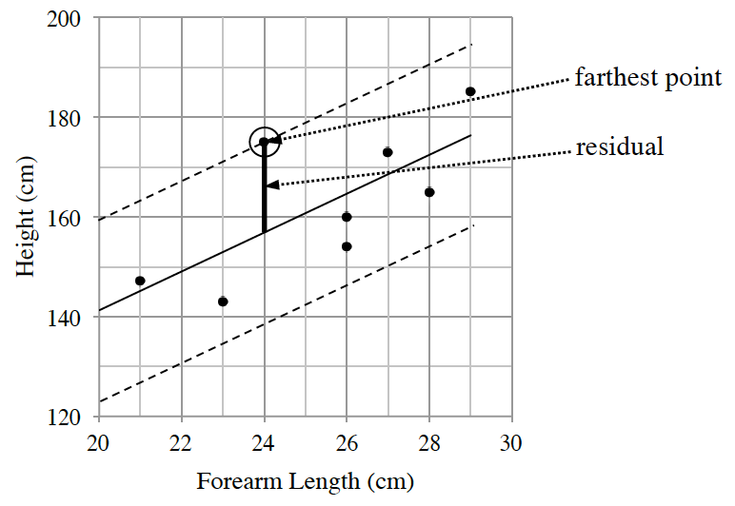

* 1. Using the upper and lower bounds that you just drew, create a range of values for the possible height of a humanoid with a forearm length of 26.4 cm.
  2. With your team, discuss the bounds of the data.  Was your model useful for predicting the height of the humanoid?

Name________________________Per______

**HOMEWORK ASSIGNMENT**

**4-25.**A study was done for a vitamin supplement that claims to shorten the length of the common cold.  The data the scientists collected from ten patients in an early study is shown in the table below.

|  |  |  |  |  |  |  |  |  |  |  |
| --- | --- | --- | --- | --- | --- | --- | --- | --- | --- | --- |
| **Number of months** **taking supplement** | 0.5 | 2.5 | 1 | 2 | 0.5 | 1 | 2 | 1 | 1.5 | 2.5 |
| **Number of days** **cold lasted** | 4.5 | 1.6 | 3 | 1.8 | 5 | 4.2 | 2.4 | 3.6 | 3.3 | 1.4 |

* 1. 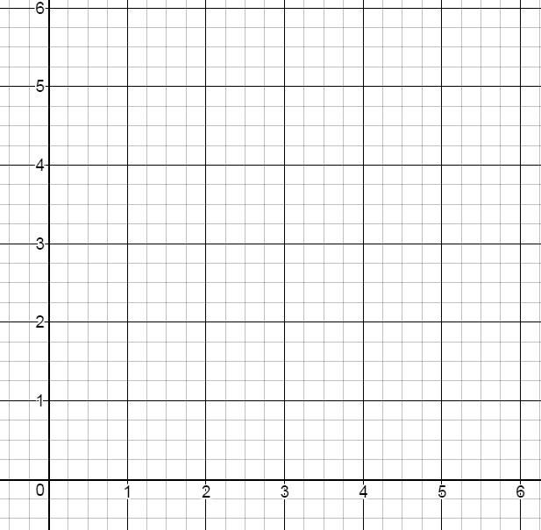Describe the association.
  2. Model the data with a line of best fit.  According to your model, how many days do you expect a cold to last for a patient taking the supplement for 1.5 months?
  3. Calculate the residual for 1.5 months.  Interpret the residual in the context of the problem.
  4. Interpret the y-intercept in context.

**4-26.** A line with slope   passes through the point (–12, 16).

1. What is an equation of the line?
2. What is the x-intercept of the line?

**4-27.**For each area model, fill in the missing parts.  Write an expression showing that the area as a sum equals the area as a product.

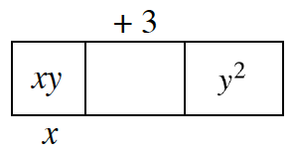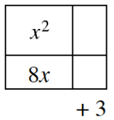 a. b.

**4-28.**  If f(x) = 3 −|x|  and g(x) = 3x + 5, then calculate the value of :

|  |  |  |
| --- | --- | --- |
| a. f (−5) | b. g(4) | c. f (0) |
| d. f (2) | e. g(1) | f. g(0) |

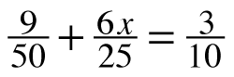**4-29.** Solve the equations below by first rewriting each equation as a simpler, equivalent equation.  Check your solutions.

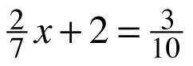 a. b.

**4-30.** At Jaques’ Bistro they serve two sizes of espressos, small (S) and large (L).  In a given day they made x of the small drinks and y of the large drinks.  What do the following expressions represent in this context?

a. S + L

b. x + y

c. xS + yL

**Who’s Line is better?**

1) Draw a line of best fit for the El Toro Basketball data shown below.

2) Give the equation for your line of best fit?

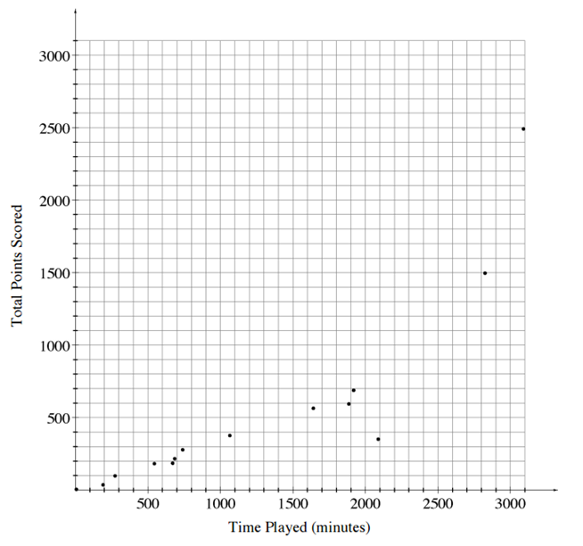

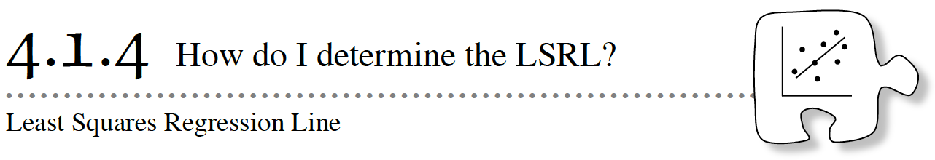

In previous lessons, when drawing a line of best fit, each team drew a slightly different line.  Today your class will agree on a single line of best fit for any particular situation.

**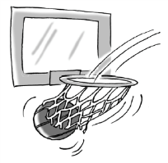****4-31.** The following table shows data for one season of the El Toro professional basketball team.  El Toro team member Antonio Kusoc was inadvertently left off of the list.  Antonio Kusoc played for 2103 minutes.  We would like to predict how many points he scored during the season.

|  |  |  |
| --- | --- | --- |
| **Player Name** | **Time Played (minutes)** | **Total Points Scored** **During a Season** |
| Sordan, Scottie | 3090 | 2491 |
| Lippen, Mike | 2825 | 1496 |
| Karper, Don | 1886 | 594 |
| Shortley, Luc | 1641 | 564 |
| Gerr, Bill | 1919 | 688 |
| Jodman, Dennis | 2088 | 351 |
| Kennington, Steve | 1065 | 376 |
| Bailey, John | 7 | 5 |
| Bookler, Jack | 740 | 278 |
| Dimkins, Rickie | 685 | 216 |
| Edwards, Jason | 274 | 98 |
| Gaffey, James | 545 | 182 |
| Black, Sandy | 671 | 185 |
| Talley, Dan | 191 | 36 |
| checksum 17627 | | checksum 7560 |

a. Which data point is an outlier for this data?

b. Whose data does that point represent?

c. What is his residual?

d. Would a player be more proud of a negative or positive residual?

e. Predict how many points Antonio Kusoc scored.

**4-34.** Different people will come up with different models for the relationship between total points scored and minutes played in the previous problem.  They will also have different estimates for the number of points scored by Antonio Kusoc. A **least squares regression line (LSRL)** is a unique line that has the smallest possible value for the sum of the squares of the residuals.

a. Use your calculator to make a scatterplot and sketch your scatterplot.

b. Use your calculator to determine the LSRL and sketch it above.

c. How many points does the LSRL predict for Antonio Kusoc?

d. Interpret the slope and y-intercept of the model in context.  Explain why this LSRL model is not reasonable for players that played less than about 350 minutes.

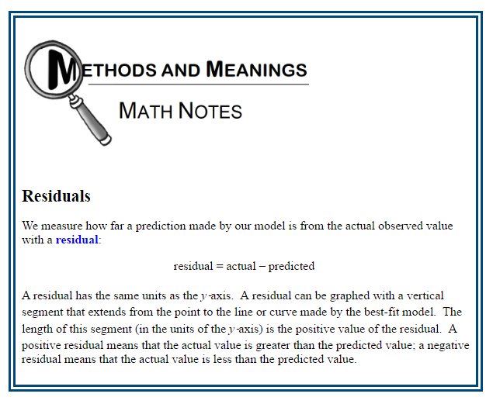

Name________________________Per______

**HOMEWORK ASSIGNMENT**

**4-36.** Charlie’s friend is visiting from Texas and asked him, “What does a hamburger cost in this town?”  This caused Charlie to wonder, because the price of a hamburger seems to be different at every restaurant.  Charlie thinks there may be an association between the amount of meat in the patty and the cost of the hamburger.  He collected the following data.

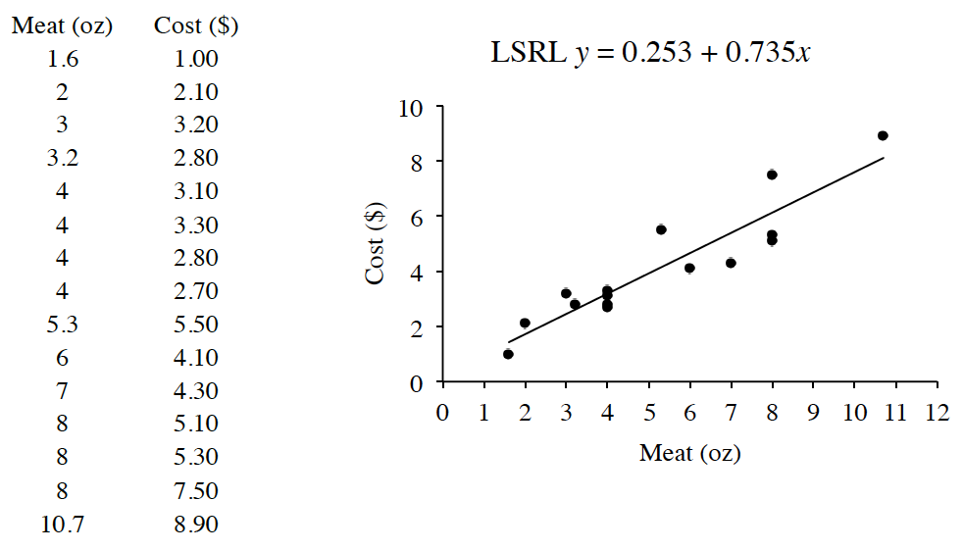

a. Interpret the slope and y‑intercept in context.  Does the y‑intercept make sense in this situation?

b. What is the residual for the hamburger with the 3-ounce patty?  What does it mean in context?

c. Charlie’s friend says that in his home town he can buy a 1 pound hamburger for $14.70.  Would this be a reasonable price in Charlie’s town?  Show how you know.

**4-37.** Determine the slope and intercepts for the line 2x + 3y = 6 and then draw a graph.

**4-38.** Trace the figures in parts (a) and (b) onto your paper and perform the indicated transformations.  Copy the figure from part (c) onto graph paper and perform the indicated transformation.  Label each image with prime notation (A → A′).

|  |  |  |  |  |  |
| --- | --- | --- | --- | --- | --- |
| a | Rotate *EFGHI*90° counter-clockwise (↺) about point *Z* https://ebooks.cpm.org/images/int1/ch4/int1.4-38a.png | b | Rotate *JKLMN* over line *t* https://ebooks.cpm.org/images/int1/ch4/int1.4-38b.png | c | Translate *ABCD*down 3 units and left 4 units https://ebooks.cpm.org/images/int1/ch4/int1.4-38c.png |

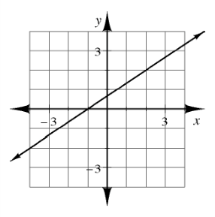**4-39.** **Multiple Choice:** Martha’s equation has the graph shown at right.  Which of these are solutions to Martha’s equation?  (Remember that more than one answer may be correct.)

a. (– 4, –2)

b. (–1, 0)

c. x= 0 and y = 1

d. x= 2 and y = 2

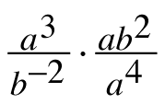**4-40.** Simplify each expression.  In parts (c) and (d), write your answers using scientific notation.

a. 50 · 2−3 b.

c.  (2.3 × 10−3)(4.2 × 102) d. (3.5 × 103)2

**4-41.**Solve each equation by rewriting, undoing, or looking inside.

a. 252 = 125x+1 b. 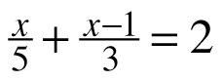

**4.2.1 Analyzing situations**

**4-48.** A person is trying to watch a football game through binoculars. The closer the person is to the wall the less of the field he sees. 4021

|  |  |
| --- | --- |
| Distance from wall (in) | Width of field of view (in) |
| 144 | 20.7 |
| 132 | 19.6 |
| 120 | 17.3 |
| 108 | 16.2 |
| 96 | 14.8 |
| 84 | 13.1 |
| 72 | 11.4 |
| 60 | 9.3 |

a. Use your calculator or the to create a scatterplot and LSRL.

b. **Sketch** the graph to the right.

c. What is the equation of the LSRL?

d. When entering the data in her calculator, Amy accidentally entered (144, 10.7) for the first data point.  Make this change to your data and sketch the new point and new LSRL in a different color.  Would you consider this point an outlier?

e. What is the impact of the outlier?

f. Will Amy’s predictions for the field of view be too large or too small?  How do you know?

**4-49.**Giulia’s father would like to open a restaurant, and is deciding how much to charge for the toppings on pizza.  He sent Giulia to eight different restaurants around town to find out how much they each charge.  Giulia returned with the following information:

|  |  |  |
| --- | --- | --- |
|  | # Toppings on Pizza (not including cheese) | Price ($) |
| Paolo’s Pizza | 1 | 10.50 |
| Vittore’s Italian | 3 | 9.00 |
| Ristorante Isabella | 4 | 14.00 |
| Bianca’s Place | 6 | 15.00 |
| JohnBoy’s Pizza Delivery | 3 | 12.50 |
| Ristorante Raffaello | 5 | 16.50 |
| Rosa’s Restaurant | 0 | 8.00 |
| Casa di Pizza | 2 | 9.00 |

Giulia needs to write a report for her father about what he should charge for a two-topping pizza.  With your team discuss what elements a statistical analysis report should contain.

Write the report you described in part (a), and predict what Giulia’s father should charge for a two-topping pizza.

Name________________________Per______

**HOMEWORK ASSIGNMENT**

**4-42.** Fabienne compared annual grocery bills with the other mothers at her church.  She discovered a linear relationship between the total cost (in dollars) of groceries and the number of miles the mother lived from the downtown church.

a. Do you think that the association would be positive or negative?  Strong or weak?

b. The upper boundary for Fabienne’s prediction was modeled by g = 11.27 – 0.14d, where gis the cost of groceries (in thousands of dollars) and d is the distance from church (miles).  The lower boundary was g = 7.67 – 0.14d.  What is the equation of Fabienne’s line of best fit?

c. Interpret the slope of Fabienne’s model in context.

d. Fabienne lives 8 miles from church.  Her residual was $510.  How much did she spend on groceries this year?

**4-43.** Solve each equation below.  Check each solution.

1. 6 – (3 + x) = 10 b. 100(x + 3) = 200

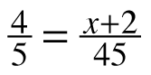c.  d.

**4-44.** The area of a square was measured as 240.56 square centimeters.

a. Make a diagram and determine the length of each side.  Consider the precision of the measurements and use the same number of decimal places in your answer.

1. Determine the length of the squares diagonal.  Again, consider the precision of your final answer.

**4-45.**Simplify each expression below, if possible.

a. 5x(3x)

b. 5x + 3x

c. 6x(x)

d. 6x + x

**4-46.**Solve for x in each equation below.

a. 2x = 8 b. 2x + 2 = 10

c. 6x + 2 – 4x = 10 d. 2(3x + 1) – 4x = 10

e. Check your solutions for the equations above.  What do you notice?

**4-47.**Write an equation for this situation.  You do not need to solve it.

Ryan is thinking of a number.  When he multiplies this number by 6 and then subtracts 15 from it, he ends up with his original number.  What number is Ryan thinking of?

**4.2.2 Linear Regression & Correlation Coefficient**

1. The correlation coefficients for the six scatter plots shown below are -0.85, -0.40, 0, 0.50,

0.90 and 0.99. Match each scatter plot with the correct correlation coefficient.



2. Multiple Choice. What does it mean to say that data has a strong negative correlation?

a. The variables in the data have no relationship at all.

b. A linear model is appropriate and the slope of that line is negative.

c. There is a negative causation relationship in the data.

d. One variable in the data set always has a negative value.

Interpret correlation:

Since ____ is _________ _____, there is a

r= close / far from 1 or -1

____________ , ___________, linear

(strength: Strong/Weak) (direction: Pos/Neg)

relationship between ________ and _________.

x – variable y- variable

3. Sketch the graph of a scatter plot with the following correlations and interpret the correlation.

|  |  |  |
| --- | --- | --- |
| a. r= 0  Interpret r: | b. r= .25  Interpret r: | c. r= -.95  Interpret r: |

4. Sketch the graph of a scatter plot that has a correlation coefficient of exactly 1, but the slope of the line of best fit is greater than 1.

Name________________________Per______

**HOMEWORK ASSIGNMENT**

**4-56.** In problem 4-25 you looked at the data for a study conducted on a vitamin supplement that claims to shorten the length of the common cold.  The data is shown in the table below:

|  |  |  |  |  |  |  |  |  |  |  |
| --- | --- | --- | --- | --- | --- | --- | --- | --- | --- | --- |
| **Number of months** **taking supplement** | 0.5 | 2.5 | 1 | 2 | 0.5 | 1 | 2 | 1 | 1.5 | 2.5 |
| **Number of days** **cold lasted** | 4.5 | 1.6 | 3 | 1.8 | 5 | 4.2 | 2.4 | 3.6 | 3.3 | 1.4 |

* 1. You previously created a linear model for this data by “eyeballing” it.  Now create a model that is consistent with your classmates by determining the LSRL.  Sketch the graph and the LSRL.
  2. Draw the upper and lower boundary lines on the graph following the process you used in problem 4-24.  What is the equation of the upper boundary line?  Of the lower boundary line?
  3. Based on the upper and lower boundary lines of your model, what do you predict is the length of a cold for a person who has taken the supplement for three months?  Consider the precision of the data and use an appropriate number of decimal places in your response.
  4. How long do you predict a cold will last for a person who has taken no supplement?  Interpret the y-intercept in context.
  5. How long do you predict a cold will last for a person who has taken six months of supplements?
  6. If you have a cold, would you prefer a negative or positive residual?

**4-57.** Solve each equation.  For part (b) justify or explain your steps.

a. 3x + 2 = 10 – 4(x – 1) b. 4(x – 1) – 2(3x + 5) = –3x +1

**4-58.** A cockroach can travel at a speed of 80 centimeters per second.  A centipede can travel at 30 meters per minute.  Which can travel faster?

**4-59.** A tile pattern has 10 tiles in Figure 2 and increases by 2 tiles for each figure.  Write an equation for this pattern and then determine how many tiles are in Figure 100.

**4-60.** Graph the points (–3, 2) and (–4, 5).

a. Calculate the slope of the line determined by them.  b. Calculate the distance between them.

**4-61.**This problem is a checkpoint for laws of exponents and scientific notation.  It will be referred to as Checkpoint 4.

Simplify each expression.  In parts (e) through (f), write the final answer in scientific notation.

* 1. 42 · 4 5
  2. (50)3
  3. x−5 · x3
  4. (x−1 · y2)3
  5. (8 × 105) · (1.6 × 10−2)
  6. 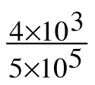

Check your answers by referring to the [Checkpoint 4 materials](https://ebooks.cpm.org/bookdb.php?title=cc4&name=reference.checkpoints&type=tcheckpoints#ui-tabs-5).

Ideally, at this point you are comfortable working with these types of problems and can solve them correctly.  If you feel that you need more confidence when solving these types of problems, then review the Checkpoint 4 materials and try the practice problems provided.  From this point on, you will be expected to do problems like these correctly and with confidence.

**Correlation in Context**

Use the graphing calculator to get the linear regression equations and correlation coefficient.

For each problem interpret the correlation.

1. The table shows the average and maximum longevity of various animals in captivity.



2. The amount of antibiotic that remains in your body over a period of time varies from one drug to the

next. The table given shows the amount of Antibiotic X that remains in your body over a period of two

days.



3. The Center for Disease Control collected data on the percent of children aged 12 to 19 that were

considered obese between the years 1971 and 2007. The data are given in the table.



Name________________________Per______

**HOMEWORK ASSIGNMENT**

**4-63.**Figure 3 of a tile pattern is shown at below.  If the pattern grows linearly and Figure 7 has 13 tiles, write an equation for the tile pattern.

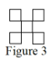

**4-64.** Solve each equation.

* 1. 6(2x – 5) = –(x + 4)  b. (x + 1)(x – 7) = (x – 1)(x + 3)

**4-65**. Calculate the value of g(–5) for each function below.

a. g(x) = x3 – 2 b. 

c. g(x) = 2x d. g(x) = 1.6x – 0.476

**4-66.** On graph paper, graph quadrilateral MNPQ if M(–3, –8), N(2, –10), P(1, –7), and Q(– 4, –5).  MNPQ is a parallelogram, which means that it has two pairs of parallel sides.

a. Show that MNPQ is, indeed, a parallelogram.

b. Use the function (x → x, y → –y) to reflect  MNPQ across the x-axis, creating M′N′P′Q′.  What are the coordinates of P′?

* 1. Name a different sequence of rigid transformations (one that is not the same as part (b) above) that will take M′N′P′Q′ back onto MNPQ.

**4-67.**Solve for x: 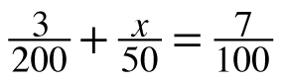

**4-74.** Sam collected data in problem 4-4 by measuring the pencils of her classmates.  She recorded the length of the painted part of each pencil and its weight.  Her data is listed in the table below.

|  |  |  |  |  |  |  |  |  |  |  |  |
| --- | --- | --- | --- | --- | --- | --- | --- | --- | --- | --- | --- |
| **Length of paint (cm)** | 13.7 | 12.6 | 10.7 | 9.8 | 9.3 | 8.5 | 7.2 | 6.3 | 5.2 | 4.5 | 3.8 |
| **Weight (g)** | 4.7 | 4.3 | 4.1 | 3.8 | 3.6 | 3.4 | 3.0 | 2.8 | 2.7 | 2.3 | 2.3 |

* 1. Graph the data on your calculator and sketch the graph on your paper.
  2. What is the equation of the LSRL?  Sketch it on your scatterplot.
  3. The teacher’s pencil, when it was new, had 16.8 cm of paint and weighed 6 g.  What was the residual?  Consider the precision of the original data and use an appropriate number of decimal places.
  4. What does a positive residual mean in this context?

**4-75.** Simplify each expression.

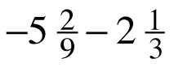a. 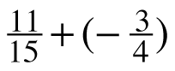 b.

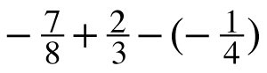 c. d. 

**4-76.** For each of the following area models, determine the dimensions (length and width) and write the area as a product and as a sum.

|  |  |  |  |
| --- | --- | --- | --- |
| a. | https://ebooks.cpm.org/images/int1/ch4/int1.4-76a.png | b. | https://ebooks.cpm.org/images/int1/ch4/int1.4-76b.png |

**4-77.**Determine the slope and y‑intercept for each line.

|  |  |
| --- | --- |
| * 1. a. 2x + 7y = 14 | b. |
| c. | d. y = 3x |

**4-78.** A local deli sells 4-inch sub sandwiches for $2.95.  It has decided to sell a “family sub” that is 50 inches long.  How much should it charge?  What is the unit rate in dollars per foot?  Show all work.

**4-79.** Solve each equation.

a. 8x = 26 b. 

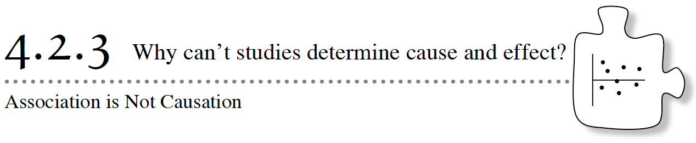

A study found that the more hours students spent on activities outside of school, the higher their grades tended to be.  Does that mean if you go sign up for more activities, your grades will go up?

Another study found a link between how often you brush your teeth and a reduction in heart disease.  Does that mean if you brush your teeth twice a day, your heart will be healthier?

As a consumer of statistical information, you need to be aware of the difference between association and causation.  Today’s investigation will explore that difference.

**4-80.** Fire hoses come in different diameters.  How far the hose can throw water depends on the diameter of the hose.  The Smallville Fire Department collected data about their fire hoses.  The residual plot for the data is shown at right.

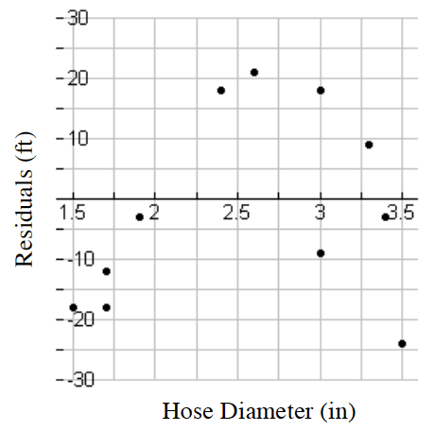

* 1. What does the residual plot tell you about the LSRL model the fire department used?
  2. Determine the worst prediction made with the LSRL.  How different was the worst prediction from what was actually observed?  Explain what this means in context.
  3. Make a conjecture about what the original scatterplot might have looked like and sketch it.  Label both axes.

**4-81.** The mayor of Smallville finds the following graph in the town’s annual financial report.

a. Describe the association, if any, in the scatterplot.

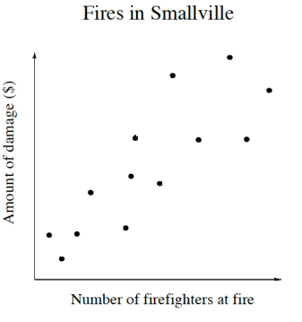b. The mayor immediately orders the fire department to send fewer firefighters to each fire so that there is less damage.  Why do you think the mayor said this?  Do you agree with the mayor’s decision?  Explain why or why not.

**4-82.** ****A dietician studying the benefits of eating spinach surveyed a large sample of individuals.  She recorded the amount of spinach they ate and their physical strength.  The dietician found the spinach eaters to be much stronger than the non-spinach eaters.  The next day the newspaper headline was,  *“Popeye was right!  Eating spinach makes you stronger!”*

* 1. Do you agree with the newspaper?  Do you agree that if you eat more spinach, you will grow stronger muscles and increase your strength?
  2. The dietician correctly found an association.  What could explain this association other than the idea that spinach makes you stronger?

**4-83.**A **lurking variable** is a hidden variable that was not part of the study.  The size of the fire in problem 4-81, and the amount people work out in problem 4-82, are lurking variables.

A medical study found a strong link between the number of hours high school students wear a helmet and the number of concussions (head injuries).  However, it is unlikely that wearing helmets causes head injuries.  Can you think of a **lurking variable** that might explain this association?

**4-84.**A web of associated variables like the one shown below can get complex and be difficult to unravel.  Consider a medical study focused on hearing loss.  It may associate variables like eating prunes to hearing loss as strongly as it associates an actual cause like long-term noise exposure to hearing loss.

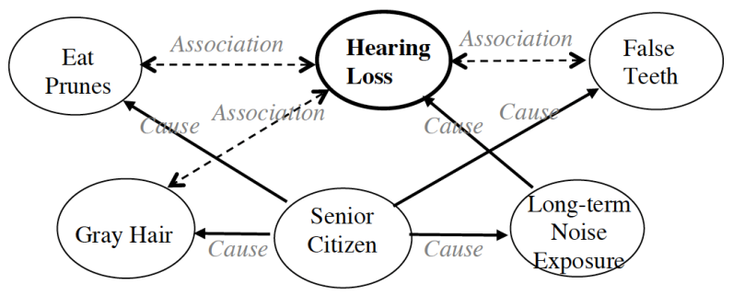

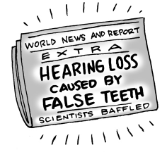Here are some newspaper headlines from actual observational studies.  Each of them found an association.  Some even imply a cause and effect relationship.    Determine at least one plausible lurking variable that could explain the actual cause.

a. “Calcium in diet may cut risk for some cancers, study finds”

b. “Study: Family time declines as Web use booms”

* 1. “Chocolate is linked to depression”
  2. “Study: Kids who were spanked have lower IQs”
  3. “Lack of Health Insurance Kills 45,000 a Year”

**4-85.** Come up with your own original news headlines.  The first sentence should contain a reasonable link between two variables.  The second statement should be a clear misinterpretation of the link.  Two examples are given below.

1st  Statement: Facial Tissue linked to Colds and Flu.   
2nd Statement: Surgeon General calls for a shift to paper towels!

1st  Statement: Bathing Suits tied to Sunburn.   
2nd Statement: Doctors recommend: Swim Naked!

Name________________________Per______

**HOMEWORK ASSIGNMENT**

**4-86.** A human resources manager recorded the experience and hourly wage for a sample of 10 technology workers.

|  |  |  |  |  |  |  |  |  |  |  |
| --- | --- | --- | --- | --- | --- | --- | --- | --- | --- | --- |
| **Experience** **(years)** | 1 | 2 | 3 | 4 | 5 | 6 | 7 | 8 | 9 | 10 |
| **Hourly** **Wage ($)** | 12.00 | 13.25 | 14.00 | 16.00 | 17.00 | 18.00 | 19.50 | 21.00 | 22.00 | 23.25 |

* 1. Sketch a scatterplot showing the association between the wage and the years of experience.  Describe the association.
  2. Sketch the residual plot.  Is a linear model appropriate?
  3. 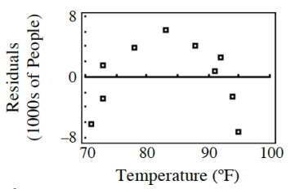What is the correlation coefficient?  What does it tell you?

**4-87.** Marissa went with her friends to the amusement park on a beautiful spring day.  The park was crowded.  Marissa wondered if there was an association between the weather and attendance.  From data she received at the theme park office, Marissa randomly picked ten Saturdays and analyzed the data.

* 1. Marissa calculated the least squares regression line a = –14 + 0.41t, where a is the attendance (in 1000s) and t is the high temperature (ºF) that day.  Interpret the slope in this context.
  2. The residual plot Marissa created is shown at right.  On days when temperatures were in the 80s, would you expect the predictions made by Marissa’s model to be too high, too low, or pretty accurate?
  3. What was the actual attendance on the day when the temperature was 95ºF?
  4. Marissa drew the upper boundary line at a = –7 + 0.41t and the lower boundary line ata = –21 + 0.41t.  What are the upper and lower bounds for the predicted number of people attending when the temperature is 80ºF?
  5. Would you rely on this model to make predictions?  Why or why not?

**4-88.** Simplify each expression.  In parts (c) and (d) write your answers using scientific notation.

a. 23· 5−2 b. (xy2)3· (x−2)

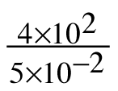c. 3 × 103· 4 × 105 d.

**4-89.**For each graph below, what is the domain and range?

|  |  |  |  |  |  |
| --- | --- | --- | --- | --- | --- |
| a. | https://ebooks.cpm.org/images/int1/ch4/int1.4-89a.png | b. | https://ebooks.cpm.org/images/int1/ch4/int1.4-89b.png | c. | https://ebooks.cpm.org/images/int1/ch4/int1.4-89c.png |
| d. | Which, if any, of the graphs represents a function? | | |  |  |

**4-90.** If  f(x) = 4x + 1, calculate each of the following values.

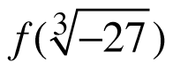 a. f(0) b. c. x if f(x) = 17

**4-91.** Write the equation of the line passing through the points (–3, 1) and (9, 7).

Integrated 1: Two Variable Statistics Name:____________________Per___

**Father Daughter**

|  |
| --- |
| a) Sketch a scatterplot of the data in the table to the left, where *x*  represents the height of the father and *y* represents the height of the woman (the daughter). |
| b) Describe how the variables height of father and height of woman are related. |
| c) Determine the LSRL for the data points. |

|  |  |  |  |
| --- | --- | --- | --- |
| Height of Father (in) | Height of Woman (in) |  |  |
| 62 | 60 |
| 63 | 60 |
| 65 | 60 |
| 65 | 63 |
| 66 | 65 |
| 66 | 66 |
| 67 | 61 |
| 68 | 63 |
| 68 | 64 |  |
| 68 | 69 |
| 69 | 68 |
| 70 | 63 |
| 70 | 64 |
| 70 | 66 |
| 71 | 66 |
| 72 | 64 |
| 73 | 64 |
| 73 | 65 |  |
| 74 | 70 |
| 75 | 65 |
| 76 | 69 |
| 77 | 66 |
| 68 | 64 |
| 77 | 66 |
| 76 | 69 |
| |  |  | | --- | --- | | d) Interpret the slope. | e) Interpret the y-intercept. | | f) Predict the height of the woman if the father is 71 inches tall. | g) Calculate the residual for your prediction. | | h) Determine the correlation coefficient. | i) Interpret the correlation coefficient. | |  |

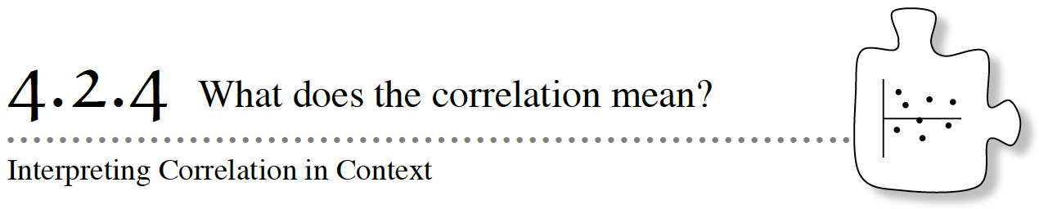

Although the correlation coefficient is widely used to describe the amount of scatter in a linear association, it is, unfortunately, an arbitrary computation.  Correlation does not have a real-world meaning.  In this lesson, you will learn a way to make sense—in context—of the correlation coefficient.

**4-92.** In Lesson 4.1.3, Kerin discovered that a human’s height is associated with their forearm length.  Kerin is curious whether height is also associated with foot size.

* 1. It was not practical for Kerin to measure her classmates’ feet, so she collected the following shoe-size data from her classmates.  Read the Math Notes box in this lesson then use the definition of R2, and the data below, to write a sentence about the variation in height in Kerin’s class.

|  |  |  |  |  |
| --- | --- | --- | --- | --- |
| Shoe size | Height (cm) |  | Shoe size | Height (cm) |
| 6 | 153 |  | 9 | 167 |
| 8 | 160 |  | 7.5 | 162 |
| 7 | 158 |  | 8 | 162 |
| 8.5 | 161 |  | 7.5 | 166 |
| 8 | 168 |  | 8.5 | 167 |
| 8 | 166 |  | 6.5 | 159 |
| 8.4 | 164 |  | 7 | 160 |
| 6.5 | 156 |  | 9 | 169 |
| 10 | 170 |  | 8 | 164 |
| 9.5 | 167 |  | 8.5 | 166 |
| 7.5 | 158 |  | 7.5 | 159 |
| 7 | 158 |  | 9.5 | 169 |
| 8 | 161 |  | checksum 198.9 | checksum 4070 |

* 1. If only a portion of the variability in height can be explained by shoe size, what other factors might go into determining someone’s height?

**4-93.** Suppose Alyse collected the following data for five random students in her class: Explore using the

|  |  |
| --- | --- |
| Shoe size | Height (cm) |
| 6 | 154 |
| 7½ | 160 |
| 8 | 162 |
| 8½ | 164 |
| 10 | 170 |

a. What is the correlation coefficient?  Why is the data unusual?  In the context of this problem, what does the correlation coefficient tell Alyse about the association between height and shoe size for these very unusual students?

b. What can Alyse say about the variability in height in her unusual class?  What can she say about predicting height for a student?

**4-94.** Holly created the scatterplot shown at right for the girls in her class.

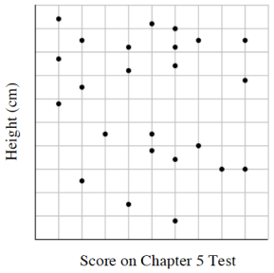

* 1. What do you notice about the pattern of this data? What do you suppose the correlation coefficient is? Write a sentence about the variability in girls’ height in Holly’s class.
  2. The best prediction Holly can make is that a girl has average height no matter what her test score was. Holly calculated the average height of the girls in her class to be 162 cm. What would the line of best fit look like? What is the equation of the line of best fit?

**4-95.** When Giulia went around town in problem 4-49 comparing the price of pizzas, she gathered this data.

|  |  |  |
| --- | --- | --- |
|  | # Toppings on Pizza (not including cheese) | Price ($) |
| Paolo’s Pizza | 1 | 10.50 |
| Vittore’s Italian | 3 | 9.00 |
| Ristorante Isabella | 4 | 14.00 |
| Bianca’s Place | 6 | 15.00 |
| JohnBoy’s Pizza Delivery | 3 | 12.50 |
| Ristorante Raffaello | 5 | 16.50 |
| Rosa’s Restaurant | 0 | 8.00 |
| Casa di Pizza | 2 | 9.00 |

* 1. What is the LSRL?  Interpret the y-intercept in context.
  2. What is the correlation coefficient and R2?
  3. In problem 4-49 you wrote a report describing this association.  Now improve upon the report by making it more mathematically precise and quantitative.  Use slope when describing the “direction”, and use a sentence about R2 when describing “strength”.

**4-96.**Giulia’s father finally opened his pizza parlor.  He charges $7.00 for a cheese pizza plus $1.50 for each additional topping.

* 1. ****Choose four or five points and make a scatterplot of the price of pizza versus the number of toppings at Giulia’s father’s pizza parlor.  What is the LSRL?  Interpret the slope and y-intercept in context.
  2. What is r?  R2?  Write a sentence about the variation in price of pizza at this parlor.  Explain, in context, the difference between this R2 and the one that you calculated in problem 4-95.

**4-97.** LEARNING LOG

In your Learning Log describe everything you have learned in this chapter about how to write a complete description of an association, including numerical values where possible.  Use problem 4-95 as an example.  Title this entry “Completely Describing Association” and include today’s date.

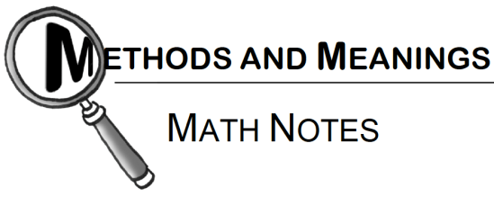

### Correlation Coefficient

The **correlation coefficient**, r, is a measure of how much or how little data is scattered around the LSRL; it is a measure of the strength of a linear association.  The correlation coefficient can take on values between –1 and 1.  If r = 1 or r = –1, the association is perfectly linear.  There is no scatter about the LSRL at all.  A positive correlation coefficient means the trend is increasing (slope is positive), while a negative correlation means the opposite.  A correlation coefficient of zero means the slope of the LSRL is horizontal and there is no linear association whatsoever between the variables.

The correlation coefficient does not have units, so it is a useful way to compare scatter from situation to situation no matter what the units of the variables are.  The correlation coefficient does not have a real-world meaning other than as an arbitrary measure of strength.

The value of the correlation coefficient squared, however, does have a real-world meaning.  **R-squared**, the correlation coefficient squared, is written as R2 and expressed as a percent.  Its meaning is that R2% of the variability in the dependent variable can be explained by a linear relationship with the independent variable.

For example, if the association between the amount of fertilizer and plant height has correlation coefficient r = 0.60, we can say that 36% of the variability in plant height can be explained by a linear relationship with the amount of fertilizer used.  The rest of the variation in plant height is explained by other variables: amount of water, amount of sunlight, soil type, and so forth.

The correlation coefficient, along with the interpretation of R2, is used to describe the strength of a linear association.

Name________________________Per______

**HOMEWORK ASSIGNMENT**

**4-98.** Data from a study of a vitamin supplement that claims to shorten the length of the common cold is shown below:

|  |  |  |  |  |  |  |  |  |  |  |
| --- | --- | --- | --- | --- | --- | --- | --- | --- | --- | --- |
| Number of months taking supplement | 0.5 | 2.5 | 1 | 2 | 0.5 | 1 | 2 | 1 | 1.5 | 2.5 |
| Number of days cold lasted | 4.5 | 1.6 | 3 | 1.8 | 5 | 4.2 | 2.4 | 3.6 | 3.3 | 1.4 |

* 1. Determine the LSRL of this data again.  Create a scatterplot on graph paper (or use your scatterplot from problem 4-56) and draw the LSRL.
  2. Is a linear model appropriate?  Provide evidence.
  3. Calculate r and interpret R‑squaredin context.
  4. Describe the association.  Make sure you describe the form and provide evidence for the form.  Provide numerical values for direction and strength and interpret them in context.  Describe any outliers.

**4-99.**Here are some more news headlines from real observational studies.  Just as you did in problem 4-84, determine at least one plausible lurking variable that could explain the cause and effect.  Remember, do not argue about the link expressed in the headline.  Accept the association or link as true.  Your task is to find the other variable(s) that could be the actual cause(s).

* 1. “Teens with own cars more likely to crash”
  2. “Bottled water linked to healthier babies”

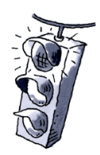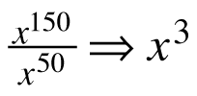**4-100.** Gerardo is rewriting expressions with very large exponents.  He arrives at each of the results below.  For each result, decide if he is correct and justify your answer using the meaning of exponents.

* 1. b. y20 · y41 ⇒ y61 c. (2m2n15)3 ⇒ 2m6n45

**4-101.** Write the equation of the line with a slope of  that passes through the point (12, – 4).

**4-102.** Using the variable x, write an equation that has no solution.  Explain how you know it has no solution.

**4-103.** Match each graph below with its domain.

|  |  |  |  |  |  |
| --- | --- | --- | --- | --- | --- |
| a. | D: all real numbers | b. | D: x > –2 | c. | D: x < 3 |
| 1) | https://ebooks.cpm.org/images/int1/ch4/int1.4-103.1.png | 2) | https://ebooks.cpm.org/images/int1/ch4/int1.4-103.2.png | 3) | https://ebooks.cpm.org/images/int1/ch4/int1.4-103.3.png |

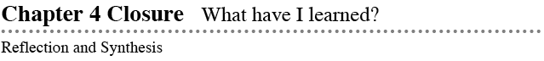

The activities below offer you a chance to reflect on what you have learned during this chapter.  As you work, look for concepts that you feel very comfortable with, ideas that you would like to learn more about, and topics that you need more help with.  Look for connections between ideas as well as connections to material you learned previously.

### 1. TEAM BRAINSTORM

What have you studied in this chapter?  What ideas were important in what you learned?  With your team, brainstorm a list.  Add as much detail as you can.  To help get you started, Learning Log entries and Math Notes boxes are listed below.

What topics, ideas, and words that you learned before this chapter are connected to the new ideas in this chapter?  Again, write down as many details as you can.

How long can you make your list?  Challenge yourselves.  Be prepared to share your team’s ideas with the class.

* **Learning Log Entries**
  + [Lesson 4.1.2](https://ebooks.cpm.org/bookdb.php?title=cc4&name=4.1.2&type=lesson#4-16) – Residuals
  + [Lesson 4.2.1](https://ebooks.cpm.org/bookdb.php?title=cc4&name=4.2.1&type=lesson#4-55) – Residual Plots
  + [Lesson 4.2.2](https://ebooks.cpm.org/bookdb.php?title=cc4&name=4.2.2&type=lesson#4-71) – Correlation Coefficient, r
  + [Lesson 4.2.4](https://ebooks.cpm.org/bookdb.php?title=cc4&name=4.2.4&type=lesson#4-97) – Completely Describing Association

**Math Notes**

* + [Lesson 4.1.1](https://ebooks.cpm.org/bookdb.php?title=cc4&name=4.1.1&type=lesson#notes) – Right Triangles and the Pythagorean Theorem
  + [Lesson 4.1.2](https://ebooks.cpm.org/bookdb.php?title=cc4&name=4.1.2&type=lesson#notes) – Interpreting Slope and y-Intercept of Linear Associations
  + [Lesson 4.1.4](https://ebooks.cpm.org/bookdb.php?title=cc4&name=4.1.4&type=lesson#notes) – Residuals
  + [Lesson 4.2.1](https://ebooks.cpm.org/bookdb.php?title=cc4&name=4.2.1&type=lesson#notes) – Least Squares Regression Line
  + [Lesson 4.2.2](https://ebooks.cpm.org/bookdb.php?title=cc4&name=4.2.2&type=lesson#notes) – Residual Plots
  + [Lesson 4.2.4](https://ebooks.cpm.org/bookdb.php?title=cc4&name=4.2.4&type=lesson#notes) – Correlation Coefficient

### 2. MAKING CONNECTIONS

Below is a list of the vocabulary words used in this chapter.  Make sure that you are familiar with all of these terms and know what they mean.  Refer to the glossary or index for any words that you do not yet understand.

|  |  |  |
| --- | --- | --- |
| **association** | **cause** | **correlation coefficient** |
| **direction** | **extrapolation** | **form** |
| **line of best fit** | **least squares regression line (LSRL)** | **lurking variable** |
| **model** | **outliers** | **predictions** |
| **r** | R2(**R-squared**) | **random scatter** |
| **residual** | **residual plot** | **slope** |
| **strength (of an association)** | **lower bound** | **upper bound** |

Make a concept map showing all the connections you can make among the key words and ideas listed above.  To show a connection between two words, draw a line between them and explain the connection, as shown in the model below.  A word can be connected to any other word as long as you can justify the connection.  For each key word or idea, provide an example or sketch that shows the idea.

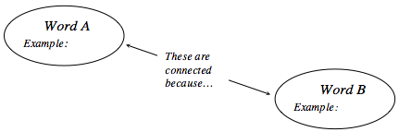

Your teacher may provide you with vocabulary cards to help you get started.  If you use the cards to plan your concept map, be sure either to re‑draw your concept map on your paper or to attach the vocabulary cards to a poster with all the connections explained for others to see and understand.

While you are making your map, your team may think of related words or ideas that are not listed above.  Be sure to include these ideas on your concept map.

### 3. PORTFOLIO: EVIDENCE OF MATHEMATICAL PROFICIENCY

If you did not already do so when you completed Chapter 2, precisely copy your previous work from problem 2-47 into your portfolio.  This will serve as evidence of your early understanding of association.

The following problem will showcase your current understanding of describing an association with statistics.

Scientists were concerned that there might be arsenic in unregulated drinking wells and that people were ingesting arsenic, a poison, by drinking from these wells.  Arsenic in the human body, like many toxins, can most easily be measured in toenails.  The amount of arsenic that has collected in a toenail is an indication of how much arsenic is in the whole body.

In a study in the journal Cancer Epidemiology, Biomarkers, and Prevention, the arsenic level in 21 people was measured along with the unregulated drinking wells from which each of them obtained their water.  The units “ppb” and “ppm” refer to parts per billion and parts per million, respectively.

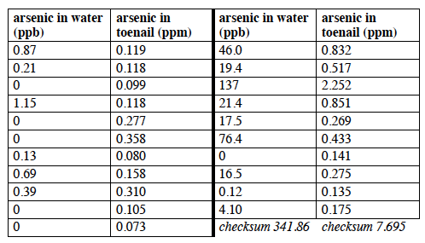

What would you include in a mini-report that fully describes all aspects of the association?  Make as detailed a list as you can.

Fully describe all aspects of the association in context.  Include appropriate graphs and statistical analysis.

### 4. WHAT HAVE I LEARNED?

Most of the problems in this section represent typical problems found in this chapter.  They serve as a gauge for you.  You can use them to determine which types of problems you can do well and which types of problems require further study and practice.  Even if your teacher does not assign this section, it is a good idea to try these problems and find out for yourself what you know and what you still need to work on.

Solve each problem as completely as you can.  The table at the end of the closure section has answers to these problems.  It also tells you where you can find additional help and practice with problems like these.

**CL 4-104.** Ranger Sarah is responsible for monitoring the population of the elusive Gray’s nightingale in Holly State Park.  She would like to find a relationship between the oak trees (their preferred nesting site) and the number of nightingales in the park.  She randomly selects seven different areas in the park and painstakingly counts the oak trees and Gray’s nightingales in each area.

|  |  |  |  |  |  |  |  |
| --- | --- | --- | --- | --- | --- | --- | --- |
| Oaks | 8 | 13 | 4 | 5 | 10 | 9 | 4 |
| Nightingales | 5 | 9 | 3 | 5 | 7 | 7 | 5 |

* 1. Make a scatterplot on graph paper and describe the association.
  2. Calculate the LSRL and add it to your scatterplot.  Round to the nearest tenth.
  3. Interpret the slope and y‑intercept of your model in context.

**CL 4-105.** Consider Ranger Sarah’s situation from the previous problem.

About how many nightingales would Ranger Sarah expect to find in a particular area with 6 oaks?

* 1. Sarah went back to Holly State Park and observed 4 nightingales on the plot with 6 oaks.  What is the residual for this particular area?
  2. Draw the upper and lower boundary lines by hand on your scatterplot.  What are the equations for these lines?
  3. What is the upper and lower bound of your prediction in part (a)?

**CL 4-106.**Consider Ranger Sarah’s situation from problem 4-104.  Calculate and interpret the correlation coefficient.

**CL 4-107.** Plot ΔABC on graph paper with vertices A(–2, –2), B(2, –2), and C(–2, 4).

* 1. What is the area of ΔABC?
  2. ΔABC is rotated 90° clockwise (↻) about point B to become ΔA′B′C′.  Name the coordinates of A′, B′, and C′.
  3. Describe a transformation that would take ΔABC to A″(0, –6), B″(4, –6), and C″ at the origin.

**CL 4-108.** Rewrite each expression without zero or negative exponents.  In part (d), write the answer in scientific notation.

* 1. 3–2
  2. a3b2(b–1)3
  3. https://ebooks.cpm.org/images/int1/chap04/4-108c.gif
  4. https://ebooks.cpm.org/images/int1/chap04/4-108d.gif

**CL 4-109.** Solve each equation.

a. (x – 1)(x + 7) = (x + 1)(x – 3)

b. 2x – 5(x + 4) = –2(x + 3)

**CL 4-110.**Solve the equations below using any method.

* 1. https://ebooks.cpm.org/images/int1/chap04/4-110a.gif
  2. 6(x+9) = 36x
  3. (x – 13)3 = 8

**CL 4-111.**Check your answers using the table at the end of the closure section.  Which problems do you feel confident about?  Which problems made you think?  Use the table to make a list of topics you need help on and a list of topics you need to practice more.

### Answers and Support for Closure Activity #4 What Have I Learned?

MN = Math Note, LL = Learning Log

|  |  |  |  |  |  |
| --- | --- | --- | --- | --- | --- |
| **Problem** | **Solution** | **Need Help?** | **More Practice** | | |
| CL 4-104. | a.  See graph below.  There is a strong positive linear association with no outliers. https://ebooks.cpm.org/images/int1/chap04/CCA_6-122a.png b.  n = 1.9 + 0.5k  c.  In an area with no oak trees, we would expect 1.9 nightingales.  For each additional oak tree in a given area, we predict an additional 0.5 nightingales. | [Lesson 4.1.1](https://ebooks.cpm.org/bookdb.php?title=cc4&name=4.1.1&type=lesson)  [MN: 2.1.1](https://ebooks.cpm.org/bookdb.php?title=cc4&name=2.2.1&type=lesson#notes)  [MN: 2.2.1](https://ebooks.cpm.org/bookdb.php?title=cc4&name=2.2.1&type=lesson#notes)  [MN: 4.1.2](https://ebooks.cpm.org/bookdb.php?title=cc4&name=4.1.2&type=lesson#notes)  [MN: 4.2.1](https://ebooks.cpm.org/bookdb.php?title=cc4&name=4.2.1&type=lesson#notes)  [MN: 4.2.4](https://ebooks.cpm.org/bookdb.php?title=cc4&name=4.2.4&type=lesson#notes) | Problems [4-4](https://ebooks.cpm.org/bookdb.php?title=cc4&name=4.1.1&type=lesson#4-4), [4‑25](https://ebooks.cpm.org/bookdb.php?title=cc4&name=4.1.3&type=lesson#4-25), [4-36](https://ebooks.cpm.org/bookdb.php?title=cc4&name=4.1.4&type=lesson#4-36), [4‑42](https://ebooks.cpm.org/bookdb.php?title=cc4&name=4.1.4&type=lesson#4-42), [4-56](https://ebooks.cpm.org/bookdb.php?title=cc4&name=4.2.1&type=lesson#4-56), [4‑62](https://ebooks.cpm.org/bookdb.php?title=cc4&name=4.2.1&type=lesson#4-62), [4-86](https://ebooks.cpm.org/bookdb.php?title=cc4&name=4.2.3&type=lesson#4-86), and [4-87](https://ebooks.cpm.org/bookdb.php?title=cc4&name=4.2.3&type=lesson#4-87) | | |
| CL 4-105. | a.  About 4.9 nightingales  b.  4 – 4.9 = –0.9 nightingales  c.  See graph below.  About n = 0.9 + 0.5k and n = 2.9 + 0.5k https://ebooks.cpm.org/images/int1/chap04/CCA_6-123.png d.  In an area with 6 oak trees, we would expect to find between 3.9 and 5.9 nightingales. | [Section 4.1](https://ebooks.cpm.org/bookdb.php?title=cc4&name=4.1.1&type=lesson) and [Lesson 4.2.1](https://ebooks.cpm.org/bookdb.php?title=cc4&name=4.2.1&type=lesson)  [MN: 4.1.4](https://ebooks.cpm.org/bookdb.php?title=cc4&name=4.1.4&type=lesson#notes)  [MN:4.2.3](https://ebooks.cpm.org/bookdb.php?title=cc4&name=4.2.3&type=lesson#notes)  [LL: 4.1.2](https://ebooks.cpm.org/bookdb.php?title=cc4&name=4.1.2&type=lesson#4-16)  [LL: 4.2.1](https://ebooks.cpm.org/bookdb.php?title=cc4&name=4.2.1&type=lesson#4-55) | Problems [4-17](https://ebooks.cpm.org/bookdb.php?title=cc4&name=4.1.2&type=lesson#4-17), [4-25](https://ebooks.cpm.org/bookdb.php?title=cc4&name=4.1.3&type=lesson#4-25), [4-36](https://ebooks.cpm.org/bookdb.php?title=cc4&name=4.1.4&type=lesson#4-36), [4‑42](https://ebooks.cpm.org/bookdb.php?title=cc4&name=4.1.4&type=lesson#4-42), [4-56](https://ebooks.cpm.org/bookdb.php?title=cc4&name=4.2.1&type=lesson#4-56), [4‑62](https://ebooks.cpm.org/bookdb.php?title=cc4&name=4.2.1&type=lesson#4-62), [4-74](https://ebooks.cpm.org/bookdb.php?title=cc4&name=4.2.2&type=lesson#4-74), [4‑86](https://ebooks.cpm.org/bookdb.php?title=cc4&name=4.2.3&type=lesson#4-86), and [4-87](https://ebooks.cpm.org/bookdb.php?title=cc4&name=4.2.3&type=lesson#4-87) | | |
| CL 4-106. | r = 0.92 The association is very strong and positive.  As the number of oak trees increase, we expect the number of nightingales to increase. | [Lessons 4.2.2](https://ebooks.cpm.org/bookdb.php?title=cc4&name=4.2.2&type=lesson) and [4.2.4](http://bookdb.php/?title=cc4&name=4.2.4&type=lesson)  [MN: 4.2.4](https://ebooks.cpm.org/bookdb.php?title=cc4&name=4.2.4&type=lesson#notes)  [LL: 4.2.2](https://ebooks.cpm.org/bookdb.php?title=cc4&name=4.2.2&type=lesson#4-71) | Problems [4‑86(c)](https://ebooks.cpm.org/bookdb.php?title=cc4&name=4.2.3&type=lesson#4-86) and [4‑98(c)](https://ebooks.cpm.org/bookdb.php?title=cc4&name=4.2.4&type=lesson#4-98) | | |
| CL 4-107. | a.  Using side AB as the base, https://ebooks.cpm.org/images/common/1-2.gifbh = https://ebooks.cpm.org/images/common/1-2.gif(4)(6) = 12 units2  b.  A′(2, 2), B′(2, 2), and C′(8, 2)  c.  Translate down 4 and right 2 units. | [Lessons 3.1.2](https://ebooks.cpm.org/bookdb.php?title=cc4&name=3.1.2&type=lesson) and [3.1.4](https://ebooks.cpm.org/bookdb.php?title=cc4&name=3.1.4&type=lesson)  [MN: 3.1.4](https://ebooks.cpm.org/bookdb.php?title=cc4&name=3.1.4&type=lesson#notes)  [LL: 3.1.1](https://ebooks.cpm.org/bookdb.php?title=cc4&name=3.1.1&type=lesson#3-7) | | Problems [3‑81](https://ebooks.cpm.org/bookdb.php?title=cc4&name=3.2.1&type=lesson#3-81), [3‑104](https://ebooks.cpm.org/bookdb.php?title=cc4&name=3.2.3&type=lesson#3-104), [3‑119](https://ebooks.cpm.org/bookdb.php?title=cc4&name=3.3.1&type=lesson#3-119), and [3‑138](https://ebooks.cpm.org/bookdb.php?title=cc4&name=3.3.3&type=lesson#3-138),[CL 3‑144](https://ebooks.cpm.org/bookdb.php?title=cc4&name=3.closure&type=lesson#CL3-144), [4‑21](https://ebooks.cpm.org/bookdb.php?title=cc4&name=4.1.2&type=lesson#4-21), [4-38](https://ebooks.cpm.org/bookdb.php?title=cc4&name=4.1.4&type=lesson#4-38), and [4‑66](https://ebooks.cpm.org/bookdb.php?title=cc4&name=4.2.1&type=lesson#4-66) |
| CL 4-108. | a.  https://ebooks.cpm.org/images/common/1-9.gif b.  https://ebooks.cpm.org/images/int1/chap04/4-108.gif  c.  y4  d.  5 × 10–3 | [Lessons 1.3.1](https://ebooks.cpm.org/bookdb.php?title=cc4&name=1.3.1&type=lesson) and [1.3.2](https://ebooks.cpm.org/bookdb.php?title=cc4&name=1.3.2&type=lesson)  [MN: 1.3.1](https://ebooks.cpm.org/bookdb.php?title=cc4&name=1.3.1&type=lesson#notes)  [LL: 1.3.2](https://ebooks.cpm.org/bookdb.php?title=cc4&name=1.3.2&type=lesson#1-80)  [Checkpoint 4](https://ebooks.cpm.org/bookdb.php?title=cc4&name=reference.checkpoints&type=tcheckpoints#ui-tabs-5) | | Problems [CL 1‑88](https://ebooks.cpm.org/bookdb.php?title=cc4&name=1.closure&type=lesson#CL1-88),  [4-5](https://ebooks.cpm.org/bookdb.php?title=cc4&name=4.1.1&type=lesson#4-5), [4‑18](https://ebooks.cpm.org/bookdb.php?title=cc4&name=4.1.2&type=lesson#4-18), [4-40](https://ebooks.cpm.org/bookdb.php?title=cc4&name=4.1.4&type=lesson#4-40), [4‑61](https://ebooks.cpm.org/bookdb.php?title=cc4&name=4.2.1&type=lesson#4-61), and[4-88](https://ebooks.cpm.org/bookdb.php?title=cc4&name=4.2.3&type=lesson#4-88) |
| CL 4-109. | a.  x = https://ebooks.cpm.org/images/common/1-2.gif  b.  x = –14 | [Lesson 3.3.1](https://ebooks.cpm.org/bookdb.php?title=cc4&name=3.3.1&type=lesson) | | Problems [4‑43](https://ebooks.cpm.org/bookdb.php?title=cc4&name=4.1.4&type=lesson#4-43),  [4-46](https://ebooks.cpm.org/bookdb.php?title=cc4&name=4.1.4&type=lesson#4-46), [4-57](https://ebooks.cpm.org/bookdb.php?title=cc4&name=4.2.1&type=lesson#4-57), and [4-64](https://ebooks.cpm.org/bookdb.php?title=cc4&name=4.2.1&type=lesson#4-64) |
| CL 4-110. | a.  x = https://ebooks.cpm.org/images/common/12-5.gif  b.  *x*= 9  c.  x = –15 | [Section 3.3](https://ebooks.cpm.org/bookdb.php?title=cc4&name=3.3.1&type=lesson)  [MN: 3.3.2](https://ebooks.cpm.org/bookdb.php?title=cc4&name=3.3.2&type=lesson#notes) and [3.3.3](https://ebooks.cpm.org/bookdb.php?title=cc4&name=3.3.3&type=lesson#notes) | | Problems [4‑8](https://ebooks.cpm.org/bookdb.php?title=cc4&name=4.1.1&type=lesson#4-8), [4‑29](https://ebooks.cpm.org/bookdb.php?title=cc4&name=4.1.3&type=lesson#4-29), [4‑41](https://ebooks.cpm.org/bookdb.php?title=cc4&name=4.1.4&type=lesson#4-41), [4‑43](https://ebooks.cpm.org/bookdb.php?title=cc4&name=4.1.4&type=lesson#4-43), [4-67](https://ebooks.cpm.org/bookdb.php?title=cc4&name=4.2.1&type=lesson#4-67), and [4‑79](https://ebooks.cpm.org/bookdb.php?title=cc4&name=4.2.2&type=lesson#4-79) |

***Review Preview Answers***

4.1.1

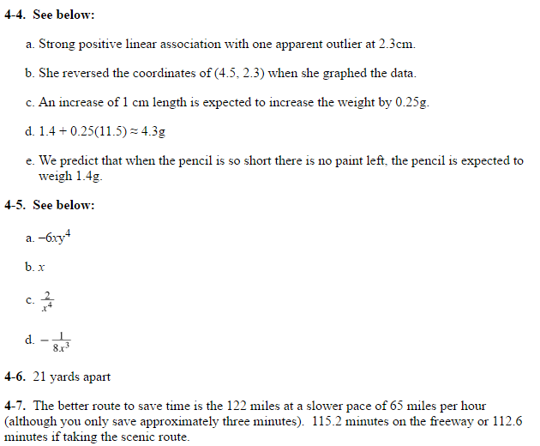

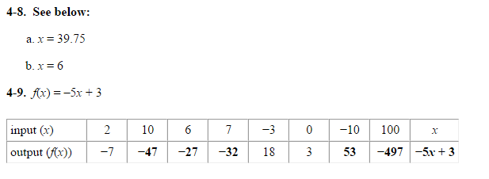

4.1.2

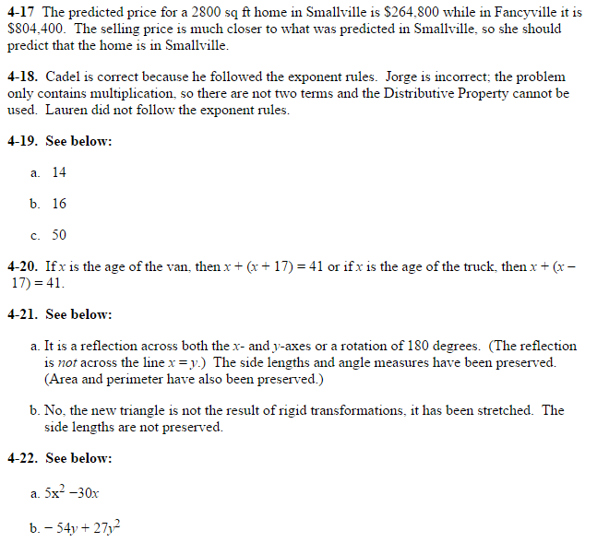

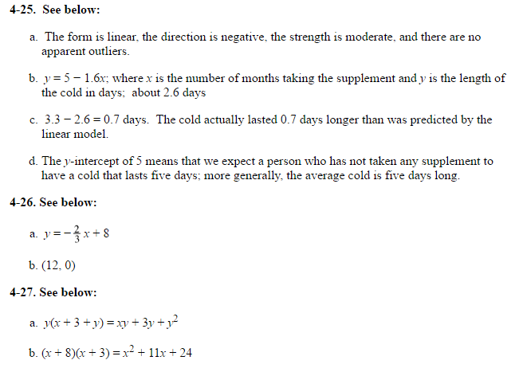

4.1.3

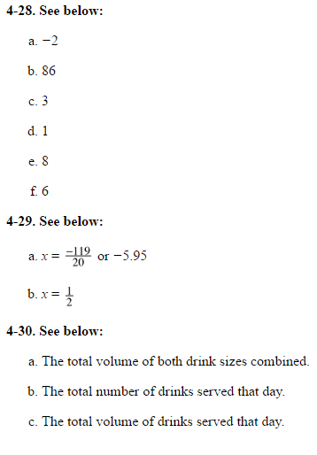

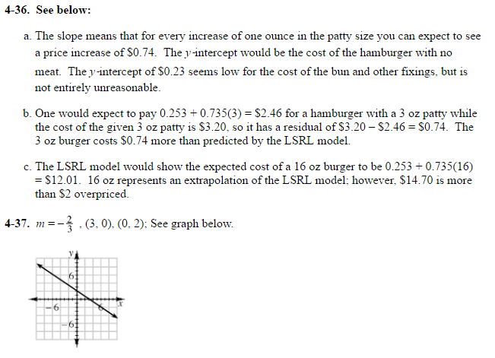

4.1.4

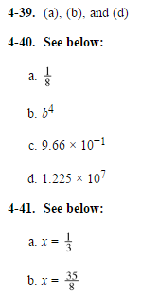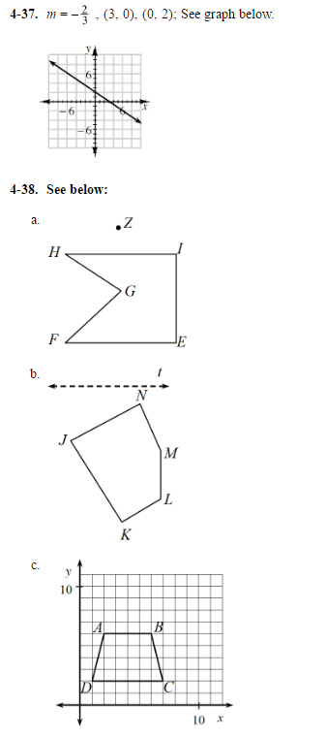

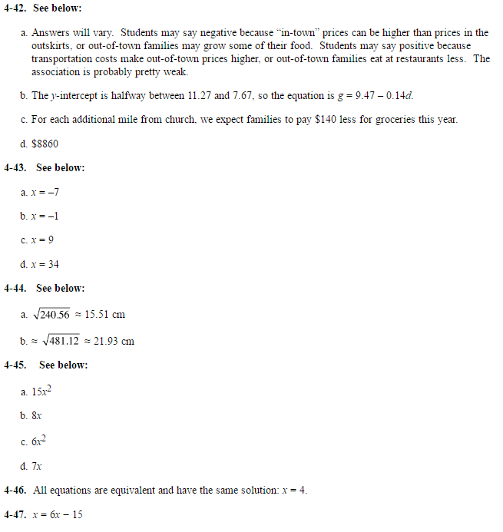

4.2.1 4.2.1 continued

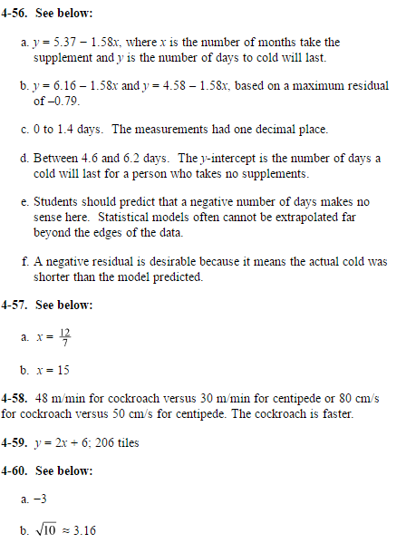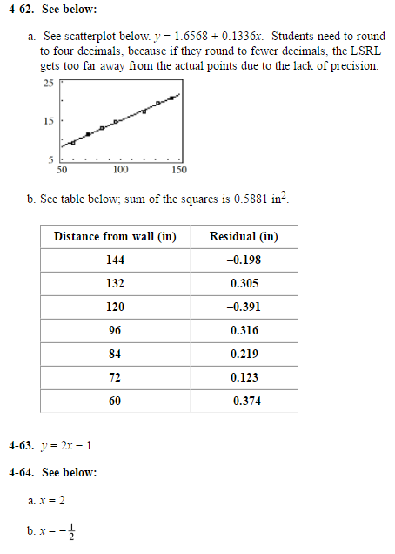

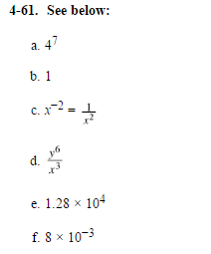

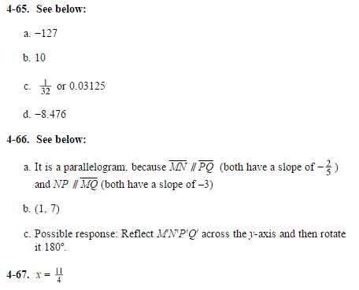

4.2.2 4.2.3

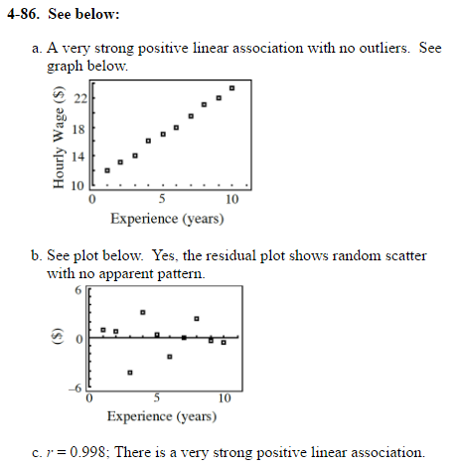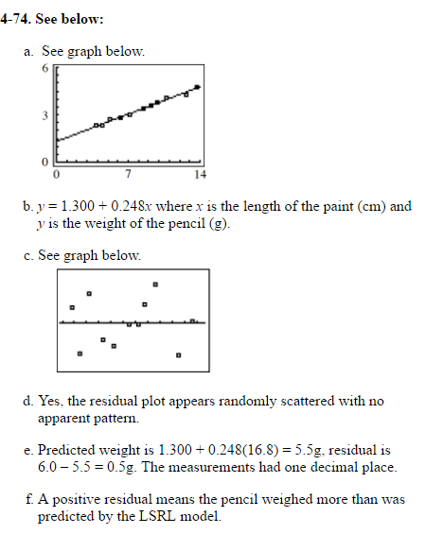

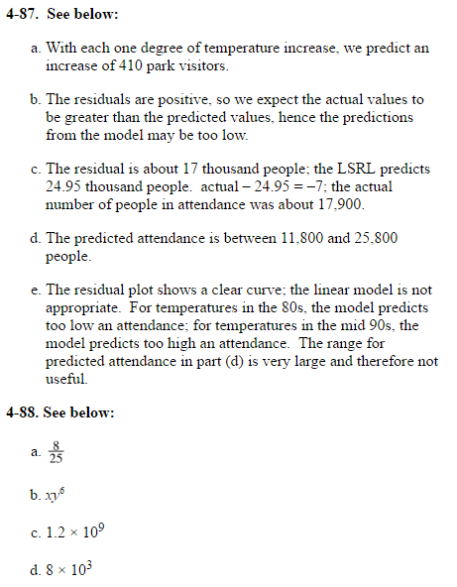9.3.4

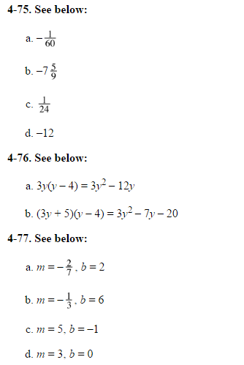

4.2.3 (cont) 4.2.4 (cont)

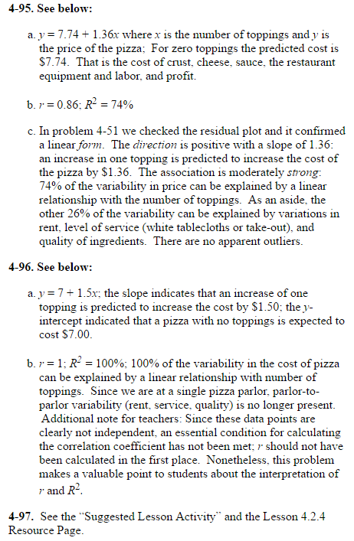

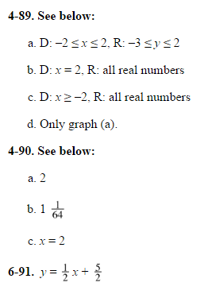

4.2.4

