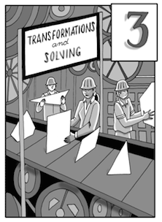

Chapter 3         Solving and Transformations

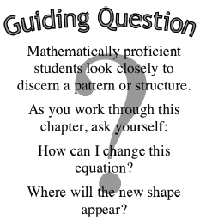In this chapter you will investigate the three basic rigid transformations of geometric shapes.  You will rewrite expressions that contain products.  Finally, you will learn methods for solving complex equations.

http://textbooks.cpm.org/images/int1/common/chapteroutline.jpg

|  |  |  |
| --- | --- | --- |
| http://textbooks.cpm.org/images/int1/chap03/3.1.png | **Section 3.1** | You will learn about rigid transformations as you study how to flip, turn, and slide shapes.  Then you will learn how to use these transformations to build new shapes and describe symmetry. |
| pic | **Section 3.2** | You will develop a method to rewrite products of binomials and other polynomials, such as (3*x* – 2)(4 + *x*), using area models. |
| http://textbooks.cpm.org/images/int1/chap03/3.3.png | **Section 3.3** | You will look at three methods for solving equations: rewriting, looking inside, and undoing.  You will develop new ways to solve complicated equations involving multiplication, fractions, and exponents. |

# 3.1.1a Leaping Lizards!



CC0 Shared by Tracy 04-140-2011

<http://www.clker.com/clipart-green-gecko.html>

## A Develop Understanding Task

Animated films and cartoons are now usually produced using computer technology, rather than the hand-drawn images of the past. Computer animation requires both artistic talent and mathematical knowledge.

Sometimes animators want to move an image around the computer screen without distorting the size and shape of the image in any way. This is done using geometric transformations such as translations (slides), reflections (flips), and rotations (turns), or perhaps some combination of these. These transformations need to be precisely defined, so there is no doubt about where the final image will end up on the screen.

So where do you think the lizard shown on the grid on the following page will end up using the following transformations? (The original lizard was created by plotting the following anchor points on the coordinate grid, and then letting a computer program draw the lizard. The anchor points are always listed in this order: tip of nose, center of left front foot, belly, center of left rear foot, point of tail, center of rear right foot, back, center of front right foot.)

Original lizard anchor points:

{(12,12), (15,12), (17,12), (19,10), (19,14), (20,13), (17,15), (14,16)}

***1) Lazy Lizard***

Translate the original lizard so the point at the tip of its nose is located at (24, 20), making the lizard appears to be sunbathing on the rock.

1. plot the anchor points for the lizard in its new location
2. connect the **pre-image** and **image** anchor points with line segments, or circular arcs, whichever best illustrates the relationship between them

***2) Lunging Lizard***

Rotate the lizard 90° about point *A* (12,7) so it looks like the lizard is diving into the puddle of mud.

1. plot the anchor points for the lizard in its new location
2. connect the **pre-image** and **image** anchor points with line segments, or circular arcs, whichever best illustrates the relationship between them

***3) Leaping Lizard***

Reflect the lizard about given line $y=\frac{1}{2}x+16$ so it looks like the lizard is doing a back flip over the cactus.

1. plot the anchor points for the lizard in its new location
2. connect the **pre-image** and **image** anchor points with line segments, or circular arcs, whichever best illustrates the relationship between them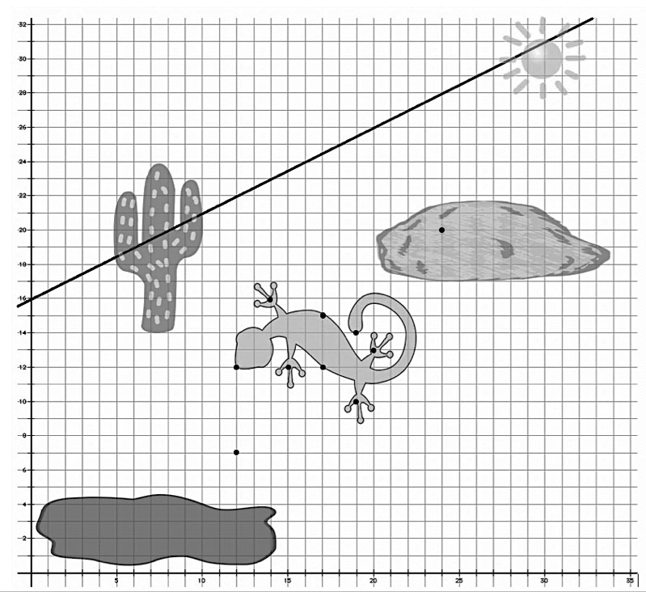

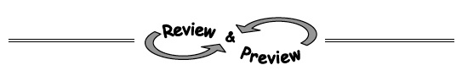Name________________________Per______

**HOMEWORK ASSIGNMENT**

##### **Transform points as indicated in each exercise below.**

1a. Rotate point A around the origin 90o clockwise, label as A’

1. Reflect point A over x-axis, label as A’’
2. Apply the rule (x − *2* , y − 5), to point A and label A’’’



2 a. Reflect point B over the line y = x, label as B’

1. Rotate point B 180o about the origin, label as B’’
2. Translate point B the point up 3 and right 7 units, label as B’’’

**3. Read the Math Notes on the next page and annotate key information.**

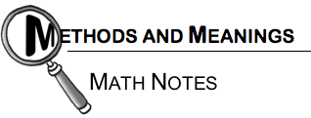

### Naming Parts of Shapes

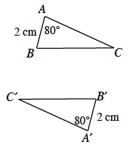Part of geometry is the study of parts of shapes, such as points, line segments, and angles.  To avoid confusion, standard notation is used to name these parts.

The point on a polygon where two line segments meet to form a “corner” is called a **vertex**.  (The plural form of “vertex” is vertices.)  A **point** is named using a single capital letter.  For example, the vertices (corners) of the triangle at right are named A, B, and C.

If a shape is transformed, the image shape is often named using **prime notation**.  The image of point A is labeled A′ (read as “A prime”), the image of Bis labeled B′ (read as “B prime”), etc.  At right, ΔA′B′C′ is the image of ΔABC.  We also say ΔABC is **mapped**to ΔA′B′C′.

A **line segment** is a portion of a line between two points, and it is named by its endpoints and placing a bar above them.  The side of a polygon is a line segment.  For example, one side of the first triangle above is named AB .  When referring to the length of a segment, the bar is omitted.  In ΔABC above, AB = 2 cm.

http://textbooks.cpm.org/images/int1/chap03/3.1.3_MNc.pngA **line**, which differs from a segment in that it extends infinitely in either direction, is named by using two points on the line and placing a bar with arrows above them.  For example, the line at right is named .  When naming a segment or line, the order of the letters is unimportant.  The line at right could also be named .

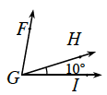An **angle** can be named by putting an angle symbol in front of the name of the angle’s vertex.  For example, the angle measuring 80° in ΔABC above is named ∠A.  Sometimes using a single letter makes it unclear which angle is being referenced.  For example, in the diagram at left, it is unclear which angle is referred to by ∠G.  When this happens**, the angle is named with three** **letters.**  For example**, the angle measuring 10° is called ∠HGI or ∠IGH**.  Note that the name of the vertex must be the second letter in the name; the order of the other two letters is unimportant.

To refer to an angle’s measure, an m is placed in front of the angle’s name.  For example, m∠HGI = 10º means “the measure of ∠HGI is 10°”.

# 3.1.1b Leap Frog



CC0 Francesco Rolandin

<http://openclipart.org/detail/33781/architetto>

## A Solidify Understanding Task

Josh is animating a scene in which a troupe of frogs is auditioning for the Animal Channel reality show, "The Bayou's Got Talent". In this scene the frogs are demonstrating their "leap frog" acrobatics act. Josh has completed a few key images in this segment, and now needs to describe the transformations that connect various images in the scene.

For each pre-image/image combination listed below, describe the transformation that moves the pre-image to the final image.

* + - If you decide the transformation is a rotation, you will need to give the center of rotation, the direction of the rotation (clockwise or counterclockwise), and the measure of the angle of rotation.
    - If you decide the transformation is a reflection, you will need to give the equation of the line of reflection.
    - If you decide the transformation is a translation you will need to describe the "rise" and "run" between pre-image points and their corresponding image points.
    - If you decide it takes a combination of transformations to get from the pre-image to the final image, describe each transformation in the order they would be completed.

|  |  |  |
| --- | --- | --- |
| **Pre-image** | **Final Image** | **Description** |
| image 1 | image 2 |  |
| image 2 | image 3 |  |
| image 3 | image 4 |  |
| image 1 | image 5 |  |
| image 2 | image 4 |  |

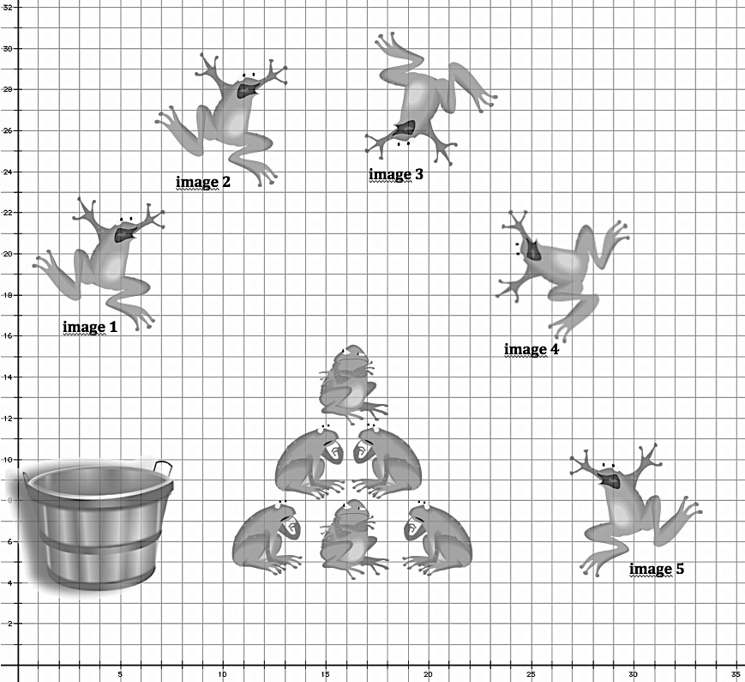

Name________________________Per______

**HOMEWORK ASSIGNMENT**

1. Graph each line below on the same set of axes.

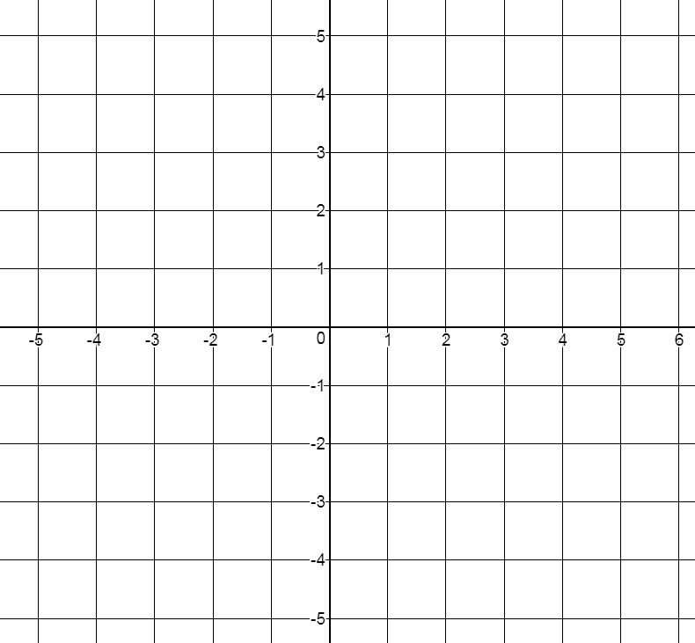

|  |  |
| --- | --- |
|  | * 1. f(x) = 3x − 3   3. f(x) = −4x + 5 |

2. AC is a straight segment as shown in the diagram below.  If the distance between points A and C is 67 miles, determine the distance between points A and B.

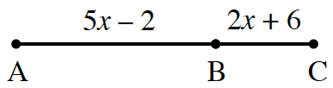

**3.** Evaluate the following expressions.      

1. 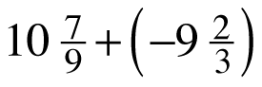

b. 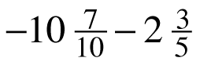

c. 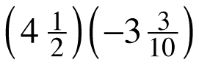

* 1. −8 ÷ 1

***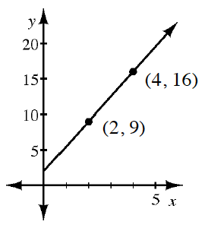*4.**Draw a slope triangle and use it to write the equation of the line shown in the graph at right.

**5. Solve for x**

|  |  |
| --- | --- |
| **a.** | **b.** |
| **c.** | **d.** |

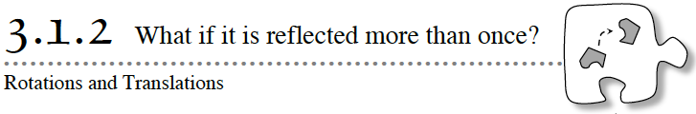

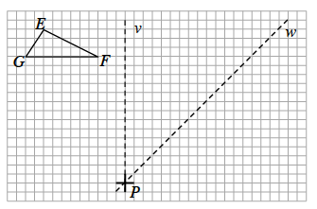**3-15.** Find Δ*EFG* and lines *v* and *w* at right.

* 1. Visualize the result when Δ*EFG* is reflected over *v* to form Δ*E*′ *F*′ *G*′, and then Δ*E*′ *F*′ *G*′  is reflected over *w* to form Δ*E*″*F*″*G*″.  Draw the resulting reflections above.  Is the final image a translation of the original triangle?  If not, describe the result.

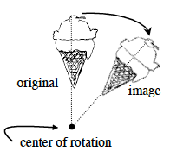

* 1. Amanda noticed that when the reflecting lines are not parallel, the image was a **rotation** of the original figure.  For example, the diagram at right shows the result when an ice cream cone is rotated about a point.   
       
     In part (a), the center of rotation is at point *P*, the point of intersection of the lines of reflection.  Use a piece of tracing paper to test that Δ*E*″*F*″*G*″ can be obtained by rotating Δ*EFG* about point *P*.  To do this, first trace Δ*EFG* and the “+” sign at point *P* on the tracing paper.  While the tracing paper and image are aligned, apply pressure on *P* so that the tracing paper can rotate about this point.  Then turn your tracing paper until Δ*EFG* rests atop Δ*E*″*F*″*G*″.
  2. The rotation of Δ*EFG* in part (a) is an example of a 90° clockwise rotation.  The term “clockwise” refers to a rotation that follows the direction of the hands of a clock, namely ↻.  A rotation in the opposite direction (↺) is called “counterclockwise”.  Perform the rotation again noticing the starting and ending orientation of the (+). Is it possible to rotate Δ*EFG* counterclockwise to obtain Δ*E*″*F*″*G*″?  If so, how?

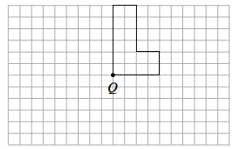

* 1. Read the Math Notes box in this lesson to remind yourself of the definition of a polygon.  Is the figure at right a polygon?
  2. On the figure at right, rotate the polygon 90° counterclockwise (↺) about point *Q*.

**3-18.** Consider what you have learned about rigid transformations.

1. Would a series of rigid transformations preserve the area of a polygon?  That is, would the area of the image always have the same area as the original polygon?  Why or why not?
2. If two polygons have the same area, are they always the image of a series of rigid transformations?
3. Verify your answer to part (a) by calculating the areas of the original triangle Δ*EFG* and its image Δ*E*″*F*″*G*″ in problem 3‑15.  Then calculate the areas of both the original “block L” in part (e) of problem 3-15 and its image.  Do any of the rigid transformations change the area of a figure?

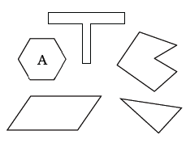

 **Polygons**

A **polygon** is a two-dimensional closed figure of three or more line segments (sides) connected end to end.  Each segment is a side and only intersects the endpoints of its two adjacent sides.  Each point of intersection is a **vertex**.

At right are some examples of polygons.  Shape A is an example of a **regular polygon** because it has been drawn with sides that are all the same length and its angles all have equal measure.

Polygons are named according to the number of sides that they have:

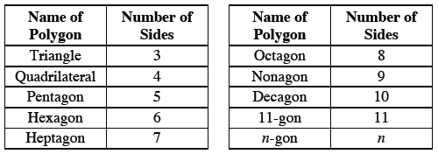

Sometimes polygons are given specialized names.  A **right triangle** is a triangle that contains a right (90º) angle.  An **isosceles triangle** (or **trapezoid**) has at least two sides of equal length.  An **equilateral triangle** has all sides of equal length.  A **scalene triangle** has no side that is the same length as any other side.

Name________________________Per______

**HOMEWORK ASSIGNMENT**

**3-19.**Determine which transformation was used on each pair of polygons below.  Some may have undergone more than one transformation, but try to name a single transformation, if possible.

|  |  |  |
| --- | --- | --- |
| a. http://textbooks.cpm.org/images/int1/chap03/3-19a.png | b. http://textbooks.cpm.org/images/int1/chap03/3-19b.png | c. http://textbooks.cpm.org/images/int1/chap03/3-19c.png |
| d. http://textbooks.cpm.org/images/int1/chap03/3-19d.png | e. http://textbooks.cpm.org/images/int1/chap03/3-19e.png | f. http://textbooks.cpm.org/images/int1/chap03/3-19f.png |

**3-20.**Jamila wants to play a game called “Guess My Line”.  She gives you the following hints: “Two points on my line are (1, 1) and (2, 4).”

a. What is the slope of her line?  A graph of the line may help.

b. What is the y‑intercept of her line?

c. What is the equation of her line?

**3-21.**For each diagram below, solve for x.  Explain what angle properties or relationship(s) you used for each problem.

|  |  |
| --- | --- |
| a.  http://textbooks.cpm.org/images/int1/chap03/3-21a.png | b.  http://textbooks.cpm.org/images/int1/chap03/3-21b.png |

**3-22.** Determine the domain and range of each of the following graphs.

|  |  |
| --- | --- |
| a. http://textbooks.cpm.org/images/int1/chap03/3-22a.png | b. http://textbooks.cpm.org/images/int1/chap03/3-22b.png |
| c. http://textbooks.cpm.org/images/int1/chap03/3-22c.png | d. http://textbooks.cpm.org/images/int1/chap03/3-22d.png |

**3-23.**Perform the indicated operations.

|  |  |  |  |
| --- | --- | --- | --- |
| a. http://textbooks.cpm.org/images/int1/chap03/3-23a.gif | b. http://textbooks.cpm.org/images/int1/chap03/3-23b.gif | c. http://textbooks.cpm.org/images/int1/chap03/3-23c.gif | d. http://textbooks.cpm.org/images/int1/chap03/3-23d.gif |

**3-24.** Rewrite the expressions below in equivalent, simpler forms so that they do not contain negative exponents.

|  |  |  |
| --- | --- | --- |
| a. http://textbooks.cpm.org/images/int1/chap03/3-24a.gif | b. (23y8)(32y–10) | c. (6g3)–3 |

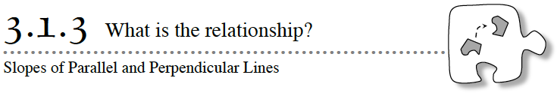

In *Leaping Lizards* you probably thought a lot about perpendicular lines, particularly when rotating the lizard about a given center a 90° angle or reflecting the lizard across a line.

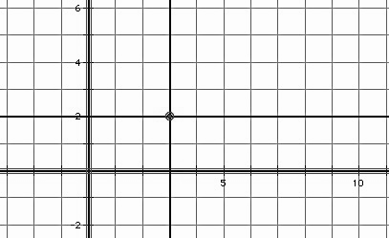In previous tasks, we have made the observation that *parallel lines have the same slope*. In this task we will make observations about the slopes of perpendicular lines. Perhaps in *Leaping Lizards* you used a protractor or some other tool or strategy to help you make a right angle. In this task we consider how to create a right angle by attending to slopes on the coordinate grid.

We begin by stating a fundamental idea for our work: *Horizontal and vertical lines are perpendicular.* For example, on a coordinate grid, the horizontal line *y* = 2 and the vertical line *x* = 3 intersect to form four right angles.

But what if a line or line segment is not horizontal or vertical? How do we determine the slope of a line or line segment that will be perpendicular to it?

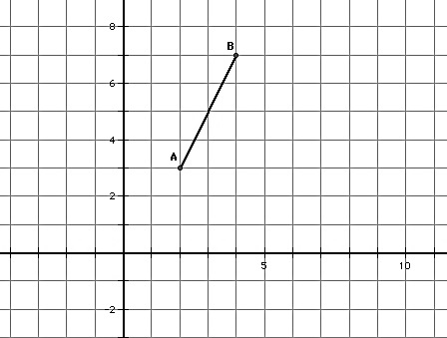Experiment 1

* 1. Consider the points *A* (2, 3) and *B* (4, 7) and the line segment, **, between them. What is the slope of this line segment?
  2. Locate a third point *C* (*x*, *y*) on the coordinate grid, so the points *A* (2, 3), *B* (4, 7) and *C* (*x*, *y*) form the vertices of a right triangle, with ** as its hypotenuse.
  3. Now rotate this right triangle 90° about the vertex point (2, 3).

Compare the slope of the hypotenuse of this rotated right triangle with the slope of the hypotenuse of the pre-image. What do you notice?

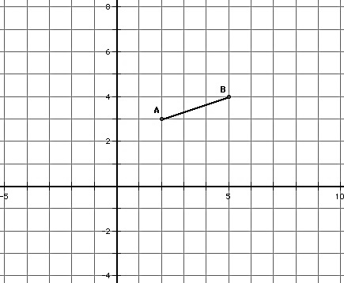Experiment 2

Repeat steps 1-3 above for the points *A* (2, 3) and *B* (5, 4).

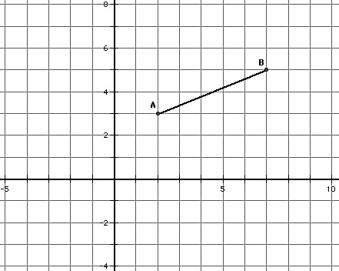

Experiment 3

Repeat steps 1-3 above for the points *A* (2, 3) and *B* (7, 5).

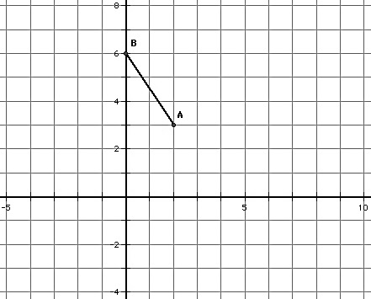

Experiment 4

Repeat steps 1-3 above for the points *A* (2, 3) and *B* (0, 6).

Based on experiments 1-4, state an observation about the slopes of perpendicular lines.

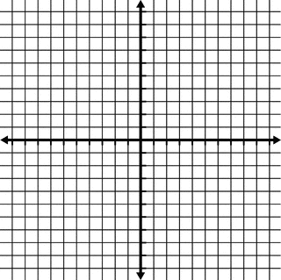

**3-26.** Slope can help reveal more about transformations.

* 1. Begin by graphing the equation $y=\frac{3}{5}x-4$.  Use tracing paper to translate the graph of $y=\frac{3}{5}x-4$  up 5 units.  Write the equation of the resulting image.  What is the relationship between $y=\frac{3}{5}x-4$  and its image?  How do their slopes compare?
  2. Now use tracing paper to rotate $y=\frac{3}{5}x-4$ 90° clockwise (↻) about (0, 0).  Write the equation of the result.  Describe the relationship between $y=\frac{3}{5}x-4$  and this new image.

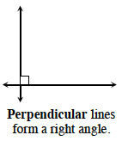

* 1. The original line and the rotated line in part (b) are **perpendicular** because they form a 90° angle where they intersect.  Look at the slopes of the original line and the rotated line and make any observations you can about the relationship between the slopes.

**3-29.** Use what you learned about the slopes of parallel and perpendicular lines to write the equation of a line that would meet the criteria given below.

* 1. Write the equation of the line that goes through the point (0, –3) and is perpendicular to the line y =x + 6.
  2. Write the equation of the line that is parallel to the line y =x + 5 and goes through the point (0, 7).

**3-30.** EXTENSION

Suppose the equation for line A is  y =x – 10.  Line A is parallel to line B, which is perpendicular to line C.  If line D is perpendicular to both line C and line E, what is the slope of line E?  Justify your conclusion.

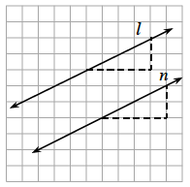

**Parallel and Perpendicular Lines**

**Parallel lines** are lines that lie in the same plane (a flat surface) and never intersect.  Lines l and n at right are examples of parallel lines.

The slopes of parallel lines are the same.  If a line has a slope m, the slope of any parallel line is also m.

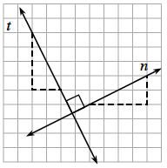On the other hand, **perpendicular lines** are lines that intersect at a right angle.  For example, lines tand nat right are perpendicular.  The small square drawn at the point of intersection indicates a right angle.

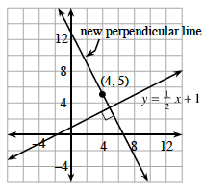The **slopes of perpendicular lines** are opposite reciprocals.  For example, if one line has a slope of , then any line perpendicular to it has a slope of .  If a line has a slope of –2, then any line perpendicular to it has a slope of .  In general, the slope of a line perpendicular to a line with a slope of m is .

You can write the equation of a new line that is perpendicular to an existing line and goes through a specified point.

For example, write the equation of the line that goes through (4, 5) and is perpendicular to y =  +1.

First write the equation of the new perpendicular line as y = mx + b.

The slope of the new perpendicular line is the negative reciprocal of , which is –2.  
Substitute –2 for m and (4, 5) for x and y, resulting in 5 = –2(4) + b.  Solve the equation to determine b = 13.

Since you now know the slope and y‑intercept of the line, you can write the equation of the new

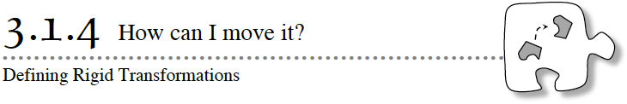

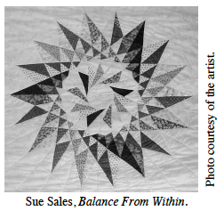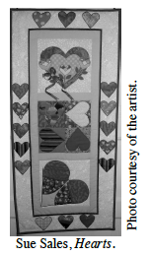Throughout American history, quilters have used transformations to create intricate geometric designs.  For example, the quilt at right is an example of a design based on rotation and reflection, while the quilt at left contains translations, rotations, and reflections.

In Lesson 3.1.3, you found ways to locate the image of a shape after it is reflected.  Today, you will work with your team to develop ways to describe the image of a shape after it is rotated or translated.

**3-38.** ROTATIONS ON A GRID

Consider what you know about rotation, a motion that turns a shape about a point.  Does it make any difference if a rotation is clockwise (↻) versus counterclockwise (↺)?  If so, in which situations does it matter?  Are there any circumstances in which it does not matter?  And are there any situations in which the rotated image lies exactly on the original shape?

Investigate these questions as you rotate the polygons below about the given point below. Use tracing paper if needed.  Be prepared to share your answers to the questions posed above.

|  |  |  |  |
| --- | --- | --- | --- |
| a.   180° ↻ http://textbooks.cpm.org/images/int1/chap03/3-38a.png | b.   180° ↺ http://textbooks.cpm.org/images/int1/chap03/3-38b.png | c.   90° ↻ http://textbooks.cpm.org/images/int1/chap03/3-38c.png | d.   90° ↺ http://textbooks.cpm.org/images/int1/chap03/3-38d.png |
| e.   270° ↻ http://textbooks.cpm.org/images/int1/chap03/3-38e.png | f.   360° ↻ http://textbooks.cpm.org/images/int1/chap03/3-38f.png | g.   180° http://textbooks.cpm.org/images/int1/chap03/3-38g.png | h.   90° http://textbooks.cpm.org/images/int1/chap03/3-38h.png |

**3-39.** DEFINITION OF ROTATION

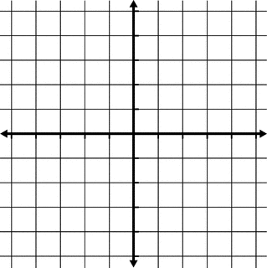So what exactly is a rotation?  If a figure is rotated, how can you describe it?  Investigate this question below.

* 1. On the graph, graph the points A(4, 1) and B(2, 5).  Then use tracing paper to rotate the two points 90° counterclockwise (↺) about point O(0, 0).  Mark points A′ and B′ on your graph paper.
  2. Draw line segments that connect A to O, B to O, A′ to O, and B′ toO.  Using tracing paper, compare the lengths of, and angles formed by, these line segments.  Which lengths are equal?  Which angle measures are equal?  Be specific.
  3. Predict m∠AOA′.  Verify its measure.
  4. Why does it make sense that for all points P on the graph, a rotation about a point O moves it to a new point P′ so that OP = OP′ and m∠POP′ equals the measure of the angle of rotation?  Use tracing paper to make sense of this relationship.
  5. Use tracing paper to help you explain why a rotation does not change any angles or lengths of a figure.  When measures do not change some mathematicians use the term “**preserved**”, as in, “The angle measures are preserved.”

**3-40.**DEFINITION OF REFLECTION

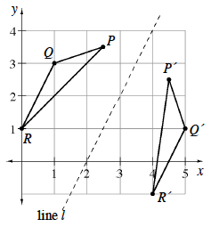Now that you know more about the slopes of parallel and perpendicular lines, revisit the reflection from problem 3‑25 and confirm the relationships you found in that problem as follows.

1. The diagram at right shows ΔPQR reflected across line l to form ΔP′Q′R′.  Use your ruler to draw three dashed line segments: ,  , and .  What is the relationship between these three dashed line segments?  Use your knowledge of slope to algebraically verify your observations.
2. Now focus only on line segment .  What is the relationship between the line of reflection and segment ?
3. Use slope to confirm that the line of reflection is perpendicular to line segment .
4. Place a point N at the intersection of  and the line of reflection.  What do you notice about the lengths of segments  and ?
5. Is what you observed for segment  true for any segment connecting a point with its image?  That is, is the line segment connecting a point to its image always perpendicular to the line of reflection?  Is the line of reflection always at the midpoint of this segment?  Use what you know about rigid transformations to explain your thinking.

Name________________________Per______

**HOMEWORK ASSIGNMENT**

Topic: Equations for parallel and perpendicular lines.

|  |  |  |
| --- | --- | --- |
|  | **Find the equation of a line PARALLEL to the given info and through the indicated y-intercept.** | **Find the equation of a line PERPENDICULAR to the**  **given line and through the indicated y-intercept.** |
| 1. Equation of a line:  y = 4x + 1. | a. Parallel line through point (0, -7): | b. Perpendicular to the line through point (0 , -7): |
| 2. Table of a line: | a. Parallel line through point (0 , 8): | b. Perpendicular to the line through point (0 , 8): |
| 3. Graph of a line: | a. Parallel line through point (0 , -9): | b. Perpendicular to the line through point (0 , -9): |

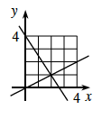**3-32.**Robert believes the lines graphed at right are perpendicular, but Mario is not convinced.  What is the slope of each line?

Explain how you know whether or not the lines are perpendicular.

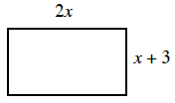**3-33.**Examine the rectangle at right.

* 1. Write an expression for the perimeter in terms of x.
  2. Assuming the perimeter is 78 cm, determine the dimensions of the rectangle.  Show all of your thinking.
  3. Verify that the area of this rectangle is 360 sq. cm.  Explain how you know this.

**3-34.**Write an equation for the tile pattern represented below.

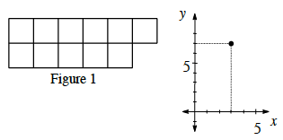

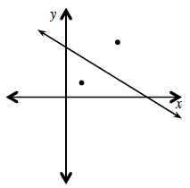**3-41.** Evan has graphed the point (5, 7) and he wants to reflect it over the line y = x + 6.  He predicts that the reflected point will have coordinates (2, 2).  Without graphing, can you confirm his answer or show that he cannot be correct?  Explain.  (The diagram is Evan’s rough sketch and is not drawn to scale.)

(Continued)

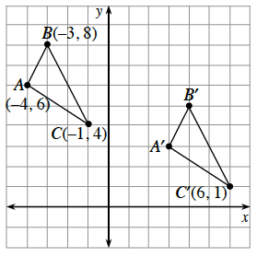

**3-42.**DEFINITION OF TRANSLATION

The formal name for a slide is a translation.  So what exactly is a translation?  (Remember that translation and transformation are different words.)  ΔA′B′C′ at right is the image of a translation of ΔABC.

* 1. Describe the translation.  That is, how many units to the right and how many units down did the translation move the triangle?
  2. On the graph at left, plot ΔEFG with coordinates E(4, 2), F(1, 7), and G(2, 0).  What are the coordinates of ΔE′F′G′ if ΔE′F′G′ is translated the same way as ΔABC was in part (a)?
  3. For the translated triangle in part (b), draw line segments connecting each vertex to its translated image.  What do you notice about these line segments?  What does this tell you about how a translation moves each point of the triangle?
  4. Use the tracing paper to help explain how you know that a translation does not change any angles or lengths of a figure.

**3-43.** CONNECTIONS TO ALGEBRA

Read the Math Notes box in this lesson.  Note that the formal definitions of transformations involve functions.

1. Plot ΔABC on graph paper with points A(3, 3), B(1, 1), and C(6, 1).  Apply the function (x, y) → (–x, –y) to find the coordinates of the image ΔA′B′C′.  For example, using the given function, the original point (8, –3) has an image point (–8, 3).
2. What single transformation is the function in part (a)?
3. Use the function (x, y) → (x – 6, y – 3) to transform the triangle ΔABC again.  Name the coordinates of the image ΔA′′B′′C′′, and describe the transformation (or sequence of transformations).
4. On a new set of axes, plot and connect the points to form quadrilateral WXYZ if its vertices are W(3, 7), X(3, 4), Y(9, 1), and Z(5, 6).  Quadrilateral WXYZ is transformed by the function (x → –x, y → y) to form quadrilateral W′X′Y′Z′.  Where is Y′?
5. What transformation mapped quadrilateral WXYZ to its image?

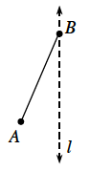**3-44.**FACTS ABOUT ISOSCELES TRIANGLES

How can transformations such as reflections help us to learn more about familiar polygons?  Consider reflecting a line segment across a line that passes through one of its endpoints.

* 1. On the diagram at right, draw , the reflection of  across line l.  When points A and A′ are connected, what special polygon is formed by points A, B, and A′?
  2. Use what you know about reflection to make as many statements as you can about the triangle formed in part (a).  For example, are there any sides that must be the same length?  Are there any angles that must be equal?  Is there anything else special about this polygon?



### Formal Definitions of Rigid Transformations

In Chapter 1, you learned that a function assigns each input a unique output.  Most of these functions involved equations such as f(x) = 3x – 5, so f(2) = 1.

In this chapter, you are studying functions that assign each point in the plane to a unique image point in the plane.  These functions are called **rigid transformations (or motions)**because they move the entire plane (the entire sheet of tracing paper) with any figures you have drawn so that all of the figures remain unchanged.  Therefore, angle measures and segment lengths are preserved.  We keep the x- and y‑axes on an underlying plane in their original position for reference.

There are three basic rigid transformations that we will consider: reflections, translations, and rotations.  All rigid transformations can be seen as a combination of them.

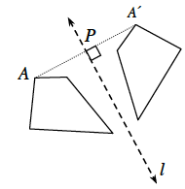**Reflections:**When a figure is reflected across a line of reflection, such as the figure at right, it appears that the figure is “flipped” over the line, looking like a mirror image.  The mirror line is a **line of reflection**, shown as line l in the diagram.  However, formally, a reflection across a line of reflection is defined as a function of each point (A) to a unique image point (A′), so that the segments connecting the points and their images (such as ) is perpendicular to the line of reflection, and so that the segment  has the same length as segment .

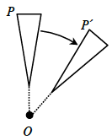**Rotations:** “Turning” a figure about a fixed point is called a rotation.  Figures can be rotated either clockwise (↻) or counterclockwise (↺).  Formally, a rotation about a point O is a function that assigns each point (P) in the plane a unique image point (P′) so that all angles of rotation ∠POP′ have the same measure (which is the angle of rotation) and OP = OP′.

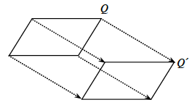**Translations:** A translation is like “sliding” a figure.  Formally, a translation is a function that assigns each point (Q) in the plane a unique image point (Q′) so that all line segments connecting a point with its image have equal length and are parallel.

Name________________________Per______

**HOMEWORK ASSIGNMENT**

**3-45.**Plot the following points on the graph and connect them in the order given.  Then connect points A and D.

A(–3, 4), B(1, 6), C(5, –2), and D(1, –4)

If ABCD is rotated 90° clockwise (↻) about the origin to form A′B′C′D′, what are the coordinates of the vertices of A′B′C′D′?

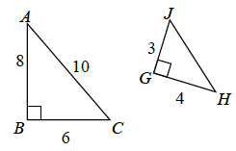**3-46.**ΔHGJ at right has been created from ΔABC. Why is ΔHGJ not a rigid transformation of ΔABC?  Explain what properties of ΔABChave been preserved and which have not been preserved.

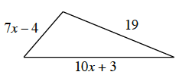**3-47.**The perimeter of the triangle at right is 52 units.  Write and solve an equation based on the information in the diagram.  Use your solution for x to calculate the length of each side of the triangle.  Be sure to confirm that your answer is correct.

**3-48.** Write the equation of each line described below:

* + A line that goes through the points (–7, 10) and (1, 4).
  + A line with a slope of  that passes through the point (–14, 4).
  + A line with a slope of 0 that passes through the point (6, –11).

**3-49.**For the function f(x) =, what is the value of each expression below?

|  |  |  |  |
| --- | --- | --- | --- |
| 1. f(1) | 1. f(9) | 1. f(4) | 1. f(0) |

**3-50.** Solve each equation below for x.  Explain or justify each of your steps.  Be sure to check your solutions.

|  |  |
| --- | --- |
|  | 1. 5x − (x + 1) = 5 – 2x |
| 1. 3x + 5 − x = x − 3 |  |

# 3.1.5 Symmetries of Quadrilaterals

A line that reflects a figure onto itself is called a **line of symmetry**. A figure that can be carried onto itself by a rotation is said to have **rotational symmetry**.

Every four-sided polygon is a **quadrilateral**. Some quadrilaterals have additional properties and are given special names like squares, parallelograms and rhombuses. A **diagonal** of a quadrilateral is formed when opposite vertices are connected by a line segment. Some quadrilaterals are symmetric about their diagonals. Some are symmetric about other lines. In this task you will use rigid-motion transformations to explore line symmetry and rotational symmetry in various types of quadrilaterals.

1. For each of the following quadrilaterals you are going to try to answer the question, “Is it possible to reflect or rotate this quadrilateral onto itself?” As you experiment with each quadrilateral, record your findings in the following chart. Be as specific as possible with your descriptions.

|  |  |  |
| --- | --- | --- |
| **Defining features of the quadrilateral** | **Lines of symmetry that reflect the quadrilateral onto itself** | **Center and angles of rotation that carry the quadrilateral onto itself** |
| A **rectangle** is a quadrilateral that contains four right angles. |  |  |
| A **parallelogram** is a quadrilateral in which opposite sides are parallel. |  |  |

|  |  |  |
| --- | --- | --- |
| **Defining features of the quadrilateral** | **Lines of symmetry that reflect the quadrilateral onto itself** | **Center and angles of rotation that carry the quadrilateral onto itself** |
| A **rhombus** is a quadrilateral in which all sides are congruent. |  |  |
| A **square** is both a rectangle and a rhombus |  |  |

2. A **trapezoid** is a quadrilateral with one pair of opposite sides parallel. Is it possible to reflect or rotate a trapezoid onto itself?

Draw a trapezoid based on this definition. Then see if you can find:

* any lines of symmetry, or
* any centers of rotational symmetry, that will carry the trapezoid you drew onto itself.

3. If you were unable to find a line of symmetry or a center of rotational symmetry for your trapezoid, see if you can sketch a different trapezoid that might possess some type of symmetry.

**Kites, Lines of symmetry and diagonals**

1. One quadrilateral with special attributes is a kite. Find the geometric definition of a kite and write it below along with a sketch. (You can do this fairly quickly by doing a search online.)
2. Draw a kite and draw all of the lines of reflective symmetry and all of the diagonals.

##### Lines of Reflective Symmetry Diagonals

1. List all of the rotational symmetry for a kite.

# 3.1.6 Symmetries of Regular Polygons

## 

A line that reflects a figure onto itself is called a **line of symmetry**. A figure that can be carried onto itself by a rotation is said to have **rotational symmetry**. A **diagonal of a polygon** is any line segment that connects non-consecutive vertices of the polygon.

For each of the following regular polygons, describe the rotations and reflections that carry it onto itself: (be as specific as possible in your descriptions, such as specifying the angle of rotation)

|  |  |
| --- | --- |
| 1. An equilateral triangle | 1. A square |
| 1. A regular pentagon | 1. A regular hexagon |

|  |  |
| --- | --- |
| 1. A regular octagon | 1. A regular nonagon |

7. What patterns do you notice in terms of the number and characteristics of the lines of symmetry in a regular polygon?

8. What patterns do you notice in terms of the angles of rotation when describing the rotational symmetry in a regular polygon?

**3-65.**CONNECTIONS WITH ALGEBRA

During this lesson, you have focused on the types of symmetry that can exist in geometric objects.  But what about shapes that are created on graphs?  What types of graphs have symmetry?

* 1. Examine the graphs below.  Decide which have reflection symmetry, rotation symmetry, translation symmetry, or a combination of these.  
     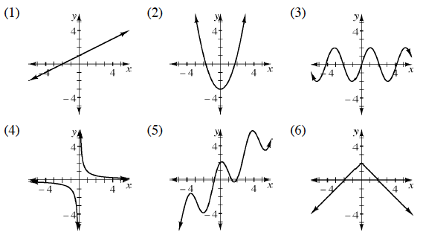



* 1. If the *y‑*axis is a line of symmetry of a graph, then its function is referred to as **even**.  Which of the graphs in part (a) are even functions?
  2. If the graph has rotation symmetry about the origin (0, 0), its function is called **odd**.  Which of the graphs in part (a) are odd functions?

Name________________________Per______

**HOMEWORK ASSIGNMENT**

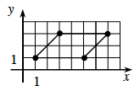

**3-67.** The diagram at right represents only half of a shape that has the graph of *y* = 1 as a line of symmetry.  Draw the completed shape and label the coordinates of the missing vertices.

**3-68.** The length of a side of a square is 5*x* + 2 units.  Assuming the perimeter is 48 units, complete the following problems.

* 1. Write an equation to represent this information.
  2. Solve for *x*.
  3. What is the area of the square?

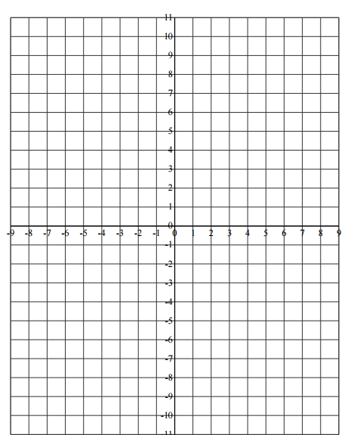**3-69.** Graph the line through the point (0, –2) with a slope of .

1. Write the equation of the line.
2. Translate the graph of the line up 4 units and to the right 3 units.  What is the result?  Write the equation for the resulting line.
3. Now translate the original graph down 5 units.  What is the result?  Write the equation for the resulting line.
4. How are the three lines you graphed related to each other?  Justify your conclusion.
5. Write the equation of a line that is perpendicular to these lines and passes through point (12, 7).

**3-70.** Write the equation of the line containing the points given in the table below.

|  |  |  |  |  |
| --- | --- | --- | --- | --- |
| *x* | –2 | –1 | 2 | 3 |
| *y* | –7 | –4 | 5 | 8 |

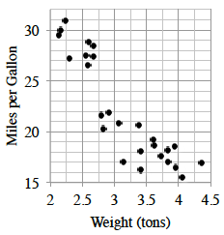**3-71.** The graph at right compares the gas mileage to the weight of numerous vehicles.

Describe the association between these two quantities.

**3-72.** If *f*(*x*) = 7 +  and *g*(*x*) = *x*3 – 5, evaluate:

|  |  |  |
| --- | --- | --- |
| 1. *f*(–5) | 1. *g*(4) | 1. *f*(0) |
| 1. *f*(2) | 1. *g*(−2) | 1. *g*(0) |

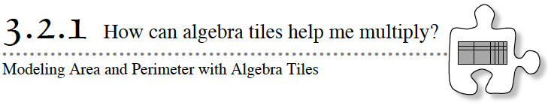

In previous math courses you worked with the areas and perimeters of shapes made up of rectangles.  Today you will find the areas and perimeters of shapes made of rectangular algebra tiles.

1. Finding area

|  |  |  |
| --- | --- | --- |
| a. What is the area of the rectangle below?  12  4 | b. What if I broke up the shape like this? Is there an easier way to find the area?  10 + 2  4 | c. Summary:  Area as a product:  Area as a sum: |

2. Finding area

|  |  |  |
| --- | --- | --- |
| a. What is the area of the rectangle below?  13  2 | b. What if I broke up the shape like this? Is there an easier way to find the area?  10 + 3  2 | c. Summary:  Area as a product:  Area as a sum: |

3. Draw the three main algebra tiles below and label the side lengths and the area.

4. Finding area

|  |  |  |
| --- | --- | --- |
| a. What is the area of the rectangle below?  x + 1  x | b. What if I broke up the shape like this? Is there an easier way to find the area?  x + 1  x | c. Summary:  Area as a product:  Area as a sum: |

5. Tiles Algebraic Representation

|  |  |  |
| --- | --- | --- |
| Tiles | Area as a product | Area as a sum |
| a. Create a rectangle using an  tile. |  |  |
| b. Create a rectangle using a  tile. |  |  |
| c. Create a rectangle using an  tile. |  |  |
| d. Create a rectangle using atile. |  |  |
| e. Create a rectangle using a  tile. |  |  |



**Using Area Models to Multiply Polynomials**

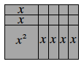The area of a rectangle can be written two different ways.  It can be written as a product of its width and length, or as a sum of the areas of smaller rectangles.  For example, the area of the shaded rectangle at right can be written two ways:

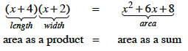

An area model helps to organize the different terms that make up the product.  For example, to multiply (2x + 5)(x + 3), an area model can be set up and completed as shown below.  Notice that each small part of the rectangle contains the product of its dimensions.

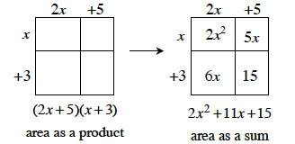

Note that while an area model helps organize the problem, its size and scale are not important.  Some students find it helpful to write the dimensions on the rectangle twice, that is, on all the sides of the area model.

**3-75.** Read the Math Notes box in this lesson.  For each polynomial below, build a rectangle using all of the algebra tiles.  Sketch each rectangle, and write an equation that shows that the area written as a product (like (x+ 3)(x + 2)) is equivalent to the area written as a sum (like x2 + 5x + 6).

|  |  |  |
| --- | --- | --- |
| 1. x2 + 3x + 2 | 1. 6x + 15 | 1. 2x2 + 7x + 6 |
| e. 2x2 + 10x + 12 | h. 3x2 + 4x + 1 |  |

Name________________________Per______

**HOMEWORK ASSIGNMENT**

**3-77.**For each of the polygons formed by algebra tiles below:

* + Label the shape on your paper and write an expression that represents the perimeter.
  + Simplify your perimeter expression as much as possible.

|  |  |
| --- | --- |
| a. http://textbooks.cpm.org/images/int1/chap03/3-77a.png | b. http://textbooks.cpm.org/images/int1/chap03/3-77b.png |
| c. http://textbooks.cpm.org/images/int1/chap03/3-77c.png | d. http://textbooks.cpm.org/images/int1/chap03/3-77d.png |

**3-78.**Use what you know about slope and *y‑*intercept to graph *y* = −½x + 3.

**3-79.** Write the equation of the line containing the points given in the table below.

|  |  |  |  |  |
| --- | --- | --- | --- | --- |
| *x* | 2 | 4 | 6 | 8 |
| *f*(*x*) | 2 | 3 | 4 | 5 |

**3-80.**In problems 3-78 and 3-79, which function has the greater *y*-intercept?  How do you know?

**3-81.**Using the rectangle *ABCD* at right:

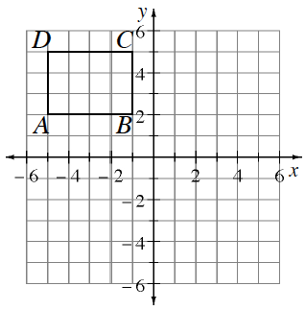

* 1. Rotate rectangle *ABCD* 90° counterclockwise (↺) about the origin to create rectangle *A*′*B*′*C*′*D*′.  Name the coordinates of *C*′.
  2. Reflect rectangle *ABCD* across the vertical line *x* = 1 to create rectangle *A*″*B*″*C*″*D*″.  Name the coordinates of *C*′′.

6

10

8

* 1. Translate rectangle *ABCD* so that *C* is moved 5 units down and 12 units right.  Name the coordinates of *C*′′′.  How is this transformation related to the line *y* = *x* + 1?
  2. What is the area of rectangle *ABCD*?

**3-82.** Interpret each of the following effects on the function, *f*(*x*).  For example, *f*(*x* + 2) indicates to “calculate the output for the input that is 2 greater than *x*”.

* 1. *f*(*c* − 4)
  2. *f*(0.5*b*)
  3. *f*(*d*) + 12

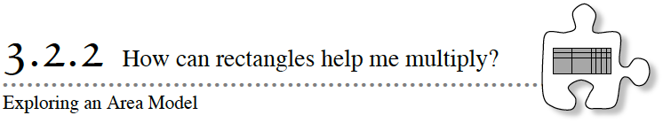

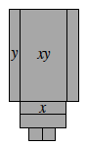In Lesson 3.2.1, you made rectangles with algebra tiles and found the dimensions of the rectangles.  Today you will represent algebraic expressions with area models of algebra tiles.  Then, you will be able to start with the area of a rectangle as a product, and write it as a sum.  This will lead to being able to multiply two algebraic expressions.

**3-83.**Use algebra tiles to build the polygon at right.  Write a simplified expression for the area and for the perimeter.

**3-84.**You have seen that the area of a rectangle can be written two different ways: as a product of its width and length, and as a sum of the areas of its parts.

Write the area of the following rectangle as the product of its dimensions equivalent to the area as the sum of its parts.  Remember to combine like terms when possible.

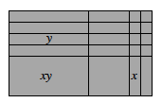

**3-85.** Write the area of the following rectangle as the product of the dimensions equivalent to the area as a sum of the parts.  Remember to combine like terms when possible.

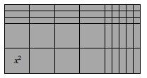

**3-86.** Now examine the following diagram.  How is it similar to the algebra tile rectangle in problem 3-85?  How is it different?  Talk with your teammates and write down all of your observations.

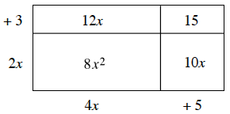

**3-87.** Write the area of each rectangle as a product equal to its area as a sum.  Combine like terms when possible.

|  |  |
| --- | --- |
| a. http://textbooks.cpm.org/images/int1/chap03/3-87a.png | b. http://textbooks.cpm.org/images/int1/chap03/3-87b.png |
| c. http://textbooks.cpm.org/images/int1/chap03/3-87c.png | d. http://textbooks.cpm.org/images/int1/chap03/3-87d.png |

**3-88.**Diagrams like the one in problem 3‑87 are referred to as **area models**.  Area models represent multiplication of algebraic expressions.

For each multiplication expression, sketch an area model.  Label the dimensions and the area of each part.  Then write an equation showing that the area as a product equals the area as a sum.

|  |  |  |
| --- | --- | --- |
| a.   (x + 1)(x+ 2) | b.   3(2x+ 5) | c.   (2x – 3)(x+ 2) |
| d.   (x – 1)(y– 1) | e.   –2y(y + 3) | f.   (–x + 1)(3x+ y– 4) |

 **Vocabulary for Expressions**

A mathematical **expression** is a combination of numbers, variables, and operation symbols.  Addition separates expressions into parts called **terms**.  For example, 4x2− 3x+ 6 is an expression.  It has three terms: 4x2, 3x, and 6.  The **coefficients** are 4 and −3.  6 is called a **constant term**.

A more complex expression is 2x + 3(5 – 9x) + 8, which has three terms: 2x, 3(5 – 9x), and 8. However, the term 3(5 – 9x) also has an expression inside the parentheses: 5 – 9x. 5 and –9x are terms of this inside expression.

A one-variable **polynomial** is an expression which only has terms of the form:

(any real  number)x(whole number)

For example, 4x2− 3x1+ 6x0is a one-variable polynomial, so the simpler form is 4x2− 3x+ 6.

The function f(x) =  7x5 + 2.5x3 − ½x + 7 is a polynomial function.

The following are not polynomials: 2x − 3,  and 

If the polynomial has one term, it is called a **monomial**, while a polynomial with two terms is called a **binomial**.  If the polynomial has three terms, it is called a **trinomial**.  Review the examples below.

Examples of monomials:     15y2   and   −2

Examples of binomials:       16m − 25   and 7h9 + ½

Examples of trinomials:       12 − 3k3 + 5k   and   x2 − 15x + 26

Name________________________Per______

**HOMEWORK ASSIGNMENT**

**3-90.**What is the area of each part of the entire rectangle at right?  What is the area of the whole figure?  Write the area of the rectangle as a product and as a sum.

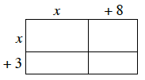

**3-91.**Solve for the variable in each equation below.  Show your thinking & check your solutions.

|  |  |
| --- | --- |
| 1. 8x − 22 = −60 | 1. ½x − 37 = −84 |
|  | 1. 9a + 15 = 10a − 7 |

**3-92.** For each expression below, write a simpler, equivalent expression using only positive exponents.

|  |  |  |  |
| --- | --- | --- | --- |
| 1. (3x2y)(5x) | 1. (x2y3)(x−2y−2) |  | 1. (2x−1)3 |

**3-93.** Write and solve an equation to represent the given situation.  Be sure to define your variable.

Samantha currently has $1500 in the bank and is spending $35 per week.  How many weeks will it take until her account is worth only $915?

**3-94.** Plot ΔABC on graph paper with vertices A(8, –4), B(8, 1), and C(2, 0).

* 1. What is the area of ΔABC?
  2. ΔABC is rotated about the origin 180° to become ΔA′B′C′.  Name the coordinates of A′, B′, and C′.
  3. This time ΔABC is rotated 180° about point C to form ΔA″B″C″.  Name the coordinates of B″.
  4. If ΔABC is rotated 90° clockwise (↻) about the origin to form ΔA′′′B′′′C′′′, what are the coordinates of point A′′′?

**3-95.** Graph the liney = x .

1. Draw a slope triangle.
2. Rotate your slope triangle 90° around the origin to get a new slope triangle.  What is the new slope?
3. Write the equation of a line perpendicular to y = x.

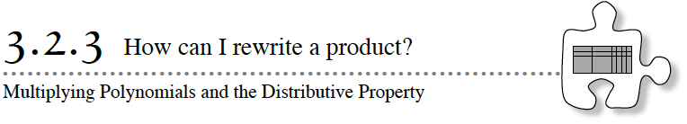

You have seen how an area model can be used to represent an expression as a sum and as a product.  Today you will use an area model to multiply polynomial expressions.

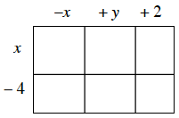**3-96.**Use the dimensions (length and width) of the area model at right to write the area as a product of the dimensions equal to the area as the sum of the parts.

**3-97.**Each expression below represents the area of a rectangle written as a product (length)(width).  Sketch an area model for each expression on your paper and label its length and width.  Then write an equation showing that the area written as a product is equal to the area written as the sum of the parts.  Be prepared to share your equations with the class.

|  |  |
| --- | --- |
| a.   (x + 3)(2x + 1) | b.   2x(x + 5) |
| c.  x(2x – y) | d.   (2x + 5)(x + y + 2) |
| e.   (2x – 1)2 | f.   (2x)(4x) |
| g.    2(3x – 5) | h.  y(2x + y + 3) |

**3-98.** With your team, examine the equations you wrote for parts (b), (c), (g), and (h) of problem 3‑97.  This pattern is the simplest form of what mathematicians call the **Distributive Property**.  Multiply the following expressions without an area model to write them as sums instead of products.  Be ready to share your process with the class.

|  |  |  |
| --- | --- | --- |
| 1. 2x(6x + 5) | 1. 6(4x – 1) | 1. x2(4x – 2y) |
| 1. 7y(10x + 11y) | 1. –5x(3x – 8) |  |

**3-99**. Does order matter when multiplying polynomials?  Investigate this question with your team by answering the following questions.

1. Are (x + 1)(7x + 1) and (7x + 1)(x + 1) equivalent expressions? Justify your answer with an area model. Then write an explanation using at least one of the properties in the Math Notes box in this lesson.
2. Are (x – 1)(7x + 1) and (1 – x)(7x + 1) equivalent expressions?  Justify your answer with an area model.  Then write an explanation using at least one of the properties as above.
3. Which expressions below have the same products?

|  |  |
| --- | --- |
| i.     (x – 5)(2x + 3) | ii.     (5 – x)(2x + 3) |
| iii.   (2x – 3)(x + 5) | iv.    (2x + 3)(x – 5) |
| v.    (–2x + 3)(x + 5) | vi.    (–5 + x)(2x + 3) |
| vii.  (–x + 5)(2x + 3) | viii.  (2x + 3)(5 – x) |

**3-100.** AREA MODEL PUZZLES

Fill in the missing dimensions and areas.  Then write the entire area as a product and as a sum.  Be prepared to share your reasoning with the class.

|  |  |
| --- | --- |
| a.  http://textbooks.cpm.org/images/int1/chap03/3-100a.png  ***x*** | b.  http://textbooks.cpm.org/images/int1/chap03/3-100b.png  ***+5*** |
| c.   http://textbooks.cpm.org/images/int1/chap03/3-100c.png  ***-3y*** | d.  http://textbooks.cpm.org/images/int1/chap03/3-100d.png |



## ****Properties of Real Numbers****

The **Commutative Property**states that when adding or multiplying two or more numbers or terms, order is not important.  That is:

            a+ b = b + a   For example, 2 + 7 = 7 + 2

            a × b = b × a   For example, 3  × 5 = 5 × 3

However, subtraction and division are not commutative, as shown below.

7 – 2 ≠  2 – 7   since 5  ≠  –5

50 ÷ 10 ≠ 10 ÷ 50  since 5 ≠ 0.2

The **Associative Property**states that when adding or multiplying three or more numbers or terms together, grouping is not important.  That is:

(a+ b) + c = a+ (b + c)   For example, (5 + 2) + 6 = 5 + (2 + 6)

(a× b) × c = a× (b × c)   For example, (5 × 2) × 6 = 5 × (2 × 6)

However, subtraction and division are not associative, as shown below.

(5 – 2) – 3 ≠  5 – (2 – 3) since 0 ≠  6

(20 ÷ 4) ÷ 2 ≠  20 ÷ (4 ÷ 2) since 2.5 ≠  10

The **Distributive Property** states that for any three terms a, b, and c:

a(b + c) = ab + ac

That is, when  a  multiplies a group of terms, such as (b + c), then a multiplies each term of the group (b + c).  For example, when multiplying 2x(3x + 4y), the 2x multiplies both the 3x and the 4y.  This can be shown with an area model.

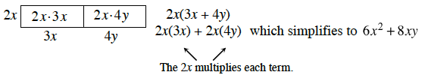

Name________________________Per______

**HOMEWORK ASSIGNMENT**

**3-101.**Write an equation for each situation below showing that the area as a product is equal to the area as a sum.

|  |  |
| --- | --- |
| a. http://textbooks.cpm.org/images/int1/chap03/3-101a.png | b. http://textbooks.cpm.org/images/int1/chap03/3-101b.png |
| c.   (2x + 5)(x + 6) | d.   (3 – 5y)(2 + y) |

**3-102.**Calculate each of the following products by drawing and labeling an area model or by using the Distributive Property.

|  |  |  |
| --- | --- | --- |
| 1. −4y(5x + 8y) | 1. 9x(−4 + 10y) | 1. (x2 − 2)(x2 + 3x + 5) |

**3-103.** On graph paper, graph ΔABCif A(–4, 3), B(–6, 1), and C(–8, 5).

* 1. Rotate ΔABC 90° clockwise (↻) about the origin to form ΔA′B′C′.  What are the coordinates of A′?
  2. Apply the function (x, y) → (x + 5, y + 1) to translate A′B′C′.  What are the new coordinates of point C″?  If you need help remembering this notation, refer to your work from problem 3-43.

**3-104.**On graph paper, graph the rectangle with vertices at (2, 1), (2, 5), (7, 1), and (7, 5).

1. What is the area of this rectangle?
2. Shirley was given the following points and asked to calculate the area, but her graph paper is not big enough.  Calculate the area of Shirley’s rectangle, and explain to her how she can determine the area without graphing the points.  
     
   Shirley’s points:

(352, 150), (352, 175), (456, 150), and (456, 175)

**3-105.**While David was solving the equation 100x + 300 = 500, he wondered if he could first change the equation to x + 3 = 5.  What do you think?

1. Solve both equations and verify that they have the same solution.
2. What could you do to the equation 100x + 300 = 500 to change it into x + 3 = 5?



**http://textbooks.cpm.org/images/int1/common/checkpoint.png3-106.** This problem is a checkpoint for operations with rational numbers.  It will be referred to as Checkpoint 3.

Compute each of the following problems with fractions.

|  |  |  |
| --- | --- | --- |
| 1. http://textbooks.cpm.org/images/int1/common/cca_ch3_less_3.3.3_3-110a.gif | 1. http://textbooks.cpm.org/images/int1/common/cca_ch3_less_3.3.3_3-110b.gif | 1. http://textbooks.cpm.org/images/int1/common/cca_ch3_less_3.3.3_3-110c.gif |
| 1. http://textbooks.cpm.org/images/int1/common/cca_ch3_less_3.3.3_3-110d.gif | 1. http://textbooks.cpm.org/images/int1/common/cca_ch3_less_3.3.3_3-110e.gif | 1. http://textbooks.cpm.org/images/int1/common/cca_ch3_less_3.3.3_3-110f.gif |

Check your answers by referring to the [Checkpoint 3 materials](http://textbooks.cpm.org/bookdb.php?title=cc4&name=reference.checkpoints&type=tcheckpoints#ui-tabs-4) located at the back of your book.

Ideally, at this point you are comfortable working with these types of problems and can solve them correctly.  If you feel that you need more confidence when solving these types of problems, then review the Checkpoint 3 materials and try the practice problems provided.  From this point on, you will be expected to do problems like these correctly and with confidence.

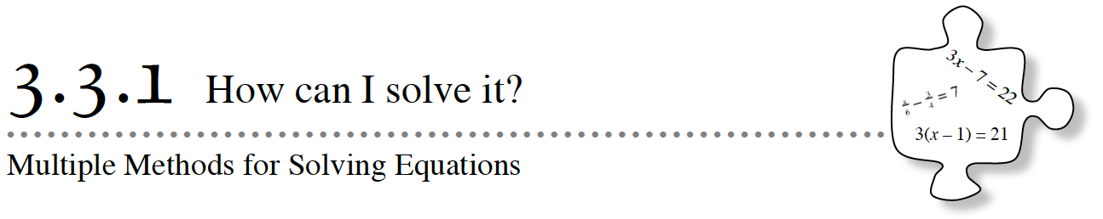

You have solved a variety of equations in this course.  In this lesson, by looking at equations in different ways, you will be able to solve even more complicated equations quickly and easily.  These new approaches will also allow you to solve new kinds of equations you have not studied before.  As you solve equations in today’s lesson, ask your teammates these questions:

How can we see it?

Is there another way?

**3-107.** Review what you learned in Lesson 3.2.3 by multiplying each expression below.  First decide whether you will multiply each expression using the Distributive Property or using an area model.

* 1. (6*x* – 11)(2*x* + 5) b. –2*x*2(15*x*2 – 3*y*)

**3-108.** DIFFERENT METHODS TO SOLVE AN EQUATION

To be prepared to solve unfamiliar equations, it helps to examine all of the solving tools you currently have.  Consider the equation:

4(*x* + 3) = 20

**Your Task:** With your team, solve 4(*x* + 3) = 20 for *x* in *at least* two different ways.  Explain how you solved for *x* in each case and be prepared to share your explanations with the class.

https://ebooks.cpm.org/images/shared/furtherguidance.png

**3-109.**SOLVING BY REWRITING

David wants to solve for *x* in the equation 4(*x* + 3) = 20.  He said, “*I can rewrite this equation by distributing the 4 on the left side.*”  After distributing, what should his new equation be?  Solve this equation using David’s method.

**3-110.** SOLVING BY UNDOING

Juan says, *“I see the whole thing a different way.”*  Here is how he explains his approach to solving 4(*x* + 3) = 20, which he calls “undoing”: “*Instead of distributing first, I want to eliminate the 4 from the left side by undoing the multiplication.*”

a. What can Juan do to both sides of the equation to remove the 4?  Why does this work?

b. Solve the equation using Juan’s method.  Did you get the same result as David?

c. Why is it appropriate for this method to be called “undoing”?

**3-111.** SOLVING BY LOOKING INSIDE

Kenya said, “*I solved David’s equation in a much quicker way!”*  She solved the equation 4(*x* + 3) = 20 with an approach that she calls “looking inside”.  Here is how she described her thinking: “*I think about everything inside the parentheses as a group.  After all, the parentheses group all that stuff together.  I think the contents of the parentheses must be 5.*”

a. Why must the expression inside the parentheses equal 5?

* 1. Write an equation that states that the contents of the parentheses must equal 5.  Then solve this equation.  Did you get the same result as with David’s method?

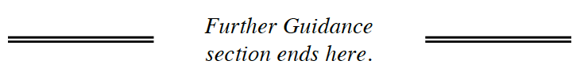

**3-112.**  THE THREE METHODS

Match the names of approaches on the left with the examples on the right.

|  |  |
| --- | --- |
| 1.  Rewriting  2.  Looking inside  3.  Undoing | a. “If 58x = 524, then 8x must equal 24.”  b. “Subtracting is the opposite of adding, so for the equation 3(x – 7) + 4 = 23, I can start by subtracting 4 from both sides.”  c. “This problem might be easier if I turned 4(2x – 3) = 31 into 8x – 12 = 31.” |

**3-113**. SOLVING BY REWRITING

Work with your team to solve each of these equations for *x*.  Use the Distributive Property or draw area models to help you rewrite the products.  Be sure to record your work for each step.  Check your solutions in the original equations.

a. 5*x*2 + 43 = (*x* – 1)(5*x* + 6) b. (*x* + 3)2 = *x*2 – 3(1 – *x*)

Name________________________Per______

**HOMEWORK ASSIGNMENT**

**3-114.**Now David wants to solve the equation 4000x − 8000 = 16,000.

* 1. What easier equation could he solve instead that would give him the same solution?  (In other words, what equivalent equation has easier numbers to work with?)
  2. Justify that your equation in part (a) is equivalent to 4000x − 8000 = 16,000 by showing that they have the same solution.
  3. David’s last equation to solve is 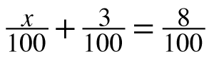.  Write and solve an equivalent equation with easier numbers that would give him the same answer.

**3-115.**Examine the rectangle at right.  If the perimeter is 120, which equation below represents this fact?  Once you have selected the appropriate equation, solve for x.

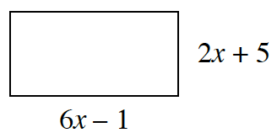 a. 2x + 5 + 6x – 1 = 120

b. 4(6x – 1) = 120

c. 2(6x – 1) + 2(2x + 5) = 120

* 1. (2x + 5)(6x – 1) = 120

**3-116.**Which of the following expressions are equivalent to 12x6?  (Note: More than one answer is possible!)

a. 3(2x3)2

b. (6x8)(2x–2)

c. (144x12)1/2

d. 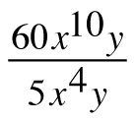

**3-117.**Multiply each of the following expressions.  Show all of your work (x + 3)(4x + 5)

a. (−2x2 − 4x)(3x + 4)

b. (3y − 8)(−x + y)

c. (y − 4)(3x + 5y − 2)

**3-118.** Copy the diagrams below on graph paper.  Then find the result when each indicated transformation is performed. .  Click in the lower right corner of the graph to view it in full-screen mode.

|  |  |  |  |
| --- | --- | --- | --- |
| a. | Reflect A across line l. https://ebooks.cpm.org/images/int1/ch3/int1.3-118a.png | b. | Rotate B 90° counterclockwise (↺) about point P. https://ebooks.cpm.org/images/int1/ch3/int1.3-118b.png |
| c. | Rotate C 180° about point Q. https://ebooks.cpm.org/images/int1/ch3/int1.3-118c.png | d. | Reflect D across line m. https://ebooks.cpm.org/images/int1/ch3/int1.3-118d.png |

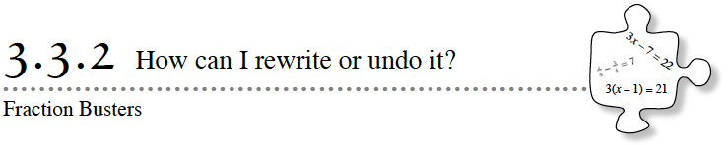

Today you will continue to solve complex equations using the three methods (rewriting, looking inside, and undoing).  You will focus specifically on equations with fractions.  As you solve these new problems, look for ways to connect today’s work with what you have learned previously.

**3-120.** MORE SOLVING BY REWRITING

Sean was trying to solve for x in the equation 0.4(x – 2) = 3.4 – 0.2x.  He said to his teammate, April, “Decimals!  I wish that we only had equations with whole numbers!” Suddenly, April blurted out, “Wait, Sean!  I think there is another way.  Can’t you first rewrite this equation so it has no decimals?  Then it will be faster and easier to solve!”

* 1. What is April talking about?  Explain what she means.  Then rewrite the equation so that it has no decimals.
  2. Now solve the new equation (the one without decimals).  Check your solution.

**3-121.** Rewriting 0.4(x – 2) = 3.4 – 0.2x in problem 3‑120 gave you at least one new, equivalent equation that was much easier to solve.

Two equations are **equivalent** if all of their solutions are the same.  There are several ways to change one equation into a different, equivalent equation.  Common ways include: adding or subtracting the same number from both sides, or multiplying or dividing both sides by the same (non-zero) number.

Rewrite an equivalent equation for each equation below.  Be sure your equivalent equation has no fractions or decimals.  Then solve the new equation and check your answer in the original equation.

|  |  |
| --- | --- |
| * 1. –7.5x2 + 4.8x – 0.3 = 2.5x2 + 10.02 – 10x2 | * 1. 2000(x – 24) + 5000 = 18,000 |

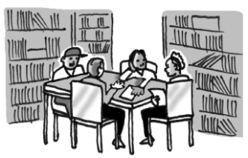**3-123.** FRACTION BUSTERS

http://textbooks.cpm.org/images/int1/chap03/3-123.gifExamine the equation:

* 1. Multiply each term by 6.  What happened?  Do any fractions remain?
  2. Since fractions remained, decide how you can continue to change your equivalent equation from part (a) so that no fractions remain.  Then solve the resulting equation.
  3. This method of eliminating fractions from an equation is called **Fraction Busters**.  Multiplying the equations by the denominator(s) is a way to undo the fractions.  
       
     Use one or more Fraction Busters to solve each equation.  Check your answer in the original equation.

i.    http://textbooks.cpm.org/images/int1/chap03/3-123i.gif          ii.    http://textbooks.cpm.org/images/int1/chap03/3-123b2.gif         iii.  http://textbooks.cpm.org/images/int1/chap03/3-123iii.gif

**3-124.** Examine the equations in part (c) of problem 3‑123.

1. Are there any “inputs” (any values of x) that are not allowed in these equations?
2. If a value of x is not allowed as an “input”, it is also not allowed as a solution.  Why not?

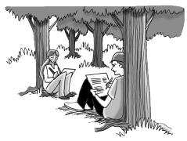**3-125.** Now you are going to reverse the process of solving equations by rewriting them.  Your teacher will give your team a simple equation that you need to “complicate”.

1. Change the equation to make it seem harder (although you know it is still equivalent to the easy equation).
2. Verify that your new equation is equivalent to the one assigned by your teacher.
3. Share your new equation with the class.



### ****Equivalent Equations and Fraction Busters****

Two equations are **equivalent** if all of their solutions are the same.  There are several ways to change one equation into a different, equivalent equation.  Common ways include:adding the same number to both sides, subtracting the same number from both sides, multiplying both sides by the same number, dividing both sides by the same (non-zero) number, and rewriting one or both sides of the equation.

For example, the equations below are all equivalent to 2x + 1 = 3:

|  |  |  |  |
| --- | --- | --- | --- |
| 20x + 10 = 30 | 2(x + 0.5) = 3 | http://textbooks.cpm.org/images/int1/chap03/3.3.2_MNa.gif | 0.002x + 0.001 = 0.003 |

Example: Solve   for x.

|  |  |
| --- | --- |
| This equation would be much easier to solve if it had no fractions.  Therefore, the first goal is to write an equivalent equation that has no fractions.  To eliminate the denominators, multiply both sides of the equation by one of the denominators, say, 3.  Then multiply by other denominators, if any remain.  In this example, multiply by 5.  The number used to eliminate a denominator is called a **Fraction Buster**.  Now the equation looks like many you have seen before, and it can be solved in the usual way.  Once you have found the solution, remember to check your answer. | http://textbooks.cpm.org/images/int1/chap03/int3.3.3.2mn.gif |

Name________________________Per______

**HOMEWORK ASSIGNMENT**

**3-126**. Solve the equations generated by your class in problem 3-125.  Be sure to check each solution and show your thinking.

**3-127.** Solve the equations below by first changing each equation to a simpler equivalent equation.  Check your solutions.

|  |  |
| --- | --- |
| 1. 3000x – 2000 = 10,000 | 1. http://textbooks.cpm.org/images/int1/chap03/3-127a.gif |
| 1. http://textbooks.cpm.org/images/int1/chap03/3-127c.gif | 1. http://textbooks.cpm.org/images/int1/chap03/3-127d.gif |

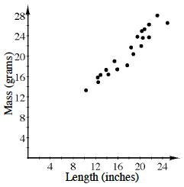**3-128.**The graph at right shows a comparison of the length of several gold chain necklaces (including the clasp) to the total mass.

1. Write an equation for the line of best fit.  What are the units for slope and y‑intercept for your equation?
2. Based on your equation, what would you expect to be the mass of a 26-inch chain?

**3-129.**Plot ΔABC on graph paper if A(6, 3), B(2, 1), and C(5, 7).

1. ΔABC is rotated about the origin 180° to become ΔA′B′C′.  Name the coordinates of A′, B′, and C′.
2. This time ΔABC is rotated 180° about point C to form ΔA″B″C″.  Name the coordinates of B″.
3. If ΔABC is rotated 90° clockwise (↻) about the origin to form ΔA′′′B′′′C′′′, what are the coordinates of point A′′′?

**3-130.**Jessica has three fewer candies than twice the number Dante has.

* 1. If Dante has d candies, write an expression to represent how many candies Jessica has.
  2. If Jessica has 19 candies, write and solve an equation to determine how many candies Dante has.

**3-131.**Determine the value of x that will make each equation below true.

|  |  |  |  |
| --- | --- | --- | --- |
| * 1. 23 = 2x | * 1. x3 = 53 | * 1. 34 = 32x | * 1. 27 = 2(2x+1) |

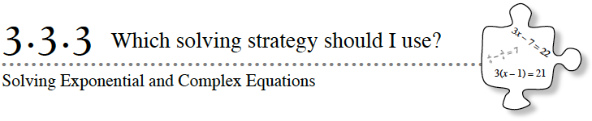

You will continue to solve complex equations using the three methods (rewriting, looking inside, and undoing).  Today you will focus specifically on looking inside.  Then you will use all three methods to solve some complex equations.

**3-132.** SOLVING BY LOOKING INSIDE

Derek and Donovan were trying to solve the equation 44 = 16x.  Derek had an idea.

“I know,” he said.  “Isn’t16equal to42 ?”

“Yeah, so what?” said Donovan.

“That means that we can rewrite the equation to look like44 = (42)x.  This is much easier to solve!”replied Derek.

“Yes,” said Donovan.  “That makes sense.  Isn’t there another way, too?  Since4is the same as22 and16is the same as24, can’t we rewrite it as(22)4 = (24)x?”

* 1. What were Derek and Donovan thinking?  Will both methods work?
  2. Use both methods to solve 44 = 16x.

**3-133.** Solve each equation below for x.

|  |  |  |  |
| --- | --- | --- | --- |
| 1. 2(x+3) = 22x | 1. 35 = 92x | 1. 3(2x+1) = 33 | 1. 870 = 2x |

******3-134.** ALL THREE METHODS

Find the Math Notes box for this lesson and read it with your team.

You have investigated three different approaches to solving one-variable equations: rewriting, looking inside, and undoing.  In this problem, you will use those approaches to solve new kinds of equations that you have not solved before.  As you solve each of these problems, be sure you have found all possible solutions.  Check your work and write down the name of the method(s) you used.

|  |  |  |  |
| --- | --- | --- | --- |
| 1. 11x2 +x2 = (4x + 8)(3x – 3) |  | 1. 6x+9 = 36x |  |
| 1. 1.2m – 0.2 = 3.8 + m |  | 1. (x + 12)2 = 9 |  |

**3-135.** Are there solutions to the equations in the previous problem that are not allowed?



**Methods for Solving One-Variable Equations**

Here are three different methods you can use to solve one-variable equations:

|  |  |
| --- | --- |
| **Rewriting:** Use algebraic techniques to rewrite the equation.  This will often involve using the Distributive Property to get rid of parentheses.  Then solve the equation using solution methods you know. | 5(x – 1) = 15 5x – 5 = 15 5x = 20 x = 4 |
| **Looking inside:** Choose a part of the equation that includes the variable and is grouped together by parentheses or another symbol.  (Make sure it includes all occurrences of the variable!)  Ask yourself, "What must this part of the equation equal to make the equation true?”  Use that information to write and solve a new, simpler equation. | 5(x – 1) = 15 5(   3   ) = 15 x – 1 = 3   x = 4 |
| **Undoing:** Start by undoing the last operation that was done to the variable.  This will give you a simpler equation, which you can solve either by undoing again or with some other approach.  Fraction Busters are a method of undoing.  With a fraction buster you are multiplying to undo the division that the denominator represents.  For more about Fraction Busters, see the Math Notes box in the previous lesson. | 5(x – 1) = 15  http://textbooks.cpm.org/images/int1/chap03/3.3.3_MN.gif x – 1 = 3    +1 = +1  x = 4 |

Name________________________Per______

**HOMEWORK ASSIGNMENT**

**3-136.**Solve each equation by first rewriting the expressions in each part with the same base.  Refer to problem 3‑132 if you need a reminder.

|  |  |  |
| --- | --- | --- |
| * 1. 8x = 26 | * 1. 92 = 32x+1 | * 1. http://textbooks.cpm.org/images/int1/common/cca_10-53c.gif |

**3-137.**Every ton of recycled office paper saves about 17 trees.  A textbook publisher recycled 8000 pounds of paper.  How many trees did this save?  Hint: There are 2000 pounds in 1 ton.

**3-138.** On graph paper, draw the triangle with vertices (–3, 3), (4, 3), and (2, –2).

1. What is the area of this triangle?
2. Translate the triangle 3 units to the left and 2 units up.  What are the new coordinates of the vertices?

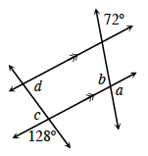**3-139.** Examine the diagram at right.  Then use the information provided in the diagram to find the measures of angles a, b, c, and d.  For each angle, name the relationship that helped justify your conclusion.  For example, did you use vertical angles?  If not, what type of angle did you use?

**3-140.**Find the result when each indicated transformation is performed.

|  |  |
| --- | --- |
| a.   Reflect Figure A across line l.                      http://textbooks.cpm.org/images/int1/common/CCG_1_97a.png | b.   Rotate Figure B 90° clockwise (↻) about point P.      http://textbooks.cpm.org/images/int1/common/CCG_1_97b.png |
| c.   Reflect Figure C across line m.      http://textbooks.cpm.org/images/int1/common/CCG_1_97c.png | c.   Rotate Figure D 180° about point Q.     http://textbooks.cpm.org/images/int1/common/CCG_1_97d.png |

**3-141.**Solve each of the following equations.  Explain or justify each of your steps.  Be sure to show your thinking carefully and check your answers.

|  |  |
| --- | --- |
| * 1. 2(3x – 4) = 22 | * 1. 6(2x – 5) = –(x + 4) |
| * 1. 2 – (y + 2) = 3y | * 1. 3 + 4(x + 1) = 159 |

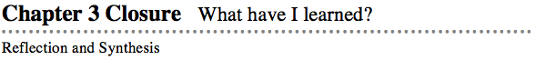

The activities below offer you a chance to reflect on what you have learned during this chapter.  As you work, look for concepts that you feel very comfortable with, ideas that you would like to learn more about, and topics that you need more help with.  Look for connections between ideas as well as connections to material you learned previously.

### 1. TEAM BRAINSTORM

What have you studied in this chapter?  What ideas were important in what you learned?  With your team, brainstorm a list.  Add as much detail as you can.  To help get you started, Learning Log entries and Math Notes boxes are listed below.

What topics, ideas, and words that you learned before this chapter are connected to the new ideas in this chapter?  Again, write down as many details as you can.

Next consider the Standards for Mathematical Practice that follow Activity ƒ3: Portfolio.  What Mathematical Practices did you use in this chapter?  When did you use them?  Give specific examples.

How long can you make your list?  Challenge yourselves.  Be prepared to share your team’s ideas with the class.

**Learning Log Entries**

[Lesson 3.1.1](http://textbooks.cpm.org/bookdb.php?title=cc4&name=3.1.1&type=lesson#3-18) – Reflections

[Lesson 3.1.3](http://textbooks.cpm.org/bookdb.php?title=cc4&name=3.1.3&type=lesson#3-28) – Slopes of Perpendicular Lines

[Lesson 3.1.4](http://textbooks.cpm.org/bookdb.php?title=cc4&name=3.1.4&type=lesson#3-68) – Isosceles Triangles

[Lesson 3.1.6](http://textbooks.cpm.org/bookdb.php?title=cc4&name=3.1.6&type=lesson#3-81) – Symmetry

[Lesson 3.2.1](http://textbooks.cpm.org/bookdb.php?title=cc4&name=3.2.1&type=lesson#3-105) – Area of Polygons

[Lesson 3.2.2](http://textbooks.cpm.org/bookdb.php?title=cc4&name=3.2.2&type=lesson#3-115) – Area Model for Multiplying Polynomials

**Math Notes**

[Lesson 3.1.2](http://textbooks.cpm.org/bookdb.php?title=cc4&name=3.1.2&type=lesson#notes) – Polygons

[Lesson 3.1.3](http://textbooks.cpm.org/bookdb.php?title=cc4&name=3.1.3&type=lesson#notes) – Naming Parts of Shapes

[Lesson 3.1.4](http://textbooks.cpm.org/bookdb.php?title=cc4&name=3.1.4&type=lesson#notes) – Formal Definitions of Rigid Transformations

[Lesson 3.1.6](http://textbooks.cpm.org/bookdb.php?title=cc4&name=3.1.6&type=lesson#notes) – Parallel and Perpendicular Lines

[Lesson 3.2.1](http://textbooks.cpm.org/bookdb.php?title=cc4&name=3.2.1&type=lesson#notes) – Vocabulary for Expressions

[Lesson 3.2.2](http://textbooks.cpm.org/bookdb.php?title=cc4&name=3.2.2&type=lesson#notes) – Using Area Models to Multiply Polynomials

[Lesson 3.2.3](http://textbooks.cpm.org/bookdb.php?title=cc4&name=3.2.3&type=lesson#notes) – Properties of Real Numbers

[Lesson 3.3.1](http://textbooks.cpm.org/bookdb.php?title=cc4&name=3.3.1&type=lesson#notes) – More Properties of Real Numbers

[Lesson 3.3.2](http://textbooks.cpm.org/bookdb.php?title=cc4&name=3.3.2&type=lesson#notes) – Equivalent Equations and Fraction Busters

[Lesson 3.3.3](http://textbooks.cpm.org/bookdb.php?title=cc4&name=3.3.3&type=lesson#notes) – Methods for Solving One-Variable Equations

### 2. MAKING CONNECTIONS

Below is a list of the vocabulary words used in this chapter.  Make sure that you are familiar with all of these terms and know what they mean.  Refer to the glossary or index for any words that you do not yet understand.

|  |  |  |
| --- | --- | --- |
| **area model** | **base (of an exponent)** | **binomial** |
| **dimensions** | **Distributive Property** | **equation** |
| **evaluate** | **exponent** | **expression** |
| **line of symmetry** | **parallel** | **perpendicular** |
| **polygon** | **polynomial** | **product** |
| **reflection** | **rigid transformations** | **rotation** |
| **slope** | **solution** | **solve** |
| **sum** | **term** | **translation** |
| **trinomial** |  |  |

Make a concept map showing all of the connections you can find among the key words and ideas listed above.  To show a connection between two words, draw a line between them and explain the connection, as shown in the model below.  A word can be connected to any other word as long as you can justify the connection.  For each key word or idea, provide an example or sketch that shows the idea.

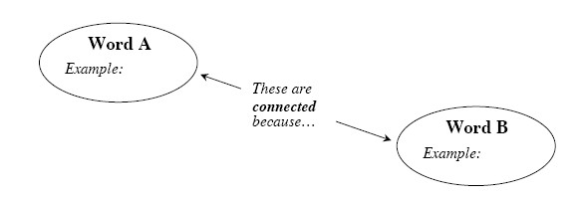

Your teacher may provide you with vocabulary cards to help you get started.  If you use the cards to plan your concept map, be sure either to re-draw your concept map on your paper or to glue the vocabulary cards to a poster with all of the connections explained for others to see and understand.

While you are making your map, your team may think of related words or ideas that are not listed here.  Be sure to include these ideas on your concept map.

### http://textbooks.cpm.org/images/int1/chap03/cca_ch1_less_1.2.3_clos_3.png3. PORTFOLIO: EVIDENCE OF MATHEMATICAL PROFICIENCY

Solve the equations in parts (a), (b), (c), and (f) of problem 3‑134.  If you have already solved them, review your work and revise it as needed.  Record your work neatly and justify each step as evidence of the mathematics you are now able to do.  Carefully show how you check your solutions.

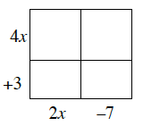Then show how you applied your understanding of area to use an area model to multiply expressions.  For example, the area of the rectangle at right represents the product (4x + 3)(2x – 7).  Copy and complete the area model and write its area as a sum.

Another student in your class thinks that (x + y)2 =x2+ y2.  Use an area model to help them understand why (x+ y)2 =  x2 + 2xy + y2.

 Extend this idea: What if one of the expressions being multiplied has three terms?  How can an area model be used to multiply two expressions such as  (x2 − 3)(3y + 2x + 1)?

 Alternatively, make this portfolio entry:

In the Shape Factory, you investigated what shapes you could create with four basic triangles.  But what if you had started with quadrilaterals instead?  Showcase what you know about rotating and reflecting by finding all shapes that could be made by rotating or reflecting the four quadrilaterals below.  Remember that once rotated or reflected, the image should share a side with the original shape.  Use tracing paper to help generate the new shapes.  If you know the name of the new figure, state it.

### http://textbooks.cpm.org/images/int1/chap03/shapes.png

Now write three “What if …?” questions that would extend your investigation above.

Choose one of your questions to investigate.  Decide how you will investigate your question.  For example, will you need tracing paper?  Do you need to make a table and record information?

After you have answered your question, write the results of your investigation clearly so that someone else can understand what question you selected, how you investigated your question, and any conclusions you made.

Your teacher may give you the Chapter 3 Closure Resource Page: Transformation Graphic Organizer to work on (or you can download these three pages from www.cpm.org).  A Graphic Organizer is a tool you can use to organize your thoughts, showcase your knowledge, and communicate your ideas clearly.

Now consider the Standards for Mathematical Practice that follow.  What Mathematical Practices did you use in this chapter?  When did you use them?  Give specific examples.

**BECOMING MATHEMATICALLY PROFICIENT**

**The Common Core State Standards For Mathematical Practice**

This book focuses on helping you use some very specific Mathematical Practices.  The Mathematical Practices describe ways in which mathematically proficient students should increasingly engage with mathematics throughout the year.

**Make sense of problems and persevere in solving them:**

**Making sense of problems and persevering in solving** **them** means that you can solve realistic problems that are full of different kinds of mathematics.  These types of problems are not routine, simple, or typical.  Instead, they combine lots of math ideas and real-life situations.  You have to stick with challenging problems, trying different strategies and using all of the resources available to you.

**Reason abstractly and quantitatively:**

Throughout this course, you are introduced to new math ideas through real-life situations.  Seeing math ideas within a context helps you make sense of things.  Once you learn about a math idea in a practical way, you are able to think about the concept more generally, or “**reason abstractly**”.  At that point, you are often able to use numbers and math symbols to represent the math idea.  This is called “**reasoning quantitatively**”.

**Construct viable arguments and critique the reasoning of others:**

An important practice of mathematics is **constructing viable arguments and critiquing the reasoning of others**.  In this course, you regularly share information, opinions, and expertise with your study team.  You and your study teams use higher-order critical thinking skills any time you provide clarification, build on each other’s ideas, analyze a problem and come to consensus, and productively criticize each other’s ideas.

**Model with mathematics:**

When you **model with mathematics** you are taking a complex situation and using mathematics to represent it, often by making assumptions and approximations to make the situation simpler.  Modeling allows you to analyze and describe the situation and make predictions.  For example, you model when you write an equation, or make graphs or tables or diagrams, to describe a situation.  In situations involving the variability of data, you learn that although a model may not be perfect, it can still be very useful for describing data and making predictions.  In the process of analyzing, you go back and improve your model by revising your assumptions and approximations.

**Use appropriate tools strategically:**

Throughout this course, you have to **use appropriate tools** **strategically**.  Examples of tools include rulers, scissors, diagrams, graph paper, blocks, tiles, calculators, computer software, and websites.  Sometimes, different teams decide to use different tools to solve the same problem.  Frequently, the lesson concludes with a discussion about which tools are most efficient and productive to solve a given problem.

**Attend to precision:**

To **attend to precision** means that when solving problems, you need to pay close attention to the details.  For example, you need to be aware of the units, or how many digits your answer requires, or how to choose a scale and label your graph.  You may need to convert the units to be consistent.  Other times, you need to go back and check whether a numerical solution makes sense in the context of the problem.

You need to **attend to precision** when you communicate your ideas to others.  Using the appropriate vocabulary and mathematical language can help to make your ideas and reasoning more understandable to others.  This is an important academic and mathematical skill.

**Look for and make use of structure:**

**Looking for and making use of structure** is an important part of this course.  By being involved in analyzing the structure and in the actual development of math concepts, you gain a deeper, more conceptual understanding than just being told what the structure is and how to do problems.  You often use this practice to bring closure to an investigation.

There are many concepts that you learn by looking at the underlying structure of a math idea and thinking about how it connects to other ideas you have already learned.  For example, you use area models to understand the structure of multiplying binomials and connecting that structure to the Distributive Property.  You understand the underlying structure of y = mx + b by analyzing the growth and starting point of linear functions.

**Look for and express regularity in repeated reasoning:**

To**look for and express regularity in repeated reasoning** means that when you are investigating a new mathematical concept, you notice if calculations are repeated in a pattern.  Then you look for a way to generalize the method to other situations, or you look for shortcuts.  For example, when working with exponents that are negative or zero, you repeat exponent patterns that you already know to construct a method for rewriting these types of exponent problems.

### 4. WHAT HAVE I LEARNED?

Most of the problems in this section represent typical problems found in this chapter.  They serve as a gauge for you.  You can use them to determine which types of problems you can do well and which types of problems require further study and practice.  Even if your teacher does not assign this section, it is a good idea to try these problems and find out for yourself what you know and what you still need to work on.

Solve each problem as completely as you can.  The table at the end of the closure section has answers to these problems.  It also tells you where you can find additional help and practice with problems like these.

**CL 3-142.**  Rewrite each of these products as a sum.

|  |  |
| --- | --- |
| 1. 6x(2x + y – 5) | 1. (2x2 – 11) (x2 + 4) |
| 1. (7x)(2xy) | 1. (x – 2)(3 + y) |

**CL 3-143.**Plot ΔMJN on graph paper with vertices M(16, –8), J(16, 2), and N(4, 0).  What is the area of ΔMJN?

**CL 3-144.**Perform the indicated transformations. Label each image with prime notation (A → A').

* 1. Rotate EFGHI 90° clockwise ↻  about point Z

### http://textbooks.cpm.org/images/int1/chap03/3-144a.png

|  |  |
| --- | --- |
| b. Reflect JKLMN over line t http://textbooks.cpm.org/images/int1/chap03/3-144b.png | c. Translate ABCD down 5 units and right 3 units http://textbooks.cpm.org/images/int1/chap03/3-144c.png |

**CL 3-145.**Write each expression below as an equivalent expression without negative exponents.

|  |  |  |  |
| --- | --- | --- | --- |
| * 1. 3–2 | * 1. m–4 |  |  |

**CL 3-146.**Graph the segment that connects the points A(–4, 8) and B(6, 3).

* 1. What is the slope of  AB?
  2. Write an equation for the line that connects points A and B.
  3. Write an equation for a line that is parallel to AB.
  4. Write an equation for a line that is perpendicular to AB.

**CL 3-147.**Write the equation of each line from the given representation.

|  |  |
| --- | --- |
| http://textbooks.cpm.org/images/int1/chap03/3-150a.png | 1. A line with a slope of  – and passes through the point (–3, 4). |
| http://textbooks.cpm.org/images/int1/chap03/3-150c.png |

**CL 3-148.**Perform the indicated operations.

|  |  |
| --- | --- |
|  |  |
|  |  |

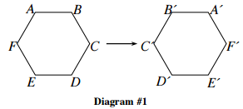**CL 3-149.**  Charlotte was transforming the hexagon ABCDEF.

* 1. What single transformation did she perform in Diagram #1?
  2. 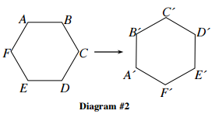What single transformation did she perform in Diagram #2?
  3. What transformation did she not do?  Write directions for this type of transformation for hexagon ABCDEF and perform it.

**CL 3-150.**  Check your answers using the table at the end of the closure section.  Which problems do you feel confident about?  Which problems made you think?  Use the table to make a list of topics you need help with and a list of topics you need to practice more.

### Answers and Support for Closure Activity #4 What Have I Learned?

Note: MN = Math Note, LL = Learning Log

|  |  |  |  |
| --- | --- | --- | --- |
| **Problem** | **Solution** | **Need Help?** | **More Practice** |
| CL 3-142. | a.  12x2 + 6xy – 30x  b.  2x4 – 3x2 – 44  c.  14*x*2*y*  d.  3x + xy –6 – 2y | [Lessons 3.2.2](http://textbooks.cpm.org/bookdb.php?title=cc4&name=3.2.2&type=lesson) and [3.2.3](http://textbooks.cpm.org/bookdb.php?title=cc4&name=3.2.3&type=lesson)  [MN: 3.2.2](http://textbooks.cpm.org/bookdb.php?title=cc4&name=3.2.2&type=lesson#notes)  [LL: 3.2.2](http://textbooks.cpm.org/bookdb.php?title=cc4&name=3.2.2&type=lesson#3-89) | Problems [3‑101](http://textbooks.cpm.org/bookdb.php?title=cc4&name=3.2.3&type=lesson#3-101), [3‑102](http://textbooks.cpm.org/bookdb.php?title=cc4&name=3.2.3&type=lesson#3-102), and [3-117](http://textbooks.cpm.org/bookdb.php?title=cc4&name=3.3.1&type=lesson#3-117) |
| CL 3-143. | 60 square units | Review from a previous course.    area Δ = ½bh | Problems [3-55](http://textbooks.cpm.org/bookdb.php?title=cc4&name=3.1.5&type=lesson#3-55),  [3‑81](http://textbooks.cpm.org/bookdb.php?title=cc4&name=3.2.1&type=lesson#3-81), [3‑94](http://textbooks.cpm.org/bookdb.php?title=cc4&name=3.2.2&type=lesson#3-94), [3‑104](http://textbooks.cpm.org/bookdb.php?title=cc4&name=3.2.3&type=lesson#3-104), and [3-138](http://textbooks.cpm.org/bookdb.php?title=cc4&name=3.3.3&type=lesson#3-138) |
| CL 3-144. | a.     http://textbooks.cpm.org/images/int1/chap03/3-148ana.png  b.     http://textbooks.cpm.org/images/int1/chap03/3-148anb.png  c.    http://textbooks.cpm.org/images/int1/chap03/3-148anc.png | [Lessons 3.1.2](http://textbooks.cpm.org/bookdb.php?title=cc4&name=3.1.2&type=lesson) and [3.1.4](http://textbooks.cpm.org/bookdb.php?title=cc4&name=3.1.4&type=lesson)  [MN: 3.1.4](http://textbooks.cpm.org/bookdb.php?title=cc4&name=3.1.4&type=lesson#notes)  [LL: 3.1.1](http://textbooks.cpm.org/bookdb.php?title=cc4&name=3.1.1&type=lesson#3-7) | Problems [3‑19](http://textbooks.cpm.org/bookdb.php?title=cc4&name=3.1.2&type=lesson#3-19), [3‑37](http://textbooks.cpm.org/bookdb.php?title=cc4&name=3.1.3&type=lesson#3-37), [3‑45](http://textbooks.cpm.org/bookdb.php?title=cc4&name=3.1.4&type=lesson#3-45), [3‑67](http://textbooks.cpm.org/bookdb.php?title=cc4&name=3.1.6&type=lesson#3-67), [3‑81](http://textbooks.cpm.org/bookdb.php?title=cc4&name=3.2.1&type=lesson#3-81), [3‑94](http://textbooks.cpm.org/bookdb.php?title=cc4&name=3.2.2&type=lesson#3-94), [3‑118](http://textbooks.cpm.org/bookdb.php?title=cc4&name=3.3.1&type=lesson#3-118), and [3‑140](http://textbooks.cpm.org/bookdb.php?title=cc4&name=3.3.3&type=lesson#3-140) |

|  |  |  |  |
| --- | --- | --- | --- |
| **Problem** | **Solution** | **Need Help?** | **More Practice** |
| CL 3-145. | a.  http://textbooks.cpm.org/images/int1/common/1-9.gif  b.  http://textbooks.cpm.org/images/int1/common/1-m4.gif  c.  8  d.  http://textbooks.cpm.org/images/int1/common/5x-3.gif | [Section 1.3](http://textbooks.cpm.org/bookdb.php?title=cc4&name=1.3.1&type=lesson)  [MN: 1.3.1](http://textbooks.cpm.org/bookdb.php?title=cc4&name=1.3.1&type=lesson#notes) and [1.3.2](http://textbooks.cpm.org/bookdb.php?title=cc4&name=1.3.2&type=lesson#notes)  [LL: 1.3.2](http://textbooks.cpm.org/bookdb.php?title=cc4&name=1.3.2&type=lesson#1-80) | Problems [CL 2‑116](http://textbooks.cpm.org/bookdb.php?title=cc4&name=2.closure&type=lesson#CL2-116), [3-24](http://textbooks.cpm.org/bookdb.php?title=cc4&name=3.1.2&type=lesson#3-24), and [3-93](http://textbooks.cpm.org/bookdb.php?title=cc4&name=3.2.2&type=lesson#3-93) |
| CL 3-146. | a.  -½  b.  y = -½x + 6  c.  Answers vary, but should be in the form  *y* = -½x + b.  d.  Answers vary, but should have a slope of 2 and be written in the form y = 2x + b. | [Chapter 2](http://textbooks.cpm.org/bookdb.php?title=cc4&name=2.opening&type=lesson) and [Lesson 3.1.3](http://bookdb.php/?title=cc4&name=3.1.3&type=lesson)  [MN: 2.1.4](http://textbooks.cpm.org/bookdb.php?title=cc4&name=2.1.4&type=lesson#notes), [2.3.2](http://textbooks.cpm.org/bookdb.php?title=cc4&name=2.3.2&type=lesson#notes), and [3.1.6](http://textbooks.cpm.org/bookdb.php?title=cc4&name=3.1.6&type=lesson#notes)  [LL: 2.1.4](http://textbooks.cpm.org/bookdb.php?title=cc4&name=2.1.4&type=lesson#2-39), [2.3.1](http://textbooks.cpm.org/bookdb.php?title=cc4&name=2.3.1&type=lesson#2-93), [2.3.2](http://textbooks.cpm.org/bookdb.php?title=cc4&name=2.3.2&type=lesson#2-101), and [3.1.3](http://textbooks.cpm.org/bookdb.php?title=cc4&name=3.1.3&type=lesson#3-31) | Problems [CL 2‑113](http://textbooks.cpm.org/bookdb.php?title=cc4&name=2.closure&type=lesson#CL2-113), [CL 2‑118](http://textbooks.cpm.org/bookdb.php?title=cc4&name=2.closure&type=lesson#CL2-118), [3‑32](http://textbooks.cpm.org/bookdb.php?title=cc4&name=3.1.3&type=lesson#3-32), [3‑56](http://textbooks.cpm.org/bookdb.php?title=cc4&name=3.1.5&type=lesson#3-56), [3‑69](http://textbooks.cpm.org/bookdb.php?title=cc4&name=3.1.6&type=lesson#3-69), and[3‑95](http://textbooks.cpm.org/bookdb.php?title=cc4&name=3.2.2&type=lesson#3-95) |
| CL 3-147 | a.  y = –2x + 3  b.  y = –x + 2  c.  y = 2x −  3 | [Chapter 2](http://textbooks.cpm.org/bookdb.php?title=cc4&name=2.opening&type=lesson)  [MN: 2.1.4](http://textbooks.cpm.org/bookdb.php?title=cc4&name=2.1.4&type=lesson#notes), [2.2.2](http://textbooks.cpm.org/bookdb.php?title=cc4&name=2.2.2&type=lesson#notes), and [2.3.2](http://textbooks.cpm.org/bookdb.php?title=cc4&name=2.3.2&type=lesson#notes)  [LL: 2.1.4](http://textbooks.cpm.org/bookdb.php?title=cc4&name=2.1.4&type=lesson#2-39), [2.3.1](http://textbooks.cpm.org/bookdb.php?title=cc4&name=2.3.1&type=lesson#2-93), and [2.3.2](http://textbooks.cpm.org/bookdb.php?title=cc4&name=2.3.2&type=lesson#2-101) | Problems [CL 2‑113](http://textbooks.cpm.org/bookdb.php?title=cc4&name=2.closure&type=lesson#CL2-113), [3‑13](http://textbooks.cpm.org/bookdb.php?title=cc4&name=3.1.1&type=lesson#3-13), [3‑20](http://textbooks.cpm.org/bookdb.php?title=cc4&name=3.1.2&type=lesson#3-20), [3‑34](http://textbooks.cpm.org/bookdb.php?title=cc4&name=3.1.3&type=lesson#3-34), [3-48](http://textbooks.cpm.org/bookdb.php?title=cc4&name=3.1.4&type=lesson#3-48), [3‑69](http://bookdb.php/?title=cc4&name=3.1.6&type=lesson#3-69),[3‑70](http://textbooks.cpm.org/bookdb.php?title=cc4&name=3.1.6&type=lesson#3-70), [3‑79](http://bookdb.php/?title=cc4&name=3.2.1&type=lesson#3-79) and [3‑117](http://textbooks.cpm.org/bookdb.php?title=cc4&name=3.3.1&type=lesson#3-117) |
| CL 3-148. | a.  http://textbooks.cpm.org/images/int1/chap03/cca_ch3_le.3.3_CL3-120a_ans.gif b.  http://textbooks.cpm.org/images/int1/chap03/cca_ch3_le.3.3_CL3-120b_ans.gif  c.  http://textbooks.cpm.org/images/int1/chap03/cca_ch3_le.3.3_CL3-120c_ans.gif d.  http://textbooks.cpm.org/images/int1/chap03/cca_ch3_le.3.3_CL3-120d_ans.gif | [Checkpoint 3](http://textbooks.cpm.org/bookdb.php?title=cc4&name=reference.checkpoints&type=tcheckpoints#ui-tabs-4) | Problems [3‑11](http://textbooks.cpm.org/bookdb.php?title=cc4&name=3.1.1&type=lesson#3-11), [3‑23](http://textbooks.cpm.org/bookdb.php?title=cc4&name=3.1.2&type=lesson#3-23), [3‑36](http://textbooks.cpm.org/bookdb.php?title=cc4&name=3.1.3&type=lesson#3-36) and [3‑106](http://textbooks.cpm.org/bookdb.php?title=cc4&name=3.2.3&type=lesson#3-106) |
| CL 3-149. | a.  Reflection (flip) across the vertical line of symmetry  b.  Rotation (turn counterclockwise 90º)  c.  Translation (slide).  Answers will vary, an example is provided.     http://textbooks.cpm.org/images/int1/chap03/3-152an.png | [Lessons 3.1.2](http://textbooks.cpm.org/bookdb.php?title=cc4&name=3.1.2&type=lesson) and [3.1.4](http://textbooks.cpm.org/bookdb.php?title=cc4&name=3.1.4&type=lesson)  [MN: 3.1.4](http://textbooks.cpm.org/bookdb.php?title=cc4&name=3.1.4&type=lesson#notes)  [LL: 3.1.1](http://textbooks.cpm.org/bookdb.php?title=cc4&name=3.1.1&type=lesson#3-7) | Problems [3‑19](http://textbooks.cpm.org/bookdb.php?title=cc4&name=3.1.2&type=lesson#3-19), [3‑37](http://textbooks.cpm.org/bookdb.php?title=cc4&name=3.1.3&type=lesson#3-37), [3‑60](http://bookdb.php/?title=cc4&name=3.1.5&type=lesson#3-60), [3‑118](http://textbooks.cpm.org/bookdb.php?title=cc4&name=3.3.1&type=lesson#3-118), and [3‑140](http://textbooks.cpm.org/bookdb.php?title=cc4&name=3.3.3&type=lesson#3-140) |

***Review Preview Answers***

Leaping Lizards!

Ready: 1. 5 2. 13 3.  4. 1 5. 1 6. 3

Set: 7a. (1, -4) b. (4, -1) c. (2, -4)

8a. (1, -5) b. (5, -1) c. (2, 4)

3.1.2

**3-19.**

* 1. Reflection
  2. Translation, or two reflections over parallel lines
  3. Rotation, or rotation and translation
  4. Rotation, or rotation and translation
  5. Reflection
  6. Reflection and translation, or rotation and translation, or reflection, rotation, and translation

**3-20.**

* 1. *m* = 3
  2. (0, –2)
  3. *y* = 3*x* – 2

**3-21.**

* 1. *x* = 8º, right angle is 90°
  2. *x* = 20º, straight angle is 180°

**3-22.**a. domain: all real numbers,  range: *y* ≤ 1;

* 1. *x* ≥ –3,  range: *y* ≥ –2;
  2. domain: all real numbers,  range: *y* ≤ 0;
  3. domain: all real numbers,  range: *y* ≥ –1

**3-23.** a.–15 b. –11 c. 17 d. –10

**3-24.** a. **http://textbooks.cpm.org/images/answers/cc4/chap03/3-24a.gif** b. **http://textbooks.cpm.org/images/answers/cc4/chap03/3-24b.gif** c. **http://textbooks.cpm.org/images/answers/cc4/chap03/3-24c.gif**

3.1.3

**3-30.**  Lines A and E are perpendicular, so the slope of line E is .

**3-32.**The slopes are and  .  Since the slopes are not opposite reciprocals, the lines must not be perpendicular.

**3-33.** a. 6*x* + 6

b. 6*x* + 6 = 78, so *x* = 12 and the rectangle is 15 cm by 24 cm.

c. (2 · 12)(12 + 3) = 360

**3-34.***y* = –2*x* + 13

**3-35.**= 800;  The flying fox bat is about 800 times heavier than the bumblebee bat.

**3-36.** a. b.  c.  d. 

**3-37.** a. It looks the same as the original.

b. Solution should be any value of 45*k* where *k* is an integer.

c. circle

3.1.4

**3-45** A'(4, 3), B'(6, –1), C'(–2, –5), D'(–4, –1)

**3-46** Rigid transformations preserve length and ΔGHJ  and ΔABC do not have the same side lengths.  They do however appear to have the same angle measures

**3-47.**19 + 7*x* – 4 + 10*x* + 3 = 52, so *x* = 2.  Side lengths are 19, 10, and 23.

**3-48.** a. 

b. 

c. 

**3-49.** a. 1 b. 5 c. √ 10  ≈ 3.16 d. undefined

**3-50.** a. *x* = 6 b. *x* = 1  c. *x* = –8  d. *x* = 16

Symmetries of Quads.

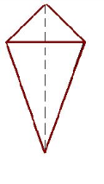Set: 1. quadrilateral whose four sides can be grouped into two pairs of equal-length sides that are adjacent to each other.

2.

3. 360°

4. Sometimes

5. No

6. Parallelogram, rectangle 7. No

Go: 8a. y=4x-7 b. y= ¼x-7

9a. y=-2x+8 b. y= ½x+8

10a. y= -1/3x-9 b. y=3x-9

3.1.5

**3-55.** a. (9, 3); 10 square units

  b. (3, –3); 20 square units

c. (–2, –7)

d. (–52, 1483); 208,680 sq units

**3-56.** (a) and (b) are perpendicular, while (b) and (c) are parallel. 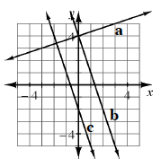

**3-57.**a. Multiply by 6.

b. *x*= 15

c. *x* = 4

**3-58.** a. 3.7 × 108

b. 7.6 × 103

**3-59.**19.9 minutes

3.1.6

**3-67.**(3, –1), (7, –1)

**3-68.**

* 1. One possibility: 4(5*x* + 2) = 48
  2. *x* = 2
  3. (12)(12) = 144 square units

**3-69.**

a. 

b. The resulting line coincides with the original line;  

c. The image is parallel; 

d. They are parallel, because they all have a slope of .

e. 

**3-70.***y* = 3*x* – 1

**3-71.**Moderate negative linear association with no outliers.  The data appears to be in two clusters, probably indicating two classes of vehicles.

**3-72.** a. 12

b. 59

c. 7

d. 9

e. –13

f. –5

3.2.1

**3-77.**

* 1. 4*x* + 2*y* + 6
  2. 2*x* + 4
  3. 4*y* + 2*x* + 6
  4. 2*y* + 2*x* + 6

**3-78.**

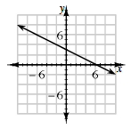

**3-79.**  *f*(*x*) = ½*x* + 1

**3-80.**Problem 3-78 does, possible response: the *b* in its equation is 3 versus 1 in problem 3-79.

**3-81.**

1. (–5, –1)
2. (3, 5)
3. (0, 11);  The rectangle is moved parallel to the given line.
4. 12 square units

**3-82.**

1. Calculate the output for the input that is 4 less than *c*.
2. Calculate the output for the input that is half of *b*.
3. 12 more than the output when the input is *d*.

3.2.2

**3-90.**(*x* + 8)(*x* + 3) = *x*2 + 11*x +*24

**3-91.**

* 1. *x* = – 4.75
  2. *x* = –94
  3. *x* ≈ 1.14
  4. *a* = 22

**3-92.**

* 1. 15*x*3*y*

1. *y*
2. *x*5
3. 

**3-93.** 1500 – 35*x* = 915;  *x* = 17 weeks

**3-94.**

* 1. Using side ***AB*** as the base, *Area* Δ = ½*bh* = ½(5)(6) = 15 square units

1. *A*'(–8, 4), *B*'(–8, –1), and *C*'(–2, 0)
2. *B*"(–4, –1)
3. *A'''*(–4, –8)

**3-95.** a. It should be a triangle with a horizontal base of length 4 and a vertical base of length 3.

b. 

c. Any equation of the form .

3.2.3

**3-101.**

* 1. (12*x*+ 1)(*x* − 5) = 12*x*2 − 59*x*− 5
  2. (2*m*2 − 4*m*− 1)(3*m +*5) = 6*m*3 − 2*m2  −*23*m*− 5
  3. (2*x +*5)(*x +*6) = 2*x*2*+*17*x +*30
  4. (3 − 5*y*)(2*+ y*)*=*6 *−*7*y*− 5*y2*

**3-102.**

* 1. −20*xy* − 32*y*2
  2. −36*x* + 90*xy*
  3. *x*4+ 3*x*3 + 3*x*2 − 6*x* − 10

**3-103.** a. (3, 4) b. (10, 9)

**3-104.**

1. 20 square units
2. 2600 square units; subtract the *x‑* and *y‑*coordinates to determine the length of the two sides.

**3-105.**   Yes, he can.

1. *x* = 2
2. Divide both sides by 100.

**3-106.**

1. 
2. 
3. 
4. 
5. 
6. 

3.3.2

**3-127.**

* 1. *x* = 4
  2. *x* = –21
  3. *x* = http://textbooks.cpm.org/images/cc4/common/16-3.gif
  4. *x* = http://textbooks.cpm.org/images/cc4/common/1-2.gif

**3-128.**

1. *y* = *x* + 2 ;  grams/inch and inches
2. 28 grams

**3-129.**

1. *A*'(–6,–3), *B*'(–2,–1) , and  *C*'(–5,–7)
2. *B"*(8, 13)
3. *A'"*(3,–6)

**3-130.**

1. 2*d* – 3
2. 2*d* – 3 = 19;  *d* = 11 candies

**3-131.**

1. *x* = 3
2. *x* = 5
3. *x* = 2
4. *x* = 3

3.3.3

**3-136.**

* 1. *x* = 2
  2. *x* = 1.5
  3. *x* = –1

**3-137.**  68 trees

**3-138.**

1. *½bh* = ½ (7)(5) = 17.5 square units
2. (–6, 5), (1, 5), and (–1, 0)

**3-139.** Reasoning will vary.  *a*= 108°, *b* = 108°,  *c* = 52°, *d*= 52°

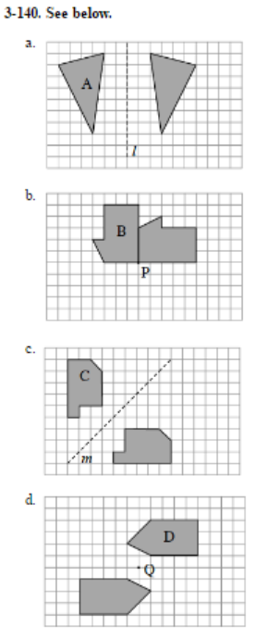

**3-141.**

* 1. *x* = 5

1. *x* = 2
2. *y* = 0
3. *x* = 38