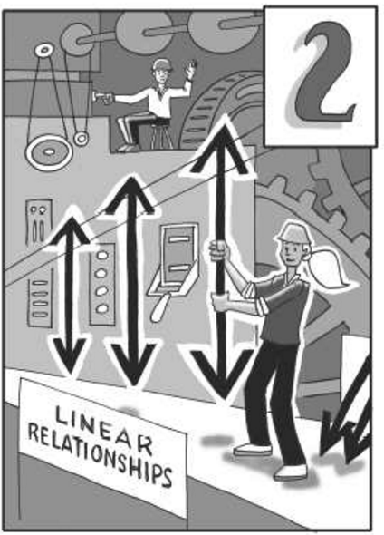

Chapter 2 Linear Functions
Chapter 2 will focus on the slope and y-intercept of linear functions. You will look for connections among the multiple representations of linear functions: table, graph, equation, and situation. In this chapter, you will come to a deeper understanding of slope than you may have had in previous courses, and you will explore the idea of slope as a rate of change.
 | Section 2.1 | In this section, you will connect the number of tiles in Figure 0 and growth in geometric tile patterns with the slope and y-intercept on a graph. You will learn how to measure the steepness of a line on a graph. You will also study the differences between lines that point upward, lines that point downward, and lines that are horizontal or vertical.
 | Section 2.2 | In this section, you will investigate situations in which slope represents speed in an everyday situation, culminating in an activity called “The Big Race”. You will also look at how slope represents rate of change in situations that do not involve motion.
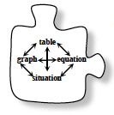 | Section 2.3 | In Section 2.3, you will complete a multiple representations web so that you can determine the slope andy-intercept in various representations, and can convert readily between them. In particular, you will develop an algebraic method for writing the equation of a line when given only two points on the line.

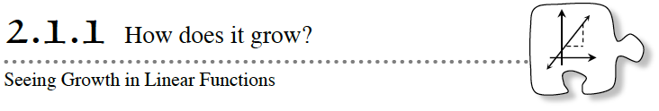
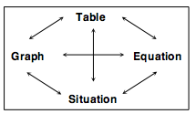
Throughout this chapter you will explore the multiple representations of a linear function. You will look at tile patterns, using the growth and number of tiles in Figure 0 of these linear relationships to find specific connections between situations, tables, graphs, and equations.
The specific situation you will work with today is the growth of tile patterns.
As you work today, keep these questions in mind:
How can you see growth in the tile pattern?
How many tiles are in Figure 0?
What is the connection between the pattern and the equation?
What is the connection between the pattern and the table?

2-1. TILE PATTERN INVESTIGATION
On the next page find Pattern A, shown below. Complete the following tasks for Pattern A, recording your work on the resource page or on your paper as appropriate. (Do not consider Patterns B or D yet.)
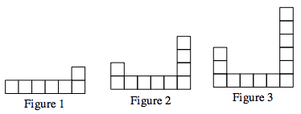

What do you notice about Pattern A? After everyone has had a moment on his or her own examine the figures, discuss what you see with your team.
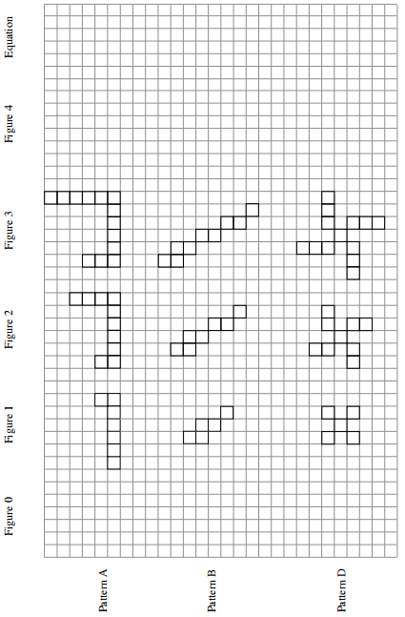
a. Sketch the next figure in the sequence (Figure 4) for Pattern A. Figure 0 is the name of the figure that comes before Figure 1. Sketch Figure 0.
b. By how much is Pattern A growing? | c. Where are the tiles being added with each new figure?
d. Color in the new tiles in each figure with a marker or colored pencil. What would Figure 100 look like for Pattern A? Describe it in words. How many tiles would be in the 100th figure? Find as many ways as you can to justify your conclusion. Be prepared to report back to the class with your team’s findings and methods.

e. Assume the starting value of any tile pattern is the number of tiles in Figure 0. Assume the growth is the number of tiles that are added from one figure to the next. What are the growth and starting value for Pattern A? |  | f. Write an equation that relates the figure number, x, to the number of tiles, y.
2-2. Answer the following for Pattern B
a. Sketch the next figure in the sequence (Figure 4) for Pattern B. Sketch Figure 0.
b. By how much is Pattern B growing? | c. Where are the tiles being added with each new figure?
d. Color in the new tiles in each figure with a marker or colored pencil. What would Figure 100 look like for Pattern B? Describe it in words. How many tiles would be in the 100th figure? Find as many ways as you can to justify your conclusion. Be prepared to report back to the class with your team’s findings and methods.

e. What are the growth and starting value for Pattern B? |  | f. Write an equation that relates the figure number, x, to the number of tiles, y.
2-3. The growth of tile Pattern C is represented by the equation y = 3x + 1.
Fill in the table for Pattern C.
Figure # x | 0 | 1 | 2 | 3 | 4
# of Tiles y
- By how many tiles is each figure in Pattern C growing? What is the starting value?

- How can you use the table to determine the growth and starting value?

- Where do you look in the equation to see the growth and starting value?

2-4. Look back at the growth of Patterns A, B, and C. Imagine that the team next to you created a brand new tile pattern, but they refused to show the pattern to you. What information would you need in order to predict the number of tiles in Figure 100? Explain your reasoning.

2-5. Now consider Pattern D
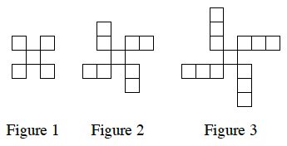
- Draw Figures 0 and 4 for this pattern on the resource page.
- Write an equation for the number of tiles in this pattern. Use color to show where the numbers in your equation appear in the tile pattern. Use x for the figure number and y for the number of tiles in the figure.

- Make a table for the equation you wrote in part (b). Does the information in your table match the figures in the tile pattern?

- What is the same about this pattern and Pattern C? What is different? What would those similarities and differences look like in a tile pattern?

- What do the similarities and differences in part (d) look like in the equations?

- What do the similarities and differences look like in the table?

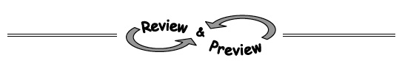
Name________________________Per______
HOMEWORK ASSIGNMENT

2-6. A tile pattern has five tiles in Figure 0 and adds seven tiles in each new figure. Write a linear equation that represents this pattern.

2-7. Benjamin is taking Algebra 1 and is stuck on the problem shown below. Examine his work so far and help him by showing and explaining the remaining steps.
Original problem: Simplify (3a⁻²b)³
He knows that (3a⁻²b)³ = (3a⁻²b)(3a⁻²b)(3a⁻²b). Now what?

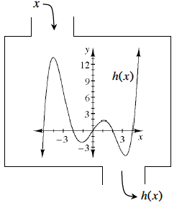
2-8. Examine the function h(x) defined at right. Then estimate the values below.
- h(1)

- h(3)

- x when h(x) = 0

- h(−1)

- h(−4)
2-9. Calculate the value of each of the following expressions.
 | - 5⁽¹⁺²⁾ + 8 − 6 | - 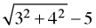
2-10. Examine the diagram below. Based on the information in the diagram, which angles can you determine the measures of? Determine the measures of only those angles that you can justify.

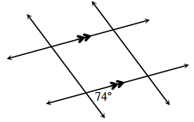

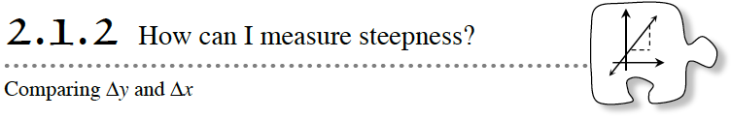
In the previous lesson, you determined the growth and starting value of geometric tile patterns, and made connections between the pattern, table, and equation. In this lesson you will use your knowledge to determine an accurate value of growth from a graph.
During this lesson, ask your teammates the following focus questions:
What makes lines steeper? What makes lines less steep?
How is growth related to steepness?
Where is the starting value on a line?
2-11. The table below represents a tile pattern.
Figure # | 0 | 1 | 2 | 3 | 4
# of tiles | 2 | 7 | 12 | 17 | 22
- Make a graph that represents this tile pattern below. Should the points be connected?
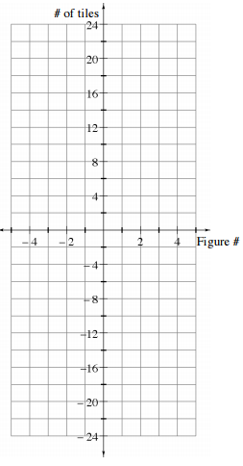
- Draw a continuous line through the tile pattern points. Extend the line to the edges of the graph and beyond.

- The line you drew models the growth of the tile pattern. Models are often imperfect, but they are useful in describing complex situations and for making predictions. What assumptions does this linear model make about the tile pattern?

2-12. Does the model in the previous problem appear to be a function? If so, write the equation in function notation. If not, explain why it is not a function.

2-13. The three graphs below each model a different tile pattern. For each model:
- Describe how the tile pattern grows and the starting value (number of tiles in Figure 0). x represents the figure number, and y represents the number of tiles in the figure.

- Write an equation that relates the figure number, x, to the number of tiles, y.

- Decide if the graph represents a function. If so, write the equation using function notation. If not, explain why the graph does not represent a function.
 | a.  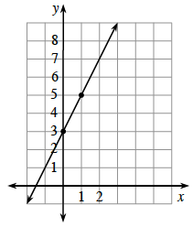 | b.  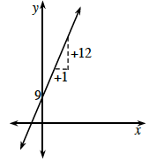 | c.  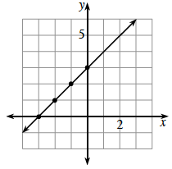
1.

2.

3.
2-14. The graph below shows a linear model for a tile pattern. How is the line growing? That is, how many tiles are added each time the figure number is increased by one? Explain how you found your answer.
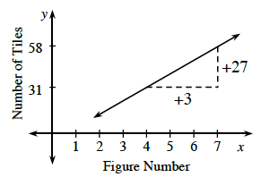
2-15. The triangles drawn on the graphs in part (b) of problem 2-13 and problem 2-14 are called slope triangles.
Slope is a measure of the steepness of a line. It is the ratio of the vertical distance to the horizontal distance of a slope triangle. The vertical distance of the triangle is called Δy (read “change in y”), while the horizontal distance of the triangle is called Δx (read “change in x”).
Note that “Δ” is the Greek letter “delta” that is often used to represent a difference or a change.

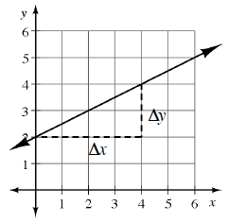
- What is the vertical distance (Δy) for this slope triangle?

- What is the horizontal distance (Δx) for this slope triangle?

- Calculate the slope of this line.

- Draw several smaller slope triangles for this line that have a horizontal distance (∆x) of 1. Use one of these smaller triangles to calculate the slope for this line.

- What is the equation of this line?

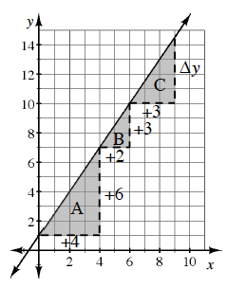
2-16. Use the graph to the right to answer the following:
- Calculate the slope using slope triangles A and B. What do you notice?

- What is the vertical distance (Δy) of slope triangle C? Explain your reasoning.

- Draw a slope triangle on the line with a horizontal length (Δx) of 1 unit. What is the vertical length (∆y) of this new triangle? What do you notice?

- What happens to the slope when the slope triangles are different sizes?
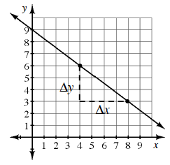
2-17. Michaela was trying to determine the slope of the line shown at right, so she selected two points where the grid lines intersect and then drew a slope triangle.
Her teammate, Cynthia, believes that Δy = 3 because the triangle is three units tall, while her other teammate, Essie, thinks that Δy = −3 because the triangle is three units tall and the line is pointing downward from left to right.
- With whom do you agree and why?

- When writing the slope of the line, Michaela noticed that Cynthia wrote on her paper, while Essie wrote . She asked, “Are these ratios equal?” Discuss this with your team and answer her question.

- What is the equation of Michaela’s line?
Name________________________Per______
HOMEWORK ASSIGNMENT

2-18. Calculate the slope of the line shown on the graph at right.
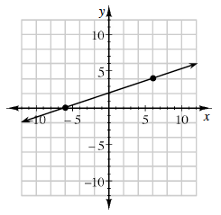
2-19. Which equation below has no solution? Explain how you know.
- 4(x + 1) = 2x + 4 b. 9 − 5x + 2 = 4 − 5x

2-20. Evaluate the expressions below for the given values.
- 1 − 2x + 3y for x = −2 and y = −5 | - 5 − (x − 2)² for x = −1
- for k = −1 | - for x = 2 and y = 5

2-21. Calculate the output for the function with the given input. If there is no possible output for the given input, explain why not.
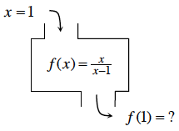

2-22. Evaluate the following expressions.
- 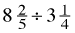 | - 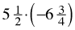
- 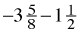 | - 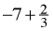

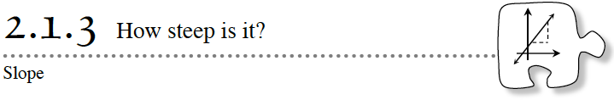
In Lesson 2.1.2, you used the horizontal and vertical distances of a slope triangle to measure the steepness of a line. Today you will use the idea of stairs to understand slope even better. You will review the difference between positive and negative slopes and will draw lines when given information about Δx and Δy.
During the lesson, ask your teammates the following focus questions:
How can we tell if the slope is positive or negative?
What makes a line steeper? What makes a line less steep?
What does a line with a slope of zero look like?
2-23. One way to think about slope triangles is as stair steps on a line.
- Picture yourself climbing (or descending) the stairs from left to right on each of the lines on the graph (below, right). Of lines A, B, and C, which is the steepest? Which is the least steep?
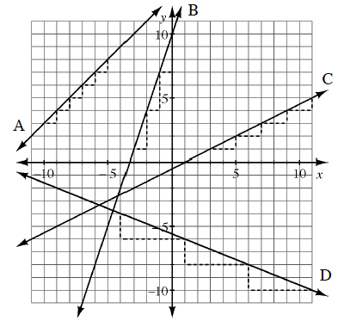
- Examine line D. What direction is it slanting from left to right? What number should be used for Δy to represent this direction?

- Label the sides of a slope triangle on each line. Then determine the slope of each line.

- How does the slope relate to the steepness of the graph?

- Cora answered part (d) with the statement, “The steeper the line, the greater the slope.” Do you agree? If so, use lines A through D to support her statement. If not, change her statement to make it correct.
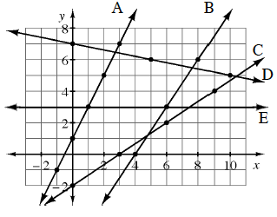
2-24. Using the graph shown at the right
- Which is the steepest line?
Which is steeper, line B or line C?

- Draw slope triangles for lines A, B, C, D, and E using the highlighted points on each line. Label Δx and Δy for each.

- Match each line with its slope using the list below. Note: There are more slopes than lines.
- Viewed left to right, in what direction would a line with slope point? How do you know?

- Viewed left to right, in what direction would a line with slope point? How do you know? How would it be different from the line in part (d)?

2-25. Examine lines A, B, C, and D on the graph at right. For each line, decide if the slope is positive, negative, or zero. Then draw and label slope triangles and calculate the slope of each line.
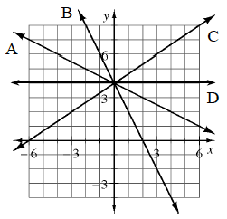
2-26. Graph a line to match each description below.
a. A line that goes up 3 each time it goes over 5. b. A line with Δx = 4 and Δy = −6.
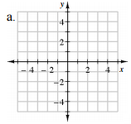. 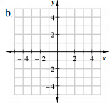
c. A line with Δy = Δx. d. A line that has Δy = 3 and Δx = 0.
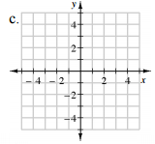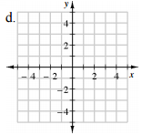

2-29. LEARNING LOG
For today’s Learning Log, you will consider what connections between different representations of a linear function you can already use. Copy the web below, without any arrows, into your Learning Log. Discuss with your team the connections you have used so far in this chapter. For example, if you have a linear equation, such as y = 3x + 1, can you complete a table? If so, draw an arrow from “equation” to “table”, as shown below.
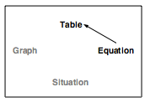
Draw arrows to show which representations you can connect already. Which connections have you not used yet but are confident that you could use? Which connections do you still need to explore?
Can you think of examples from this chapter to support your conclusions? Write down the problem numbers next to your arrows.
Title this entry “Multiple Representations Web for Linear Functions” and label it with today’s date. Be ready to share your findings with the rest of the class.

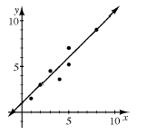
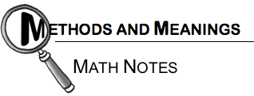

Line of Best Fit
A line of best fit is a straight line that represents, in general, data on a scatterplot, as shown in the diagram. This line does not need to touch any of the actual data points, nor does it need to go through the origin. The line of best fit is a model of numerical two-variable data that helps describe the data in order to make predictions for other data.

Name________________________Per______
HOMEWORK ASSIGNMENT

2-30. When Yoshi graphed the lines y = 2x + 3 and y = 2x − 2, she got the graph shown below.
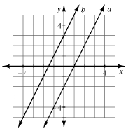
- One of the lines at right matches the equation y = 2x + 3, and the other matches y = 2x − 2. Which line matches which equation?

- Yoshi wants to add the line y = 2x + 1 to her graph. Predict where it would lie and sketch a graph to show its position. Justify your prediction.

- Where would the line y = −2x + 1 lie? Again, justify your prediction and add the graph of this line to your graph from part (b).

2-31. The Smallville High School principal is concerned about his school’s Advanced Placement (AP) test scores. He wonders if there is a relationship between the students’ performance in class and their AP test scores, so he randomly selects a sample of ten students who took AP examinations and compares their final exam scores to their AP test scores.
AP Score | 5 | 1 | 4 | 2 | 1 | 4 | 2 | 1 | 3 | 5
Final % | 97 | 70 | 84 | 66 | 62 | 79 | 73 | 63 | 82 | 90
Create a scatterplot. Draw a line of best fit that represents the data. Refer to the Math Notes box in this lesson. Use your line of best fit to predict the final exam score of another Smallville High School student who scored a 3 on their AP test.

2-32. Compute each product or quotient. Write the final answer in scientific notation.
- (6 × 10²)(4 × 10⁵)

- (1.75 × 10⁻²)(8 × 10⁻⁸)

- 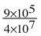
2-33. Rewrite each of the expressions below in a simpler form. Your new expressions should not contain negative exponents.
- (5x³)(−3x⁻²)

- (4p²q)³

- 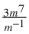
2-34. Which graphs below have a domain of all real numbers? Which have a range of all real numbers? Which are functions?
a.  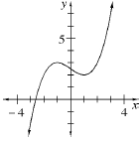 | b.  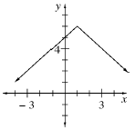 | c.  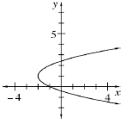

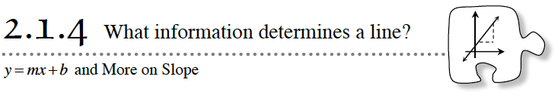
In previous lessons, you found the slope and y-intercept of linear functions. You connected slope (growth) and y-intercept (starting value) to their representations in patterns, tables, equations, and graphs. Today you will complete your focus on determining slope and learn how to use slope and the y-intercept to write the equation of a line. During this lesson, keep the following questions in mind:
How can we determine the growth? How can we determine the starting value?
Is there enough information to graph the line?
How can we calculate the slope of a line without graphing it?
2-35. Equations for linear patterns can all be written in the form y = mx + b.
- x and y represent variables. When you wrote equations relating the figure number to the number of tiles, what did x represent? What did y represent?

- m and b are parameters—they do not change within a given linear situation.
m is also called a coefficient since it multiplies a variable (x), and b is a constant term since it does not multiply a variable.
What do m and b represent in a linear situation like the tile patterns?

- What effect does m have on a graph of the line? What effect does b have?

More Slope
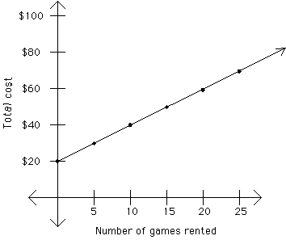 | 1. Where does the line start?  How does the equation grow?  What is the equation of the line?
2. Equations for linear patterns notes 2-35

3. Equations from a table

x | y
0 | 4
3 | 10
6 | 16
9 | 22
12 | 28

x | y
-1 | 3
0 | 5
1 | 7
2 | 9
3 | 11

b.
c.
- d
x | y
0 | 6
1 | 8
2 | 10
3 | 12
4 | 14

y-intercept?
slope?
Equation?
y-intercept?
slope?
Equation?
Start?
Grow?
Equation?

4. What if the table shrinks?
a.
x | y
1 | 8
3 | 12

b.
x | y
0 | 10
4 | 34

y-intercept?
slope?
Equation?
y-intercept?
slope?
Equation?

Is there a shortcut to finding the slope?

5. What if we only had two points? Find the equation of the line.

- (2,4) and (0,20) b. (0,-10) and (5, 35)

y-intercept?
slope?
Equation?
y-intercept?
slope?
Equation?

6. Special cases.
- (2,3) and (4,3) b. (2,3) and (2, 5)

y-intercept?
slope?
Equation?
y-intercept?
slope?
Equation?

Graph the points: Graph the points:

2-37. CALCULATING THE SLOPE OF A LINE WITHOUT GRAPHING
While determining the slope of a line that goes through the points (6, 5) and (3, 7), Gloria figured out that Δy = −2 and Δx = 3 without graphing.
- Explain how Gloria could figure out the horizontal and vertical distances of the slope triangle without graphing. Draw a sketch of the line and validate her method.

- What is the slope of the line?

- Use Gloria’s method (without graphing) to calculate the slope of the line that goes through the points (4, 15) and (2, 11).

- Use Gloria’s method to calculate the slope of the line that goes through the points (28, 86) and (34, 83).

- Another student found the slope from part (d) to be 2. What error or errors did that student make?

2-38. STEEPEST SLOPE?
What is the steepest line possible? What is its slope? Be ready to justify your statements.
2-39. LEARNING LOG
Consider the equation for a line, y = mx + b. What does the m represent? What does the b represent? Now consider the four representations of a linear function: situation (for example, a tile pattern), table, equation, and graph. Where in each of these representations would you look if you wanted to determine the slope? The y-intercept? Title this Learning Log entry “y = mx + b”, and include today’s date.
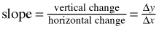

The Slope of a Line
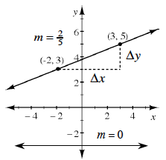
The slope of a line is the ratio of the vertical distance to the horizontal distance of a slope triangle formed by two points on a line. The vertical part of the triangle is called Δy (read “change in y”), while the horizontal part of the triangle is called Δx (read “change in x”). The slope indicates both how steep the line is and its direction, upward or downward, left to right.

Note that “Δ” is the Greek letter “delta” that is often used to represent a difference or a change.
Note that lines slanting upward from left to right have positive slope, while lines slanting downward from left to right have negative slope. A horizontal line has zero slope, while a vertical line has undefined slope.
To calculate the slope of a line, choose two points on the line, draw a slope triangle (as shown in the example above), determine Δy and Δx, and then write the slope ratio. You can verify that your slope correctly resulted in a negative or positive value based on the direction of the line. In the example above, Δy = 2 and Δx = 5, so the slope is .

Name________________________Per______
HOMEWORK ASSIGNMENT

2-40. State the slope and y-intercept of each line.
- b. c. y = −5

2-41. Without graphing, calculate the slope of each line described below.
a. A line that goes through the points (4, 1) and (2, 5). | b. A line that goes through the origin and the point (10, 5).
c. A vertical line (one that is “up and down”) that goes through the point (6, –5). | d. A line that goes through the points (1, 6) and (10, 6).
2-42. Which of the numbers below are correctly written in scientific notation? For each that is not, rewrite it correctly.
a. 4.51 × 10⁻²
b. 0.789 × 10⁵
c. 31.5 × 10²
d. 3.008 × 10⁻⁸

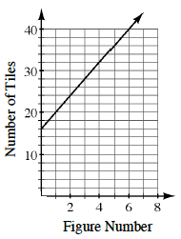
2-43. The graph at right models the number of tiles in a tile pattern.
- Based on the information in the graph, how many tiles are being added each time (that is, what is the slope of the line)? Pay close attention to the scale of the axes.

- How many tiles are in Figure 0?

- Write the equation for the tile pattern.

- How would the line change if the pattern grew by 12 tiles each time instead?

2-44. Zaheed enjoys walking his dog, Basil, each afternoon. Zaheed typically walks 12 blocks around the neighborhood, which takes about 45 minutes. Today, on his walk around the neighborhood with Basil, Zaheed noted that Basil barked at 17 other dogs. Zaheed wonders if he can predict how many dogs Basil will bark at tomorrow on the way to the dog park, which is 26 blocks away.
- What assumptions would Zaheed have to make in order to use a proportional equation to make his prediction?

- Write a proportional equation for Zaheed’s situation and solve. Make sure that the precision of your answer is reasonable.

- What is the unit rate in dogs per block for Zaheed’s walks?

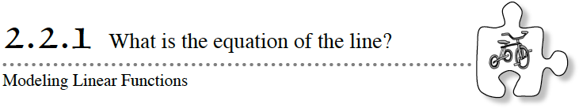
Today you will start to look at slope as a measurement of rate. Today’s activity ties together the equation of a line and motion. Look for ways to connect what you know about m and b as you create motion graphs to match equations.
2-45. SLOPE WALK
Congratulations! The president of the Line Factory has presented your class with a special challenge. She now wants a way to write the equation of a line generated when a customer walks in front of a motion detector. That way, a customer can simply “walk a line” to order it from the factory.
Your Task: Once a motion detector has been set up with the correct software, have a volunteer walk away from the motion detector at a constant rate. In other words, he or she should walk the same speed the entire time. Then, once a graph is generated, use the graphing technology provided by your teacher to write a linear equation that models the data. Then write the equation of a line formed when a different volunteer walks toward the motion detector at a constant rate.
What do we expect the first graph to look like? Why?
What will be different about the two graphs?
What would happen if the volunteer did not walk at a constant rate?
How does the volunteer’s speed affect the graph?
2-46. WALK THE WALK
To impress the president, you have decided to reverse the process: Write instructions for a client about how to walk in front of the motion detector in order to create a graph for a given equation.
Each team in the class will be assigned one or two equations from the list below. Then, as a team, decide how to walk so that you will get the graph for your equation. After the entire team understands how to walk, one member will try to graph the line by walking in front of the motion detector. Pay close attention to detail! Your team only has two tries!
a. y = 3x + 2 | b. y = −x + 10 | c. y = 6 | d. y = 2x + 4
e. y = −2x + 13 | f. y = x + 5 | g. y = −0.5x + 15 | h. y = 1.5x + 3
Describing Association
An association (relationship) between two numerical variables can be described by its form, direction, strength, and outliers.
The shape of the pattern is called the form of the association: linear or nonlinear. The form can be made of clusters of data.
If one variable increases as the other variable increases, the direction is said to be a positive association. If one variable increases as the other variable decreases, there is said to be a negative association. If there is no apparent pattern in the scatterplot, then the variables have no association.
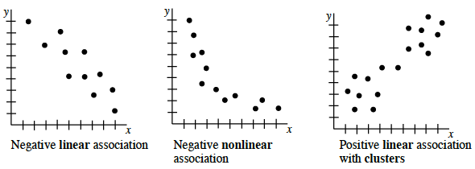
Strength is a description of how much scatter there is in the data away from the line of best fit. See some examples below.
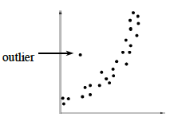
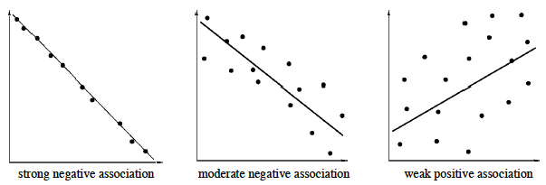
An outlier is a piece of data that does not seem to fit into the overall pattern. There is one obvious outlier in the association graphed at right.

Name________________________Per______
HOMEWORK ASSIGNMENT
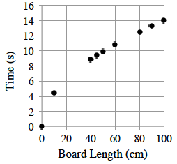
2-47. Ms. Hoang’s class conducted an experiment by rolling a marble down different lengths of slanted boards and timing how long it took. The results are shown at right. Describe the association. Refer to the Math Notes box in this lesson if you need help remembering how to describe an association.

2-48. Mikko has been going to barbecues this summer and keeping track of the number of people in attendance and the total number of burgers that were eaten. His data is shown in the table below. Graph his data. Should the points on the graph be connected?
# of people at the barbecue | 2 | 5 | 9 | 12 | 14 | 19
# of burgers eaten | 3 | 9 | 14 | 19 | 25 | 32
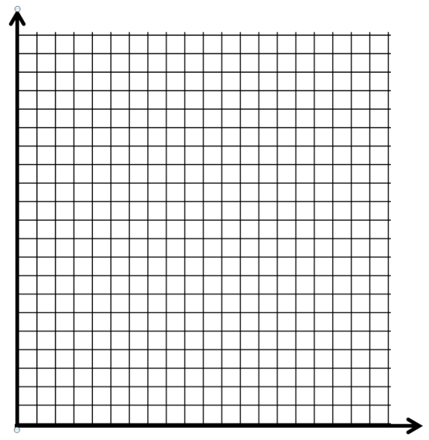

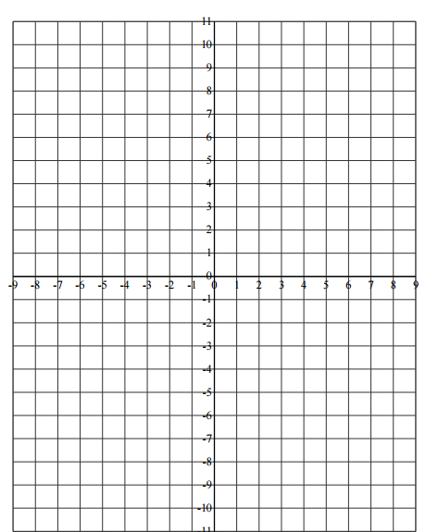
2-49. If :
- What is the slope of the line?

- What is the y-intercept of the line?

- Graph the line.

2-50. If f(x) = 3x − 9 and g(x) = −x², calculate the values of:
- f(−2)

- g(−2)

- x if f(x) = 0

- g(m)
2-51. What number is not part of the domain of ? How can you tell?

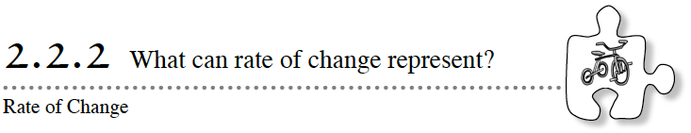
Today you will focus on the meaning of “rate of change” in various situations. What does a rate of change represent? How can you use it? As you graph the results of a competitive tricycle race today, think about how the participants’ rates of change compare to each other.
2-52. THE BIG RACE − HEAT 1
Before a big race, participants often compete in heats, which are preliminary races that determine who competes in the final race. Later in this chapter, your class will compete in a tricycle race against the winners of these preliminary heats.
In the first heat, Leslie, Kristin, and Evie rode tricycles toward the finish line. Leslie began at the starting line and rode at a constant rate of 2 meters every second. Kristin got an 8-meter head start and rode 2 meters every 5 seconds. Evie rode 5 meters every 4 seconds and got a 6-meter head start.
- On neatly scaled axes, graph and then write an equation in terms of x and y for the distance Leslie travels. Let x represent time in seconds and y represent distance in meters. Then do the same for Kristin and Evie using the same set of axes.

- After how many seconds did Leslie catch up to Evie?

- How far were they from the starting line when Leslie caught up to Evie? Confirm your answer algebraically and explain how to use your graph to justify your answer.

- The winner of this heat will race in the final Big Race. If the race is 20 meters long, who won? Use both the graph and the equations to justify your answer.

- How long did it take each participant to finish the race?

- The school newspaper wants to report Kristin’s speed. How fast was Kristin riding? Write your answer as a unit rate, that is as a rate with a denominator of 1.

Heat 1
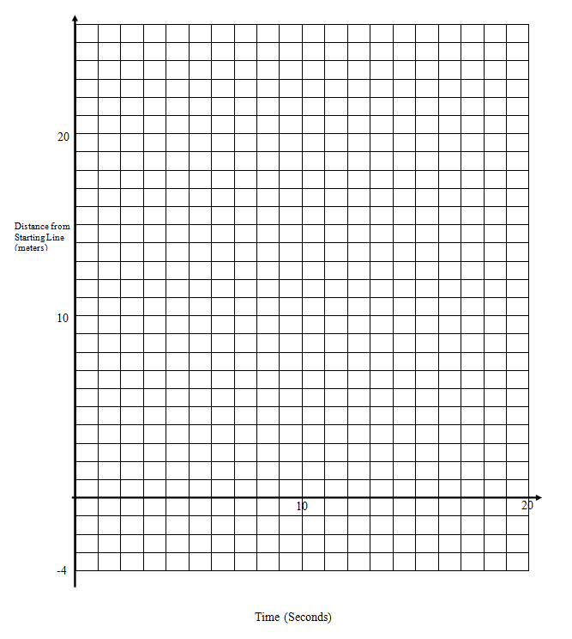

2-53. THE BIG RACE − HEAT 2
In the second heat, Elizabeth, Kaye, and Hannah raced down the track. They knew the winner would compete against the other heat winners in the final race.
- When the line representing Kaye’s race is graphed, the equation is . What was her speed (in meters per second)? Did she get a head start?

- Elizabeth’s race is given by the equation . Who is riding faster, Elizabeth or Kaye? How do you know?

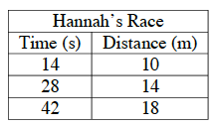
- Just as she started pedaling, Hannah’s shoelace came untied! Being careful not to get her shoelace tangled in the pedal, she rode slowly. Hannah’s race is represented in the table at right. At what unit rate was she riding?

- To entertain the crowd, a clown rode a tricycle in the race. His race can be modeled by the function f(x) = 20 − x. Without graphing or making a table, fully describe the clown’s ride.

HEAT 2

2-54. OTHER RATES OF CHANGE
The slope of a line can represent many things. In this lesson you concentrated on situations where the rate of change of a line (the slope) represented speed. However, rate of change can represent many other things besides speed, depending on the situation.
- For each graph below,
Explain what real-world quantities the slope and y-intercept represent.
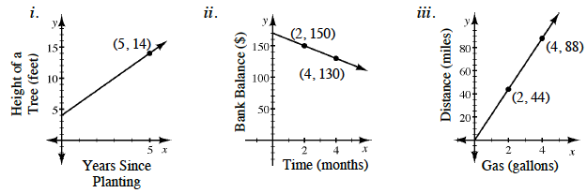
Calculate the unit rate for each situation. Be sure to include units in your answer.

- In each of the situations, would it make sense to draw a different line with a negative y-intercept?

2-57. LEARNING LOG
For today’s Learning Log entry, create your own situation with a rate of change, similar to problem 2-54. Make a sketch of the graph and label the axes. Then use the ideas you have developed in class to answer the questions below in your Learning Log. Title this entry “Rates of Change and Slope” and label it with today’s date.
What is the unit rate?
How would your situation change if the line were steeper? Less steep?
What would it mean if the line sloped in the opposite direction?
What does a line with a slope of zero look like?
What would a zero slope represent for your situation?
What does a line with undefined slope look like?

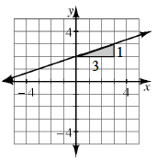
Writing the Equation of a Line from a Graph or Table
To write the equation of a line directly from a graph, first determine the slope of the line (m) and the y-intercept (b). Then substitute the values into the general slope-intercept form y = mx + b.
For example, the slope of the line at right is m = , while the y-intercept is (0, 2). (Read more about determining slope in the Math Notes box in Lesson 2.1.4.)
By substituting m = and b = 2 into y = mx + b, the equation of the line is:
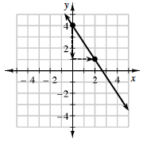
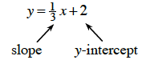
Conversely, you can sketch a graph from the equation (without making a table first). For example, to graph the equation , start by placing a point at the y-intercept of (0, 4). Move down 3 units and to the right 2 units, because the slope , then place another point. You can continue to place additional points by moving down 3 units and to the right 2 units. Then extend the line in both directions through the points.

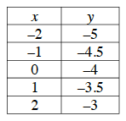
To write the equation of a line from a table that has x-values that increase by one, find the change in y-value between any two entries in the table. The slope is . The y-intercept is in the table where the x-value is zero. For example, in the table at right the slope is m = and the
y-intercept is −4. The equation is . Later in this chapter you will write equations if lines from tables where the x-values do not necessarily increase by one.

Name________________________Per______
HOMEWORK ASSIGNMENT

2-58. THE BIG RACE – HEAT 3
Barbara, Mark, and Carlos participated in the third heat of “The Big Race”. Barbara thought she could win with a 3 meter head start even though she only pedaled 3 meters every 2 seconds. Mark began at the starting line and finished the 20-meter race in 5 seconds. Meanwhile, Carlos rode his tricycle so that his distance (y) from the starting line in meters could be represented by the equation y = + 1, where x represents time in seconds.
- What is the dependent variable? What is the independent variable?

- Using the given information, graph lines for Barbara, Mark, and Carlos on the same set of axes. Who won the 20-meter race and will advance to the final race?

- Write equations that describe Barbara’s and Mark’s motion.

- How fast did Carlos pedal? Write your answer as a unit rate.

- When did Carlos pass Barbara? Confirm your answer algebraically.

2-59. Which of the expressions below are equivalent to 16x⁸? Make sure you find all the correct answers!
 | a. (16x⁴)² | b. 8x² · 2x⁶
 | c. (2x²)⁴ | d. (4x⁴)²
 | e. (2x⁴)⁴ | f. 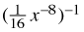

2-60. If, for a certain function, f(a) = 51, calculate the following values.
- f(a) – 8 b. c.

2-61. Write the equation for the following tile pattern.
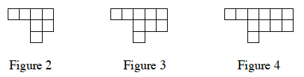
2-62. Graph the equation y = −2x + 9.

2-63. Explain what the slope of each line below represents. Then determine the slope and give its units.
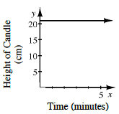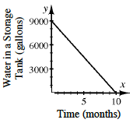
2-64. Calculate the slope of the line that goes through the points (−15, 70) and (5, 10).

2-65. Calculate f (−3) for each function below.
- f(x) = −2x + 3 b. f(x) = 4^{x} c. f(x) = x⁻² + 1 d.

2-66. Greta is opening a savings account. She starts with $100 and plans to add $50 each week. What is the unit rate of change for this situation? Write an equation Greta can use to calculate the amount of money she will have after any number of weeks. How much money will she have after 1 year?

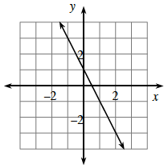
2-67. Review what you know about graphs by answering the following questions.
- What is the equation of the line graphed at right?

- What are its x- and y-intercepts?

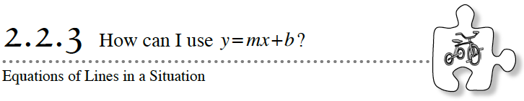
During this chapter you have found linear equations using several different strategies and starting from many different types of information. Today you are going to apply what you know about writing linear equations to solve a complicated puzzle: Who among you will win “The Big Race”?
2-68. THE BIG RACE – FINALS
Today is the final event of “The Big Race”! Your teacher will give you each a card that describes how you travel in the race. You and your team will compete against the heat 1 and 2 winners, Leslie and Elizabeth, at today’s rally in the gym. Unfortunately, Mark, the winner of heat 3, is absent from school and will not be participating against you.
Your Task: As a team, do the following:
- Draw a graph (on graph paper) showing all of the racers’ progress over time. Identify the independent and dependent variables.

- Write an equation for each participant.

- Figure out who will win the race!
Rules:
- Your team must work cooperatively to solve the problems. No team member has enough information to solve the puzzle alone!

- Each member of the team will select rider A, B, C, or D. You may not show your card to your team. You may only communicate the information contained on the card.

- Assume that each racer travels at a constant rate throughout the race.

- Elizabeth’s and Leslie’s cards will be shared by the entire team.

2-69. Use your results from “The Big Race – Finals” to answer the following questions. You may answer the questions in any order, but be sure to justify each response.
- Who won the finals of The Big Race? Who came in last place?

- Which rider(s), other than the winner, were in first place for a while? For approximately how long was this rider (or these riders) in first place?

- How many seconds did it take to win the race?

- How fast was Rider D traveling? How fast was Elizabeth traveling? Answer using unit rates.

- At one point in the race, four different participants were the same distance from the starting line. Who were they and when did this happen?

- What would the graph look like if one of the riders fell off their tricycle?

2-70. In “The Big Race” you wrote an equation and graphed a line representing Leslie’s race. Any point on a line is a solution to the two-variable equation for the line.
- Is the point (6, 8) on Leslie’s line? Is it a solution to the two-variable equation for Leslie’s line? Explain.

- Is the point (8, 10) a solution to Leslie’s equation? Is it on the line? Explain

- Why is any point on a line called a solution to its two-variable equation?

x- and y-Intercepts
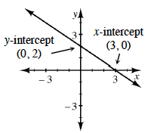
Recall that the x-intercept of a line is the point where the graph crosses the x-axis (where y = 0). To determine the x-intercept, substitute 0 for y and solve
for x. The coordinates of thex-intercept are (x, 0).
Similarly, the y-intercept of a line is the point where the graph crosses the y-axis, which happens when x= 0. To determine the y-intercept, substitute 0 for x and solve fory. The coordinates of the y-intercept are (0, y).
Example: The graph of 2x + 3y = 6 is a line, as shown above right.
To calculate the x-intercept,  let y = 0; 2x + 3(0) = 6  2x = 6  x = 3  x-intercept: (3, 0) |  | To calculate the y-intercept,  let x = 0: 2(0) + 3y = 6  3y = 6  y = 2  y-intercept: (0, 2)

Name________________________Per______
HOMEWORK ASSIGNMENT

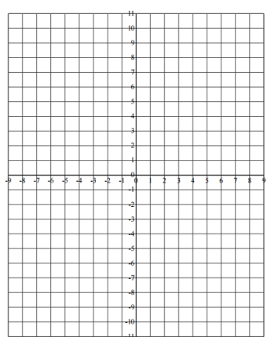
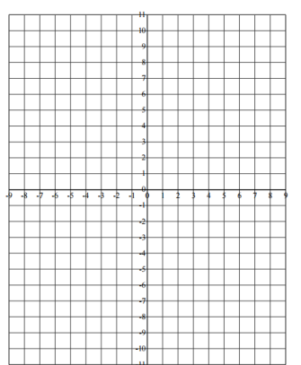
2-71. Sometimes the quickest and easiest two points to use to graph a line that is not in slope-intercept form are the x- and y-intercepts. Determine the x- and y-intercepts for the two lines below and then use them to graph each line. Write the coordinates of the x- and y-intercepts on your graph.
- x − 2y = 4 b. 3x + 6y = 24

2-72. Solve each of the following equations.
a. 2x + 8 = 3x − 4 | b. 1.5w + 3 = 3 + 2w
c. 48 + 8x + 23 = 7 | d. 6x − 21 = 5x + 17 + x
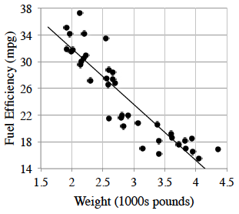
2-73. A consumer magazine collected the following data for the fuel efficiency of cars (miles per gallon) compared to weight (thousands of pounds).
e = 49 − 8.4w
w is the weight (1000s of pounds)
and e is the fuel efficiency (mpg).
- What does the −8.4 in the equation represent? What are the units on this number?

- What does the 49 in the equation represent? What are its units?

- Describe the association between fuel efficiency and weight.

- Cheetah Motors has come out with a super lightweight sports utility vehicle (SUV) that weighs only 2800 pounds. What does the model predict the fuel efficiency will be?
2-74. Each part below represents a different situation. For each situation, determine the pattern of growth and the number of tiles in Figure 0 or the y-intercept.
a.  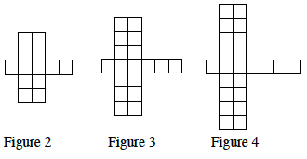 | b.  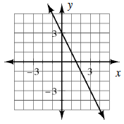
c. y = 3x − 14
d.
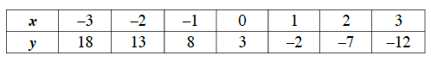
- Which situation above is growing (increasing) at the fastest rate?

2-75. Paula found a partially completed table that her friend Donna was using to determine how fast water evaporated from a bucket during the summer. Every other day she measured the height of the water remaining in the bucket in centimeters. equations.
Days (x) | 0 | 2 | 4 | 6 | 8
Height cm (y) | 30 | 27 | 24
- Review the Math Notes box in Lesson 1.1.2. Is this a proportional situation? If it is proportional, is it increasing or decreasing? If it is not proportional, explain why not.

- Complete the table.

- For this table, what is the rate of change, including the units? What is the unit rate of change?

- Write an equation to represent the height of the water after any number of days.
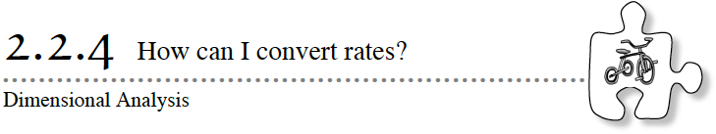
In 1999, NASA’s Mars Climate Orbiter, designed to monitor the Red Planet’s atmosphere, was lost in space because engineers failed to make a simple conversion from English units to metric units. Maybe this mistake could have been avoided if the engineers had remembered their dimensional analysis skills!
In this lesson you will learn to convert among different units of measure using dimensional analysis. A measurement is not complete without appropriate units. Using dimensional analysis of units may have prevented the loss of the $125 million spacecraft in 1999.

2-76. In “The Big Race”, Leslie rode at a rate of 2 meters every second. However, you want to know how fast she was going in feet per second. Work with your team to determine Leslie’s rate in feet per second. Refer to the Math Notes box in this lesson for equivalent units of measure.

2-77. A SNAIL’S RACE
Terri, Madeline, Matt, and Olivia were working on a different rate problem. They were preparing for the county fair snail race, and knew their species of snail could travel up to 8 feet per hour. The snail race lasts only a few minutes, so they want to know how many inches their snail could travel in one minute.
Madeline spoke up. “I know there are 12 inches in a foot and 60 minutes in one hour, but I always get mixed up about when we are supposed to divide and when we are supposed to multiply. Help!”
Olivia chimed in. “Do you think we can try using ratios so that we remember when to multiply and when to divide? Let’s list out everything we know.”
- List out all of the ratios you know about the Snail Race.

- Madeline exclaims, “I got it!”, and shares her work with her group.
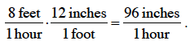
How did Madeline compute 96 inches per hour?

- Olivia said. “I think you are on to something, Madeline. We know that 1 foot is equal to 12 inches, so we can make a Giant One out of that ratio. Since we already know that multiplying by a Giant One does not change the value, let’s multiply the snail’s rate of 8 feet per hour by a Giant One.” Olivia showed them her work:
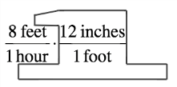
“Hey! That’s cool!”, said Matt. “Now we can rearrange like we did when we used the Giant One with exponents.”
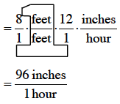 Why can Matt rearrange the terms?

- Terri is concerned because they only know the snail’s pace in inches per hour when they need to know the pace in inches per minute for the race. What is the snail’s pace in inches per minute?

2-78. BACK TO THE BIG RACE
Now that the team has practiced dimensional analysis from the Snail’s Race, they want to convert Kristin’s rate in “The Big Race” from 2 meters every 5 seconds to inches per second. They wrote down the following fraction multiplication problem, but were struggling to make Giant Ones.
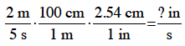
Help the team fix their mistake, and solve this problem by using Giant Ones. What is Kristin’s rate in inches per second? Consider the precision of the measurement of Kristin’s rate, and use the same number of decimal places in your answer.

2-79. Physical quantities are measured in units such as inches, grams, and hours. A dimension is the broader concept such as length, mass, and time. For example, one of the dimensions of the 1999 Mars Orbiter was height. Height was measured in units of meters.
Another dimension is mass. The launch mass of the Mars Orbiter in 1999 was 338 kilograms. What was the launch mass of the Mars Orbiter in pounds? Show your answer with the same precision as the original measurement of the launch mass.

2-80. A leaky faucet drips 1 fluid ounce of water every 5 minutes. How many gallons of water will leak from this faucet in 1 year? Show your work using dimensional analysis.

2-81. HOW MANY JABBERWOCKS ARE THERE?
JABBERWOCKY
Lewis Carroll
(from Through the Looking-Glass and What Alice Found There, 1872)
 | `Twas brillig, and the slithy toves  Did gyre and gimble in the wabe;  All mimsy were the borogoves,  And the mome raths outgrabe.  ‘Beware the Jabberwock, my son!  The jaws that bite, the claws that catch!  Beware the Jubjub bird, and shun  The frumious Bandersnatch!  He took his vorpal sword in hand:  Long time the manxome foe he sought –  So rested he by the Tumtum tree,  And stood awhile in thought.  And as in uffish thought he stood,  The Jabberwock, with eyes of flame,  Came whiffling through the tulgey wood,  And burbled as it came!  One, two! One, two! And through and through  The vorpal blade went snicker-snack!  He left it dead, and with its head  He went galumphing back.  ‘And hast thou slain the Jabberwock?  Come to my arms, my beamish boy!  O frabjous day! Callooh! Callay!’  He chortled in his joy.  `Twas brillig, and the slithy toves  Did gyre and gimble in the wabe;  All mimsy were the borogoves,  And the mome raths outgrabe. | 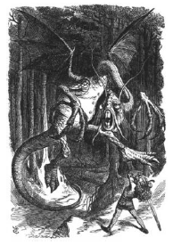
There are 20 Tumtum trees in the tulgey wood. In each tulgey wood is one frumious Bandersnatch. There are 5 slithy toves in 2 borogoves. There are 2 mome raths per Jabberwock. There are 2 Jubjub birds in 200 Tumtum trees. There are 200 mome raths in each borogove. There are 5 Jubjub birds per slithy tove.
Your Task: With your team, determine how many Jabberwocks there are if you have 5 frumious Bandersnatches. Keep your work organized so that you can share your solution with the class.
Conversion Factors, Metric Prefixes, and Common Abbreviations
Below are some commonly used conversion factors, metric prefixes, and abbreviations:
1 inch = 2.54 centimeters | 1 hour = 60 minutes | 1 fluid ounce = 2 tablespoons
1 foot = 12 inches | 1 minute = 60 seconds | 1 tablespoon = 3 teaspoons
1 yard = 3 feet | 1 day = 24 hours | 1 gallon = 4 quarts
1 mile = 5280 feet | 1 year = 365 days | 1 quart = 4 cups
1 pound = 16 ounces | 1 liter = 1.06 quarts | 1 cup = 8 fluid ounces
1 pound = 453.59 grams

Prefix Symbol Conversion Exponential  tera T 10¹²  giga G 10⁹  mega M 10⁶  kilo k 10³  hecto h 10²  deca da 10¹  No PREFIX means. 1 10⁰  deci d 10⁻¹  centi c 10⁻²  milli m 10⁻³  micro 10⁻⁶  nano n 10⁻⁹  pico p 10⁻¹² | Unit of Measurement Abbreviation  inch in  foot ft  yard yd  mile mi  meter m  centimeter cm  pound lb  grams g  liter L  quarts qt  gallon gal  cup c  fluid ounce fl. oz.  tablespoon T, Tbsp  teaspoon t, tsp  second s  minute min

Name________________________Per______
HOMEWORK ASSIGNMENT

2-82. A car gets 25 miles per gallon of gas. It travels for 45 minutes at 65 miles per hour. How many gallons of gas does the car use during that time? Show your work using units and Giant Ones.

2-83. Without graphing, identify the slope and y-intercept of the line represented by each equation below.
- y = 3x + 5
- y = 3
- y = 7 + 4x
2-84. The average distance of each of the first five planets from the Sun is shown in the table below. Is the distance to Jupiter more or less than the combined distances of the first four planets (Mercury, Venus, Earth, and Mars)?
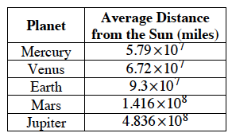

2-85. Calculate the slope of the line passing through each pair of points below.
a. (1, 2) and (4, –1) | b. (7, 3) and (5, 4)
c. (–6, 8) and (–8, 5) | d. (55, 67) and (50, 68)
e. Azizah got 1 for the slope of the line through points (1, 2) and (4, –1). Explain to her the mistake she made and how to calculate the slope correctly.

2-86. Does the table below appear to represent a function? If so, write an equation using function notation. If not, explain why it cannot represent a function.
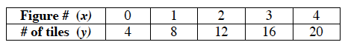

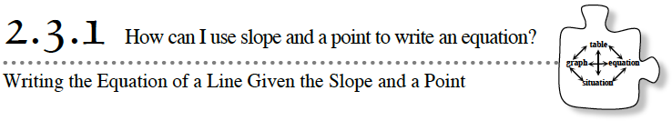
To do well in “The Big Race”, you had to write the equation of a line with a given rate (slope) that passed through a given point. Your method probably involved estimating the y-intercept of the line visually or working backward on a graph. What if the given point is far away from the y-axis? What if an estimate is not good enough in a particular situation?
During this lesson, you will develop an algebraic method for writing the equation of a line when given its slope and a point on the line.

2-87. DOWN ON THE FARM
Colleen recently purchased a farm that raises chickens. Since she has never raised chickens before, Colleen wants to learn as much about her baby chicks as possible. In particular, she wants to know how much a baby chick weighs when it is hatched.
To find out, Colleen decided to track the weight of one of the chicks that was born just before she purchased the farm. She found that her chick grew steadily by about 5.2 grams each day, and she assumes that it has been doing so since it hatched. Nine days after it hatched, the chick weighed 98.4 grams.
Your Task: Determine how much the chick weighed the day it hatched using two different representations of the chick’s growth: a graph and anx → y table. Then, assuming the chicken will continue to grow at the same rate, determine when the chick will weigh 140 grams.
What are we trying to figure out?
What information are we given?
What do we expect the graph to look like? Why?
Which representation (graph or table) will give more accurate results? Why?
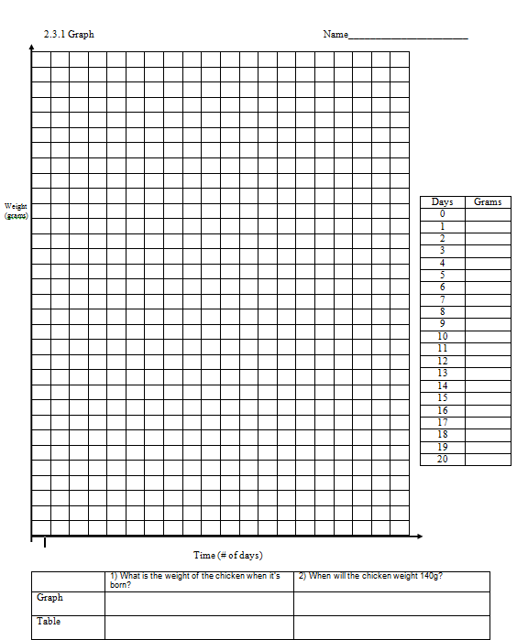

2-88. USING A GRAPH
- Use the information in problem 2-87 to answer these questions.

- What is the baby chick’s rate of growth? That is, how fast does the baby chick grow each day? How does this rate relate to the equation of the line?

- Before graphing, describe the line that represents the growth of the chick. Do you know any points on the line? Does the line point upward or downward? How steep is it?

- Draw a graph for this situation. Let the horizontal axis represent the number of days since the chick hatched, and let the vertical axis represent the chick’s weight. Label and scale your axes appropriately and title your graph “Growth of a Baby Chick”.

- What is the y-intercept of your graph? According to your graph, how much did Colleen’s chick weigh the day it hatched?

- When will the chick weigh 140 grams?

- What does the y-intercept represent in this situation?
2-89. USING A TABLE
Use the information in problem 2-87 to answer these questions.
- Make a table with two columns, the first labeled “Days Since Birth” and the second labeled “Weight in Grams”. In the first column, write the numbers 0 through 10.

- Use Colleen’s measurements to fill one entry in the table.
- Use the chick’s growth rate to complete the table.
- According to your table, how much did the chick weigh the day it hatched? When will the chick weigh 140 grams? Do these answers match your answers from the graph? Which method do you think is more accurate? Why?

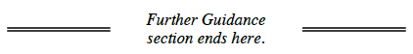
2-90. WRITING AN EQUATION WITHOUT A TABLE OR GRAPH
Now you will explore another way Colleen could find the weight of her chick when it hatched without using a table or a graph.
- Since Colleen is assuming that the chick grows at a constant rate, the equation for the weight of the chick a certain number of days after it hatched will be in the form y = mx + b. Without graphing, what do m and b represent? Do you know either of these values? If so, what are their units?

- You already know the chick’s rate of growth. Place this into the equation of the line. What information is still unknown?

- In Lesson 2.1.4, you discovered that knowing the slope and a point is enough information to determine a line. Therefore, using the point (9, 98.4) should help you determine they-intercept. How can you use this point in your equation? Discuss this with your team and be ready to share your ideas with the rest of the class.

- Solve for b (the weight of the chick when it was hatched). Write the equation of the line that represents the weight of the chick.

- Does the y-intercept you found algebraically match the one you found using the graph? Does it match the one you found using the table? How accurate do you think your algebraic answer is? What are the units for the y-intercept?

- Use your equation to determine when Colleen’s chicken will weigh 140 grams.

2-91. Use this new algebraic method to find equations for lines with the following properties:
- A slope of –3, passing through the b. A slope of 0.5 with an
point (15, –50). x-intercept of (28, 0).

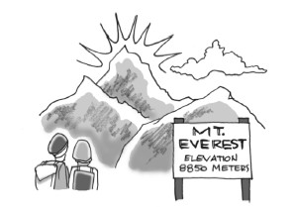
2-92. MIGHTY MT. EVEREST
The Earth’s surface is composed of gigantic plates that are constantly moving. Currently, India lies on a plate that is slowly drifting northward. India’s plate is grinding into the rest of Asia. As it does so, it pushes up the Himalayan Mountains, which contain the world’s highest peak, Mt. Everest. In 1999, mountain climbers measured Mt. Everest with satellite gear and found it to be 8850 meters high. Geologists estimate that Mt. Everest may be growing by as much as 5 cm per year.
Your Task: Assuming a constant growth of 5 cm per year, determine how tall Mt. Everest was in the year 0. (The year 0 is the year that came 2000 years before the year 2000.) Write an equation for the height of Mt. Everest over time, with x representing the year and y representing the height of the mountain.
What are the units for m and b in your equation? How many decimal places should be in your answer? Explain why.

2-93. LEARNING LOG
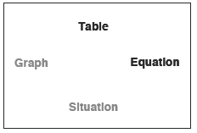
For today’s Learning Log, you will consider what connections between different representations of a linear relationship you now know. Refer to the web that you made in problem 2-29. Discuss with your team the connections you have used so far in this chapter.

Draw arrows to show which representations you can connect already. Pay special attention to arrows that you did not draw in problem 2-29. Are there any connections (arrows) that you can complete better than you did before? Can you think of examples from this chapter to support your new arrows? Write down the problem numbers next to your arrows.
Be ready to share your findings with the rest of the class.
Slope as Rate and Dimensional Analysis
Slope as Rate
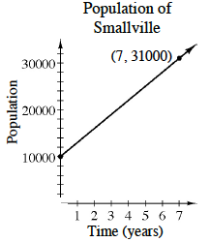
The slope of a line can represent many things. In the Big Race you concentrated on situations where the rate of change of a line (the slope) represented speed in meters/second. However, rate of change can represent many other things besides speed, depending on the situation.
Since the slope is , the units of the slope are 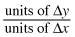. Often, rates of change are written as unit rates (that is, rates with a denominator of 1). In the situation shown in the graph at right, the slope is 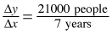, so the unit rate of change in the population of Smallville is 3000 people/year.

Dimensional Analysis
To use different units for the rate of change (or any other measurement), use dimensional analysis and the conversion factors from the Lesson 2.2.4 Math Notes box. Use the reciprocals of conversion factors as needed to make Giant Ones out of the units.
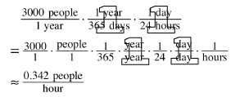
For example, to calculate the rate of change of the population of Smallville in people per hour, follow the steps at right.

Name________________________Per______
HOMEWORK ASSIGNMENT

2-94. The point (21, 32) is on a line with slope 1.5.
- Write the equation of the line. b. What are the coordinates of another point on
the line?

2-95. A one-minute advertisement on a local television station during prime time (8-10 p.m. on weeknights) costs the advertiser $12,800. To the nearest cent, how much does the advertisement cost per second? Show your work using dimensional analysis and Giant Ones.

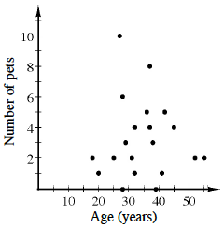
2-96. The graph at right compares the age and the number of pets for a certain population.
Describe the association for this population.

2-97. Write three different single-term expressions that are equivalent to x^{–2}. At least one expression should use division and another should use multiplication. Show how you know that your expressions are equivalent.

2-98. MATCH-A-GRAPH
Match the following graphs with their equations. Pay special attention to the scaling of each set of axes. Explain how you found each match.
a. | c.
b. y = 2x + 4 | d.
1.  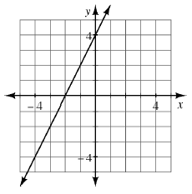 | 2.  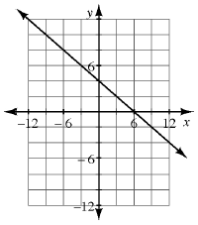
3.  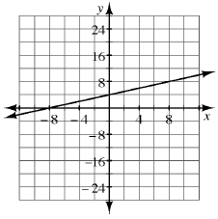 | 4.  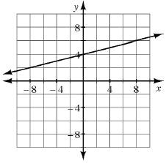

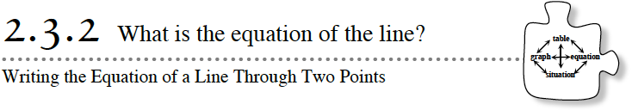
In past lessons, you learned facts about m and b by graphing lines from equations. In today’s lesson, you will reverse the process used in Lesson 2.1.4 so that you can write the equation of a line from a table or graph.

2-99. In this problem, you will write the equation of the line that goes through the points in the table below. Use the questions below to help you organize your work.
INPUT (x) | 29 | 18 | −8 | 14 | −27
OUTPUT (y) | 97 | 64 | −14 | 52 | −71
- What is the slope of the line?

- Does it matter which points you use to calculate the slope of the line? Calculate the slope using two other points to verify your answer to part (a).

- How can you use a point to write the equation? Write the equation of the line.

- Once you have the slope, does it matter which point you use to write your equation? Why or why not?

- How can you verify that your equation is correct?

2-100. LINE FACTORY LOGO
The Line Factory needs a new logo for its pamphlet. After much work, the stylish logos below were proposed. The design department knows the coordinates of the special points in each logo. However, programmers need to have the equations of the lines to program their pamphlet-production software. Explore your ideas using the
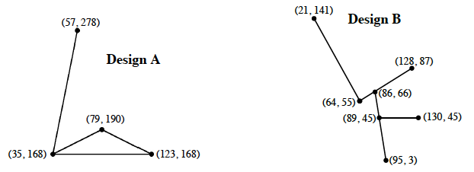
- Work in pairs today. Choose one logo for each pair in your team to work on, dividing up the work. What are the equations of the four line segments that make up this logo?

- What are the domain and range of each of the line segments in the logo? Is the line increasing or decreasing in this interval on the x-axis?

- Trade equations with the other pair of students in your team. Sketch each of their equations on graph paper. How did each sketch compare with the original logos? Discuss any equation modifications needed with your team.

2-101. LEARNING LOG
In your Learning Log, describe the process you used to write the equation of a line through two points. Include an example. Title this entry “Writing the Equation of a Line Through Two Points” and include today’s date.

Linear Equations from Slope and/or Points
If you know the slope, m, and y-intercept, (0, b), of a line, you can write the equation of the line as y = mx + b. See the Math Notes box in Lesson 2.1.4 for more about slope.
You can also write the equation of a line when you know the slope and one point on the line. To do so, first write y = mx + b. Then substitute the known slope for m, and substitute the coordinates of the known point for x and y. Solve the equation for b, and then write the new equation.
For example, write the equation of the line with a slope of –4 that passes through the point (5, 30). Write y = mx + b then substitute –4 for m, resulting in y = –4x + b. Substituting (5, 30) into the equation results in 30 = –4(5) + b. Solve the equation to determineb = 50. Since you now know the slope and y-intercept of the line, you can write the equation of the line as y = –4x + 50.
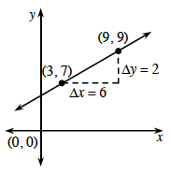
Similarly, you can write the equation of a line when you know two points. First use the two points to calculate the slope. Then substitute the known slope and either one of the known points into y = mx + b. Solve for b and write the new equation.

For example, write the equation of the line through (3, 7) and (9, 9). The slope is . Substituting and (x, y) = (3, 7) into y = mx + b results in . Then solve the equation to determine b = 6. Since you now know the slope and y-intercept, you can write the equation of the line as .

Name________________________Per______
HOMEWORK ASSIGNMENT

2-102. Write the equation for the line containing the points listed in the table below.
x | –1 | 1 | 3 | 5
y | 2 | 16 | 30 | 44

2-103. This problem is the checkpoint for evaluating expressions and the Order of Operations. It will be referred to as Checkpoint 2.
Evaluate each expression if x = −2, y = −3, and z = 5.
a. 2x + 3y + z | b. x − y | c.
d. 3x² − 2x + 1 | e. 3y(x + x² − y) | f.
Check your answers by referring to the Checkpoint 2 materials.
Ideally, at this point you are comfortable working with these types of problems and can solve them correctly. If you feel that you need more confidence when solving these types of problems, then review the Checkpoint 2 materials and try the practice problems provided. From this point on, you will be expected to do problems like these correctly and with confidence.
2-104. If you are traveling at a speed of 50 miles per hour, how many feet per second is this? Show your work using units and Giant Ones.
2-105. Tim is buying snacks for the Mathletes, who love microwave popcorn. When Tim looks at the popcorn selection he notices many brands and different prices. He wonders if the cost is related to the quality of the popcorn. To answer his question, he purchases a random sample of popcorn bags and records their price. When it is time for the Mathletes meeting he pops each bag in the same microwave, opens each bag, and counts the number of unpopped kernels.
Price ($) | 2.30 | 0.60 | 1.30 | 1.50 | 1.70 | 1.00
# Unpopped | 4 | 30 | 17 | 21 | 15 | 20
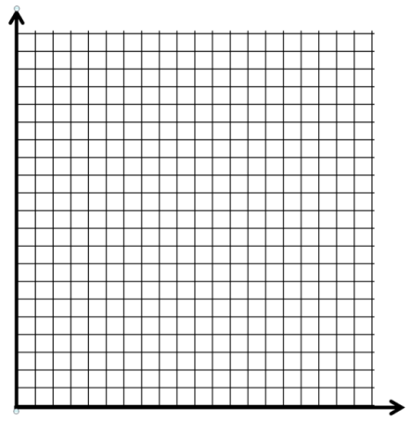
- Make a scatterplot on graph paper and draw the line of best fit. Choose two points on your drawn line and use them to determine the equation of the line of best fit. What do the slope and they-intercept represent in your equation?

- Estimate the number of unpopped kernels (after cooking) in a bag that costs $1.19.

2-106. Use what you know about y = mx + b to graph each of the following equations quickly on the same set of axes.
- y = 3x + 5
- y = −2x + 10
- y = 1.5x

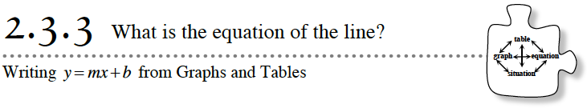
In today’s lesson, you will practice writing equations of lines from points.
2-107. SAVE THE EARTH
The Earth Protection Service (EPS) has asked your team to defend our planet against dangerous meteors. Luckily, the EPS has developed a very advanced protection system, called the Linear Laser Cannon. This cannon must be programmed with an equation that dictates the path of a laser beam and destroys any meteors in its path. Unfortunately, the cannon uses a huge amount of energy, making it very expensive to fire.
Your Mission: Using the Save The Earth: Practice Games 1-3 (Desmos) and Function Grapher Game (Desmos) or the resource page provided by your teacher, find equations of lines that will eliminate the meteors as efficiently as possible. The EPS offers big rewards for operators who use the fewest number of lasers possible to eliminate the meteors.
Game #1 | 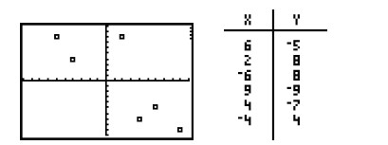
Game #2 | 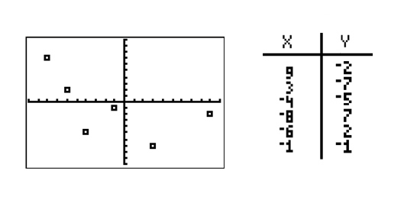
Game #3 | 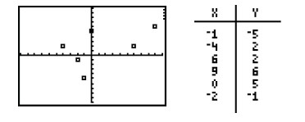

Name________________________Per______
HOMEWORK ASSIGNMENT

2-108. Graph a line with y-intercept (0, −4) and x-intercept (3, 0). Write the equation of the line.
2-109. Calculate the slope of the line containing the points in the table below.
input (x) | 2 | 4 | 6 | 8 | 10
output (f(x)) | 4 | 10 | 16 | 22 | 28
2-110. Mike knows that he can make 12 of his super delicious meatballs from one pound of hamburger. He wants to make meatballs for the football party on Sunday, and he estimates that there will be five people there (including himself) who will eat meatballs, and that each person will eat approximately seven meatballs. How many pounds of hamburger should he thaw out so that he can make enough meatballs for everyone at the party?

2-111. Use the function to calculate the value of each expression below.
a. f(1) | b. f(0) | c. f(−3) | d. f(1.5)
e. What value of x would make f(x) = 4?
2-112. Sally ordered her groceries online. She accidentally ordered 120 pounds of flour (instead of 10 pounds) and only uses five pounds of flour every two months.
- What is the unit rate of change for this situation, including the units?

- Write an equation that represents this situation.

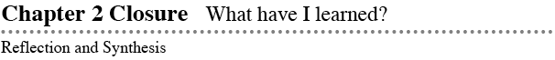
The activities below offer you a chance to reflect on what you have learned during this chapter. As you work, look for concepts that you feel very comfortable with, ideas that you would like to learn more about, and topics that you need more help with. Look for connections between ideas as well as connections to material you learned previously.

TEAM BRAINSTORM
What have you studied in this chapter? What ideas were important in what you learned? With your team, brainstorm a list. Add as many details as you can. To help get you started, Learning Log entries and Math Notes boxes are listed below.
What topics, ideas, and words that you learned before this chapter are connected to the new ideas in this chapter? Again, write down as many details as you can.
How long can you make your list? Challenge yourselves. Be prepared to share your team’s ideas with the class.
Learning Log Entries
Lesson 2.1.3 – Multiple Representations Web for Linear Functions
Lesson 2.1.4 – y = mx + b
Lesson 2.2.2 – Rates of Change and Slope
Lesson 2.3.1 – Multiple Representations Web for Linear Functions
Lesson 2.3.2 – Writing the Equation of a Line Through Two Points
Math Notes
Lesson 2.1.3 – Line of Best Fit
Lesson 2.1.4 – The Slope of a Line
Lesson 2.2.1 – Describing Association
Lesson 2.2.2 – Writing the Equation of a Line from a Graph or Table
Lesson 2.2.3 – x- and y-Intercepts
Lesson 2.2.4 – Conversion Factors, Metric Prefixes, and Common Abbreviations
Lesson 2.3.1 – Slope as Rate and Dimensional Analysis
Lesson 2.3.2 – Linear Equations From Slope and/or Points

2. MAKING CONNECTIONS
Below is a list of the vocabulary words used in this chapter. Make sure that you are familiar with all of these terms and know what they mean. Refer to the glossary or index for any words that you do not yet understand.
delta (Δ) x | delta (Δ) y | coefficient
constant term | dependent variable | dimensional analysis
evaluate | Figure 0 | function
Giant One | graph | growth
horizontal lines | independent variable | linear equation
negative slope | Order of Operations | parameter
piecewise graph | positive slope | precision (of measurement)
average rate of change | situation | slope
slope triangle | starting value (initial value) | vertical lines
unit of measure | unit rate | variable
x y table | x-intercept(s) | y=mx+b
y-intercept(s) | zero slope
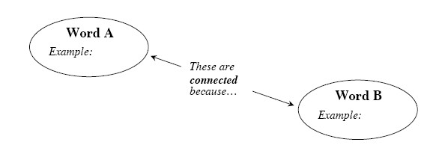
Make a concept map showing all of the connections you can make among the key words and ideas listed above. To show a connection between two words, draw a line between them and explain the connection, as shown in the model below. A word can be connected to any other word as long as you can justify the connection. For each key word or idea, provide an example or sketch that shows the idea.

Your teacher may provide you with vocabulary cards to help you get started. If you use the cards to plan your concept map, be sure either to re-draw your concept map on your paper or to glue the vocabulary cards to a poster with all of the connections explained for others to see and understand.
While you are making your map, your team may think of related words or ideas that are not listed here. Be sure to include these ideas on your concept map.

3. PORTFOLIO: EVIDENCE OF MATHEMATICAL PROFICIENCY
Part 1: Copy all your work from problem 2-47 into your portfolio. This will provide evidence of your early understanding of describing an association. After Chapter 4, you can compare your work on this problem to other statistics problems to see how much your understanding has grown.

Part 2: Congratulations! You are now the owner of the city’s premiere Line Factory. However, instead of raking in huge profits, you’ve noticed that you are only breaking even because many customers are ordering the incorrect line. After your company has produced the customer’s line (at great expense!), they have refused to pay for it, saying it was not the line that they wanted!
Your Task: To prevent your customers from ordering the wrong lines, you need to produce a pamphlet that explains how to order a line. Carefully determine what information should be in the pamphlet so that customers will know how to write their equation in y = mx + b form to get the line they want.
You can view some examples of pamphlets to help determine the layout of your pamphlet. A sample is shown at left. Your pamphlet can contain some advertisements, but remember that it needs to include everything you know about equations and graphs of lines so that your customers can order wisely. Remember to be specific and show examples!
How do m and b affect the equation of a line?
What information does a customer need to know to order a line correctly?
How could a customer figure out what line to order if he or she only knew
two points on the line, or one point and the slope?

4. WHAT HAVE I LEARNED?
Most of the problems in this section represent typical problems found in this chapter. They serve as a gauge for you. You can use them to determine which types of problems you can do well and which types of problems require further study and practice. Even if your teacher does not assign this section, it is a good idea to try these problems and find out for yourself what you know and what you still need to work on.
Solve each problem as completely as you can. The table at the end of the closure section has answers to these problems. It also tells you where you can find additional help and practice with problems like these.
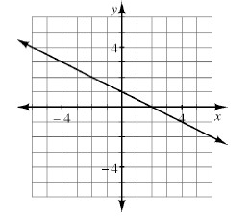
CL 2-113. For the line graphed at right:
a. What is the slope?
b. What is the y-intercept?
c. Write the equation.

CL 2-114. Identify m and b in the following equations. What do m and b represent?
- y = 2x + 1

CL 2-115. Graph each equation in problem CL 2-114.

CL 2-116. Rewrite each expression into an equivalent, simpler form with no negative exponents or parentheses remaining.
- 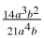
- 2m³n² · 3mn⁴
- 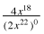
- (s⁴tu²)(s ⁷t ⁻¹)
- (3w⁻²)⁴
- m⁻³
CL 2-117. Shirley starts with $85 in the bank and saves $15 every two months. Write an equation for the balance of Shirley’s bank account. Be sure to define your variable(s).

CL 2-118. What is the slope for each of the lines with points shown in the tables below?

x | −2 | −1 | 0 | 1 | 2
y | 19 | 14 | 9 | 4 | −1

x | 2 | 3 | 4 | 5 | 6
y | 22 | 31 | 40 | 49 | 58
CL 2-119. Write an equation for the given tile pattern. How many tiles will be in Figure 58?
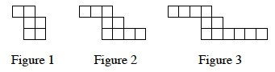

CL2-120. Complete the table below for the equation y = 2^{x} + 1. Then graph the equation.
x | −3 | −2 | −1 | 0 | 1 | 2 | 3 | 4
Y

- Is this a function?
- State the domain and range.

CL 2-121. What is the slope of the line that passes through the points (−5, 7) and (10, 1)?

CL 2-122. Evaluate the expressions below for the given values.
- −3x² + 4x + 5 for x = −2
- 6− (5x − 9)² for x = 1
- for k = −8
- for m = −2, n = 3
- If (c) were , what value of k would be excluded from the domain?

CL 2-123. A book contains an average of 300 words per page. If you read one page in 68 seconds, what is your reading rate in words per minute? In pages per hour?

CL 2-124. Check your answers using the table at the end of the closure section. Which problems do you feel confident about? Which problems made you think? Use the table to make a list of topics you need help with and a list of topics you need to practice more.

Answers and Support for Closure Activity #4
What Have I Learned?
Note: MN = Math Note, LL = Learning Log
Problem | Solution | Need Help? | More Practice
CL 2-113. | a. The slope is −.  b. The y-intercept is (0, 1).  c. y = −x + 1 | Lesson 2.1.4  MN: 2.1.4  MN: 2.2.2  LL: 2.1.3  LL: 2.1.4 | Problems2-18,2-43,2-67,2-98, and2-108
CL 2-114. | m represents the slope and b represents they-intercept.  a. m = 2, b = 1  b. m = 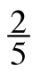, b = −4 | Lesson 2.1.4  LL: 2.1.4 | Problems2-40,2-49, and2-83
CL 2-115. | 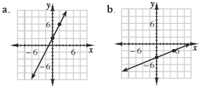 | Lesson 2.1.4  LL: 2.1.4 | Problems2-49,2-62, and2-106
CL 2-116. | a. b. 6m⁴n⁶  c. 4x¹⁸ d. s¹¹u²  e. f. | Section 1.3  MN: 1.3.2  LL: 1.3.2 | Problems CL 1-88,2-7,2-33,2-59, and2-97
CL 2-117. | Let x = # of months that have passed.  Let y = amount of money in the account. | Lesson 2.2.3  LL: 2.3.1 | Problems2-58,2-66, and2-112
CL 2-118. | a. m = −5  b. m = 9 | Section 2.1  MN: 2.1.4 | Problems2-72,2-85, and2-108
Problem | Solution | Need Help? | More Practice
CL 2-119. | y = 3x + 3  Figure 58 will have 177 tiles. | Section 2.1  LL: 2.3.1 | Problems2-6, 2-43, and2-61
CL 2-120. | 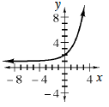y-values in table:  1.125, 1.25, 1.5, 2, 3, 5, 9, 17  a, Yes, it is a function.  b. Domain: all real numbers, Range: y > 1 | Lessons 1.1.3  Lesson 1.2.2  Lesson: 1.2.3  MN: 1.2.3  LL: 1.1.3  LL: 1.2.2 | Problems1-32, 2-8, 2-21,2-34, and2-51
CL 2-121. | m = − | Section 2.1  MN: 2.1.4 | Problems2-41,2-64, and2-85
CL 2-122. | a. −15  b. −10  c. 4  d. 3  e. x ≠ −7 | Checkpoint 2 | Problems CL 1-96,2-21, 2-51, and2-103
CL 2-123. | Approximately 265 words per minute or 53 pages per hour. | Lesson 2.2.4  MN: 2.2.4  MN: 2.3.1 | Problems2-95 and2-104

Review Preview Answers
2.1.2
2.1.1
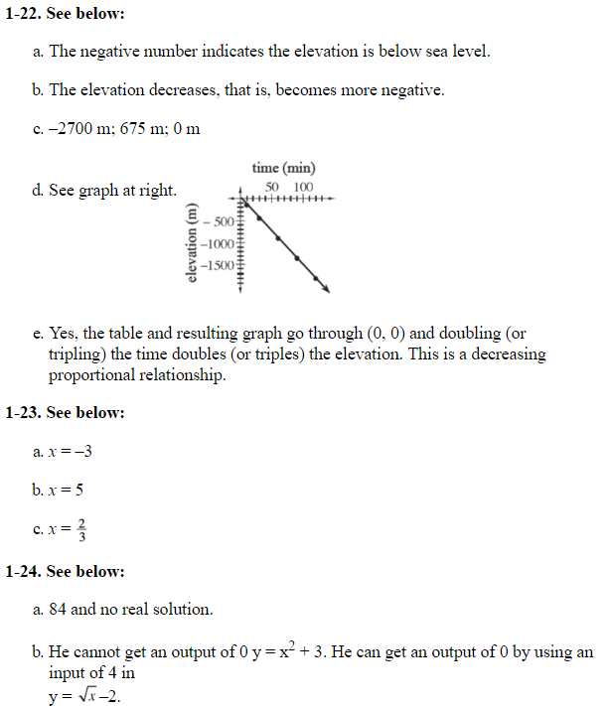
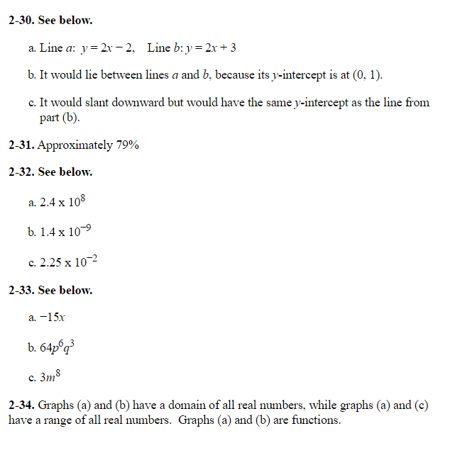
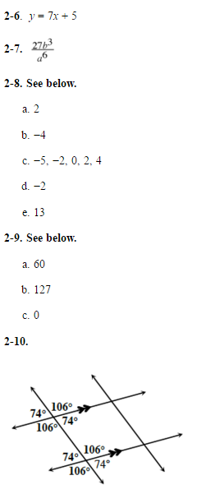
2.1.3

2.1.4 2.2.1
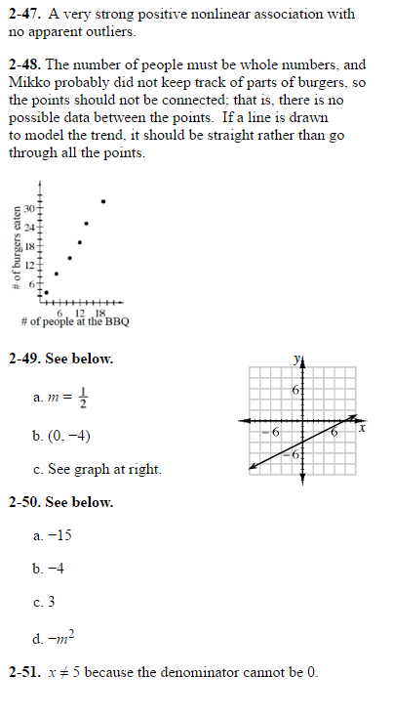
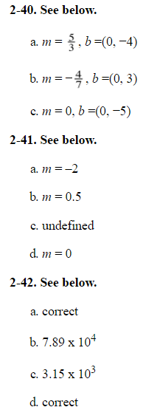

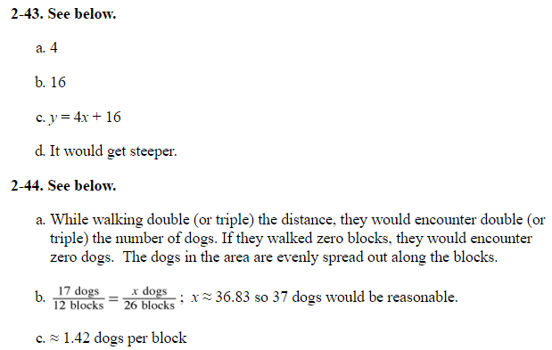

2.2.2 2.2.3
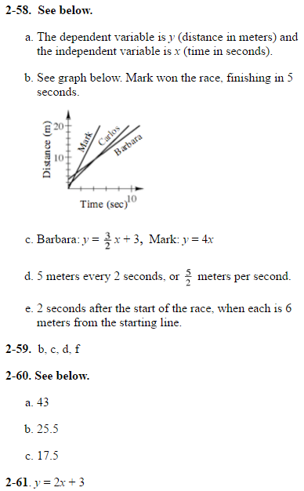
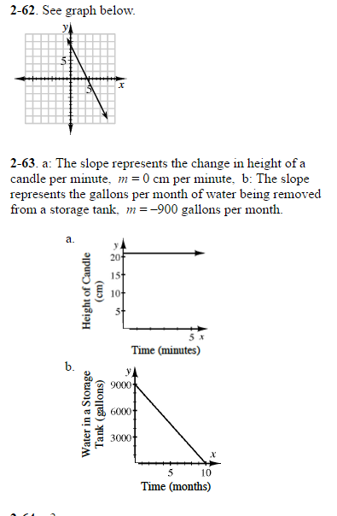

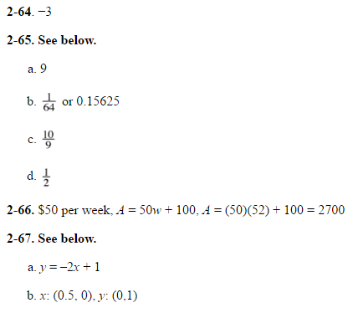

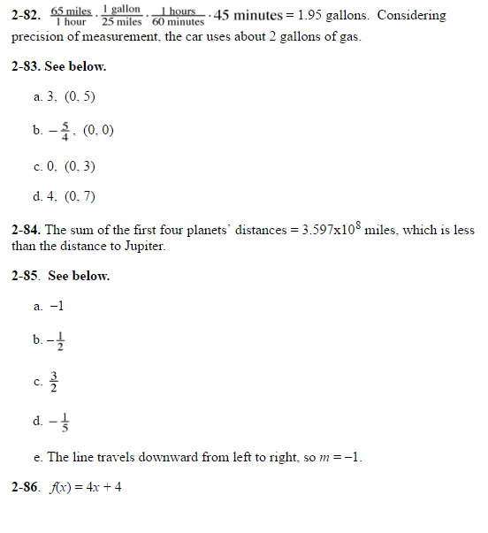
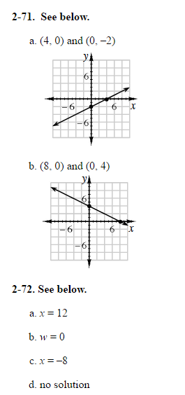
2.2.3 2.2.4

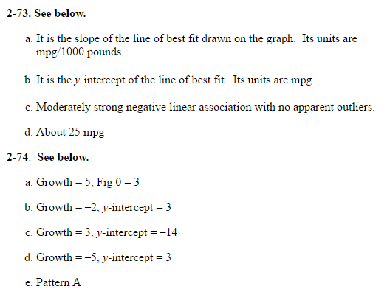
2.2.4 2.3.1
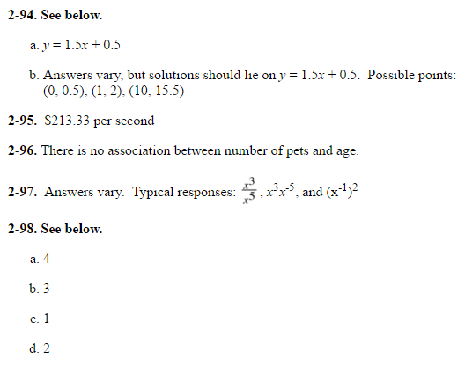

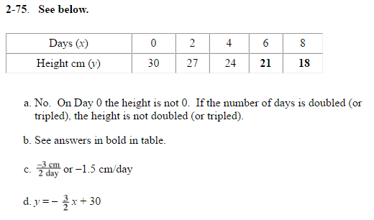

2.3.2 2.3.3
