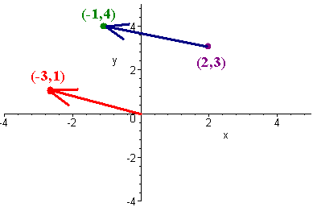
Int 3 MA Chapter 13 VECTORS & IB
Date |  | Classwork |  | Homework Assignment
Monday, April 29 |  | Day #1 wup, notes, CW ws |  | CH13H1 Day #1 Vectors WS
BLOCK  April 30, May 1 |  | Day #2 notes, worksheet2 Vectors Dot Product  Day #3 notes, worksheet |  | CH13H2 Day #2 Vectors WS  Day 3 Vectors Equation of a Line  CH13H3 Vector Land WS
BLOCK  May 2, May 3 |  | 3D Vector WS |  | CH13H4 Equations of Lines WS
Monday, May 6 |  | Vector Practice |  | CH13H5 IB Vector WS #1
BLOCK  May 7-8 |  | Group Quiz |  | CH13H6 C13 DDAY WS
Thursday, May 9 |  | IB REVIEW  Vector Practice |  | CH13H7 IB Review WS hana (1)
Friday, May 10 |  | Group Work on WS  AP US History Exam
Monday, May 13 |  | Review  wup & Airplane WS |  | CH13H8 IB WS # deux (2)
BLOCK  May 14-15 |  | IB REVIEW  AP English Exam |  | CH13H9 IB WS # tres (3)
Thursday, May 16 |  | Warmup for test ws |  | CH13H10 Complete Vector WS
Friday, May 17 |  | Vectors Test |  | CH13H11 IB WS drei (4)
Monday, May 20 |  | IB REVIEW & Group Work |  | Group Time to work on Presentation  CH13H12 RFF WS# issa
BLOCK  May 21-22 |  | IB REVIEW & Group Work |  | Group Time to work on Presentation  CH13H13 RFF WS# ni  Group Notes, Game & HW DUE on Thursday, May 23
Thursday, May 23 |  | IB REVIEW & Group Work |  | Group Time to work on Presentation
Friday, May 24 |  | Review Polynomials |  | RFFH1 C8 WS
Monday, May 27 NO SCHOOL: Memorial Day
Tuesday, May 28 |  | Review Unit Circle |  | RFFH2 C9 WS
Wednesday, May 29 |  | Review Sequence & Series |  | RFFH3 C10 WS
BLOCK, May 30-31  Thursday 6/4/2  Friday 5/3/1 |  | Review Rational Functions Review Identities |  | RFFH4 C11 WS  RFFH5 C12 WS
Monday  June 3 |  | Review for Final
FINALS | Tuesday, June 4  Per 1: 7:30-9:32  Per 2: 9:47-11:49 |  | Wednesday, June 5  Per 3: 7:30-9:32  Per 4: 9:47-11:49 |  | Thursday, June 6  Per 5: 7:30-9:32  Per 6: 9:47-11:49

