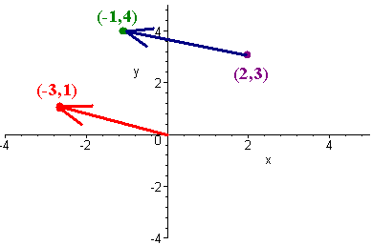
Int 3 MA Chapter 13 VECTORS
Date |  | Classwork |  | Homework Assignment
Thursday,  May 3 |  | Day #1 wup, notes, CW ws |  | Day 1 Intro to Vectors  CH13H1 IB Review WS hana (1)
Friday,  May 4 |  | Day #2 notes, worksheet |  | CH13H2 Day #1 WS
Monday  May 7 |  |  |  | Day 2 Vectors Dot Product  CH13H3 Day #2WS
BLOCK  5/8-9 |  | Group Work on WS  AP US History Exam |  | CH13H4 IB WS # deux (2)
Thursday  May 10 |  | Day #3 notes, worksheet |  | Day 3 Vectors Equation of a Line  CH13H5 Vector Land WS
Friday  May 11 |  | IB REVIEW  3D Vector (random call) WS |  | CH13H6 IB WS # tres (3)
Monday  May 14 |  | Review  wup ws & Airplane 20 Marks WS |  | CH13H7 Equations of Lines & Planes WS
BLOCK  Tues 5/15  Wed 5/16 |  | Group Quiz |  | CH13H8 2016 IB WS (heart)
Thursday  May 17 |  | Review |  | CH13H9 C13 DDAY WS
Friday  May 18 |  | Vectors Test |  | CH13H10 IB WS drei (4)
Monday  May 21 |  | IB REVIEW & Group Work |  | Group Time to work on Presentation  CH13H11 RFF WS# issa
BLOCK  Tues 5/22  Wed 5/23 |  | IB REVIEW & Group Work |  | Group Time to work on Presentation  CH13H12 RFF WS# ni
Thursday  May 24 |  | IB REVIEW & Group Work |  | Group Time to work on Presentation
Friday  May 25 |  | Review Polynomials |  | RFFH1 C8 WS
Monday, May 28 NO SCHOOL: Memorial Day
BLOCK  Tues 5/29  Wed 5/30 |  | Review Unit Circle Review Sequence & Series |  | RFFH2 C9 WS  RFFH3 C10 WS
Thursday  May 31 |  | Review Rational Functions |  | RFFH4 C11 WS
Friday  June 1 |  | Review Identities |  | RFFH5 C12 WS
Monday  June 4 |  | Review for Final
FINALS | Tuesday, June 5  Per 1: 7:30-9:32  Per 2: 9:47-11:49 |  | Wednesday, June 6  Per 3: 7:30-9:32  Per 4: 9:47-11:49 |  | Thursday, June 7  Per 5: 7:30-9:32  Per 6: 9:47-11:49

